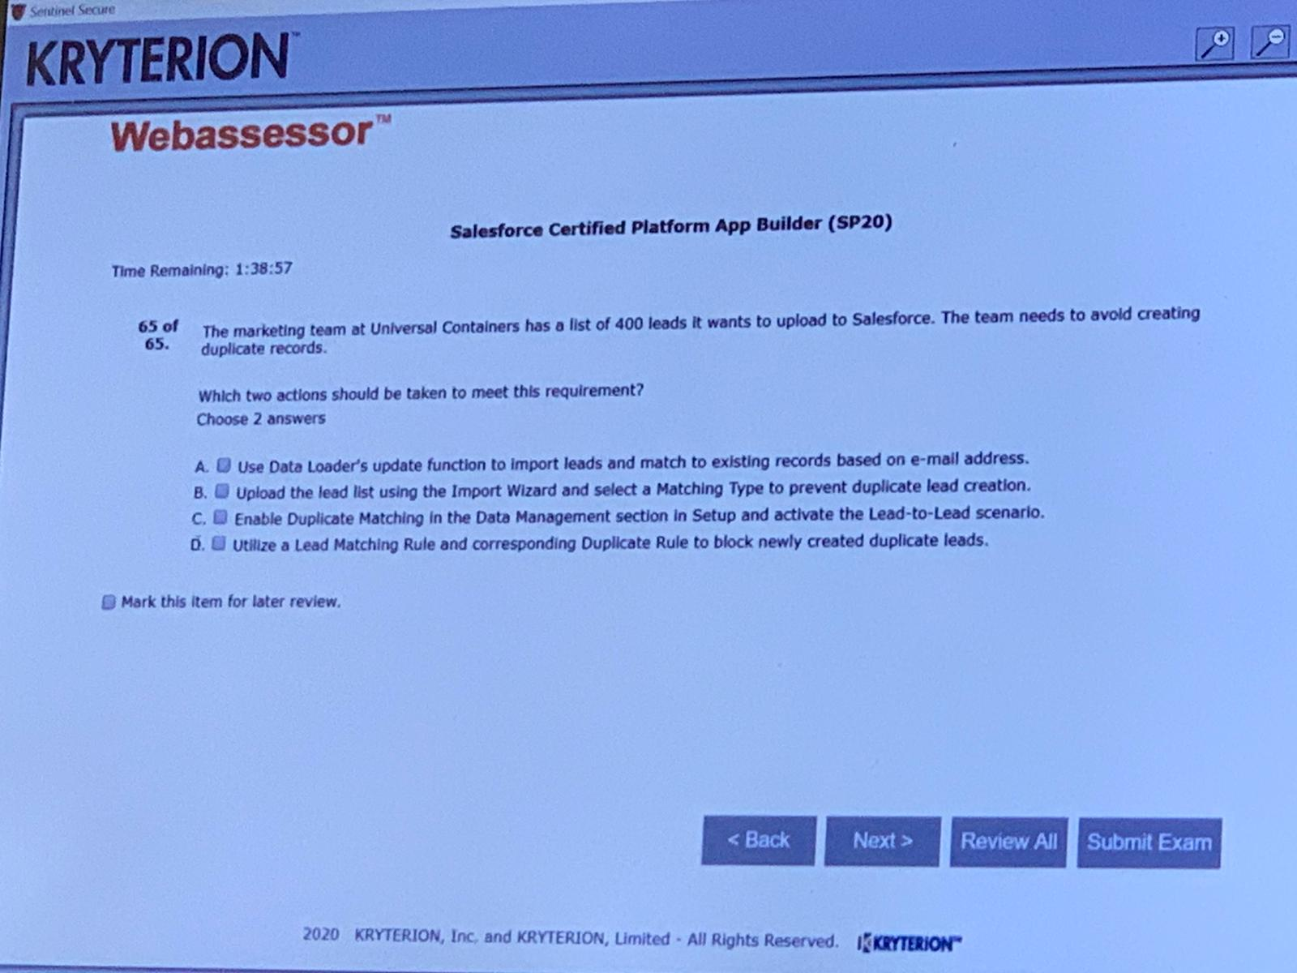B,D

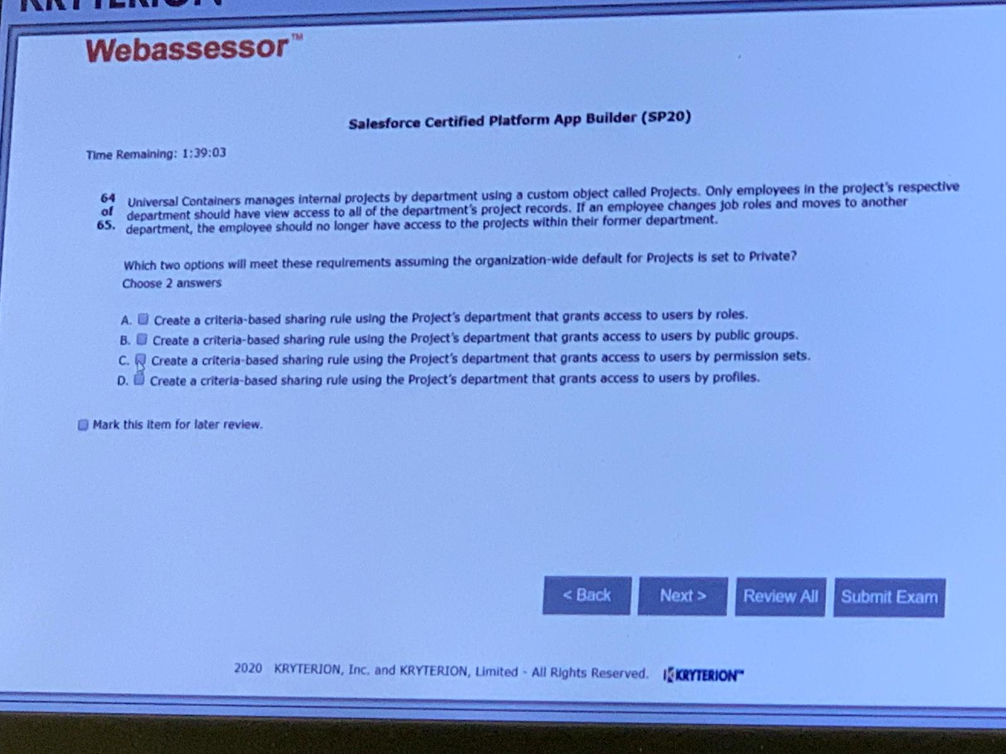

A,B

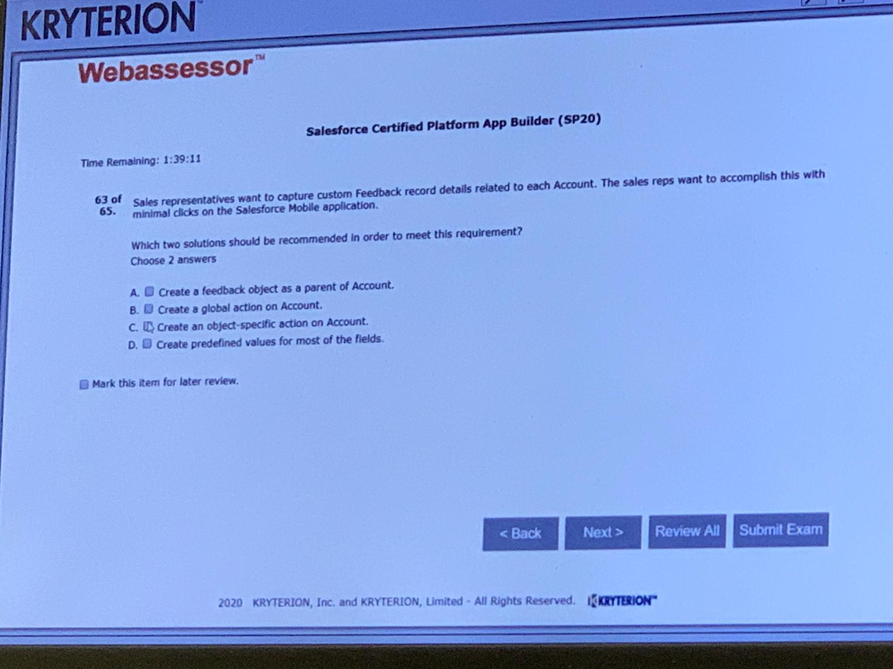

C,D

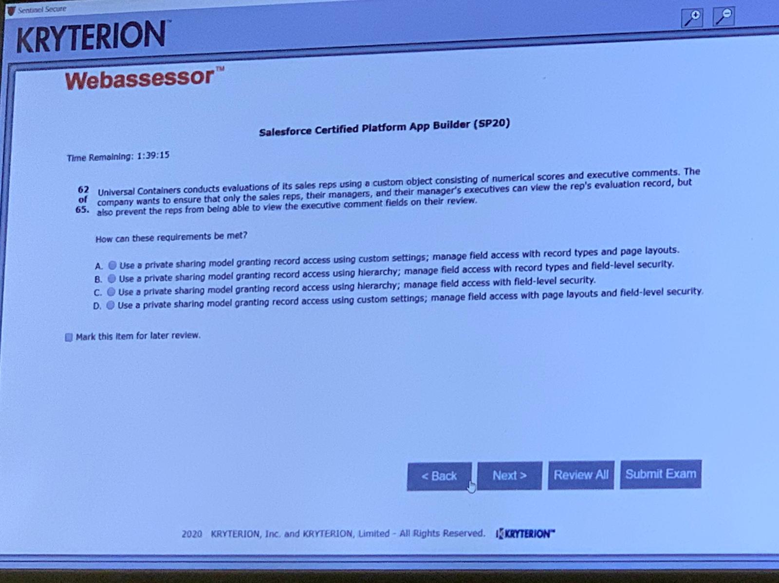

C

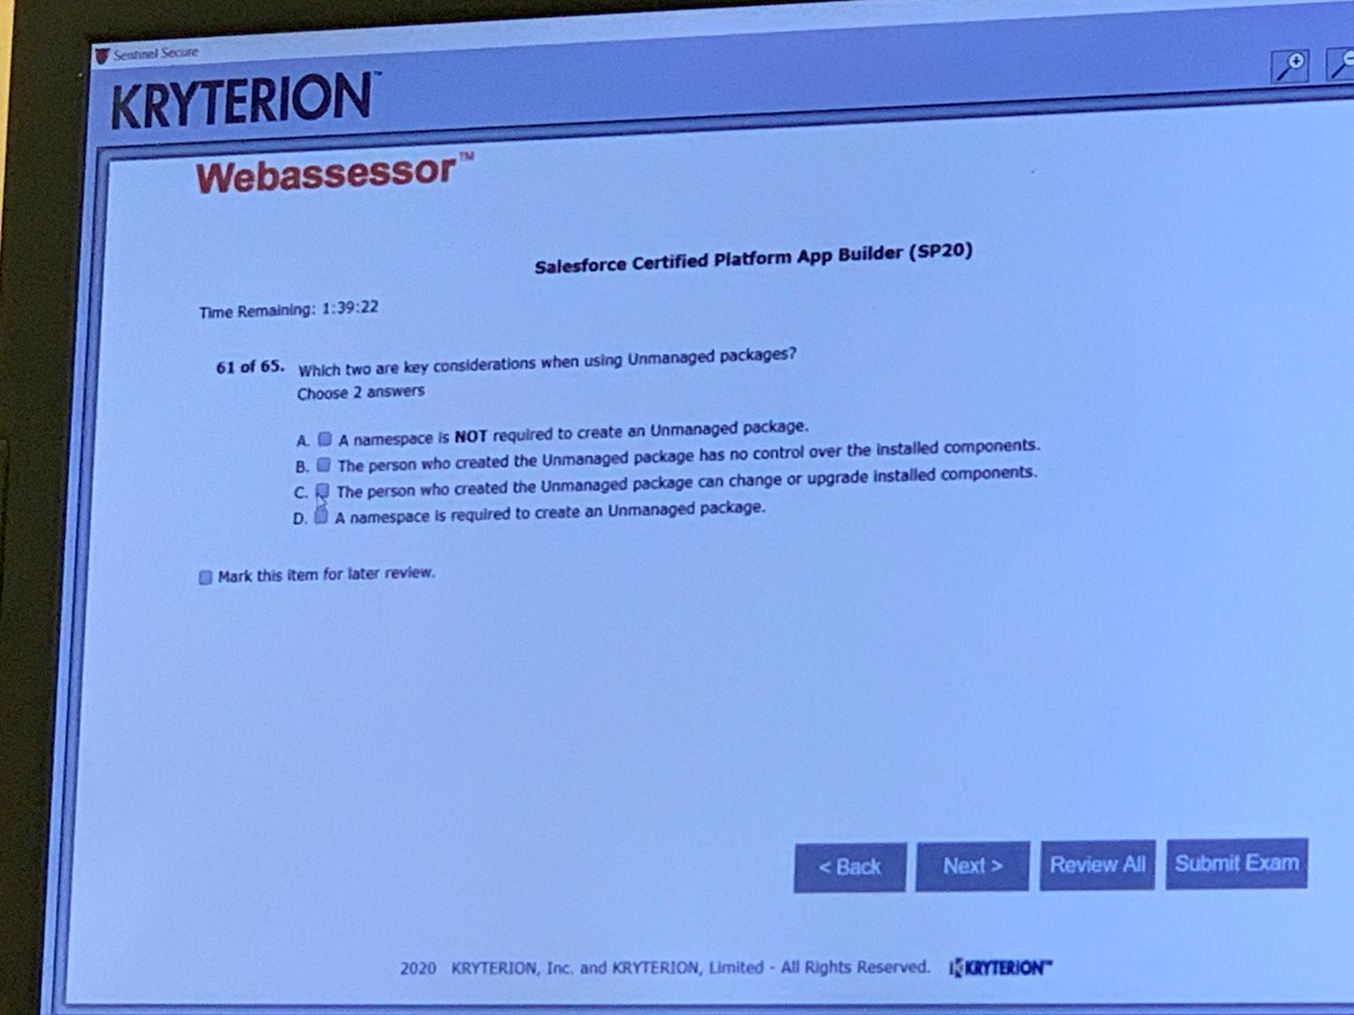

A,B

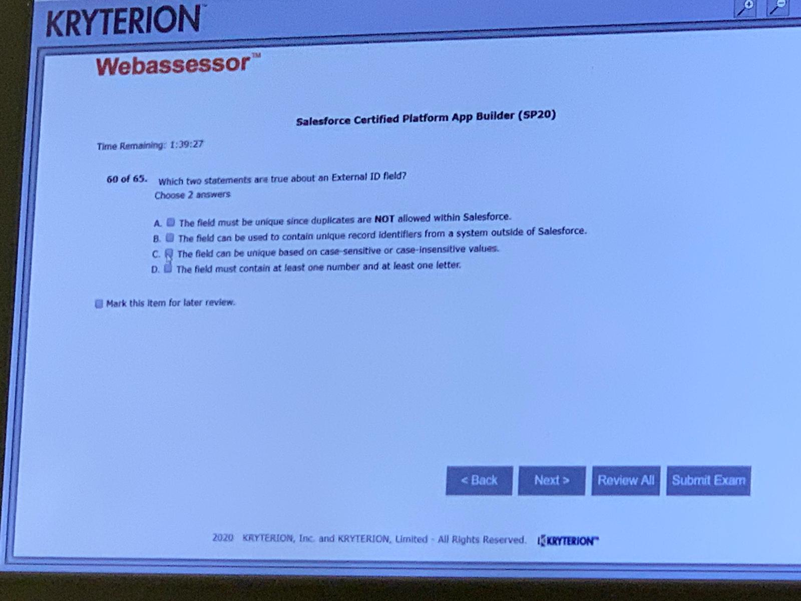

A,B

C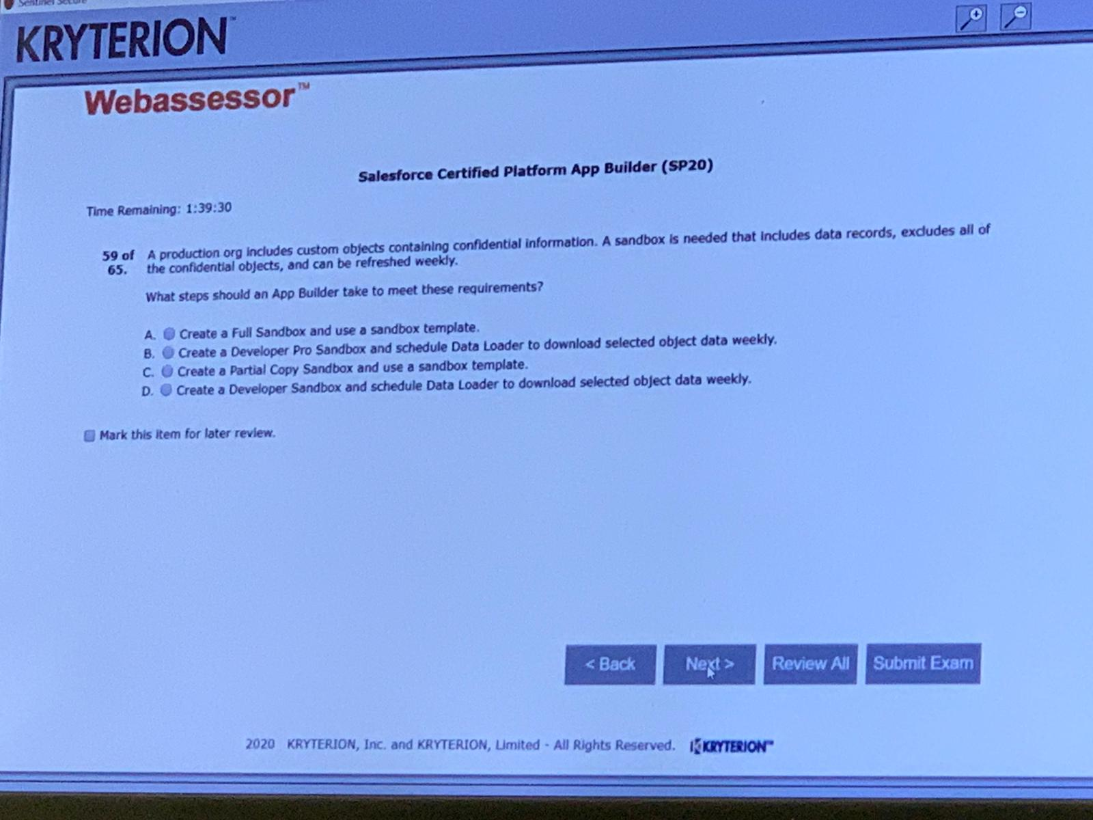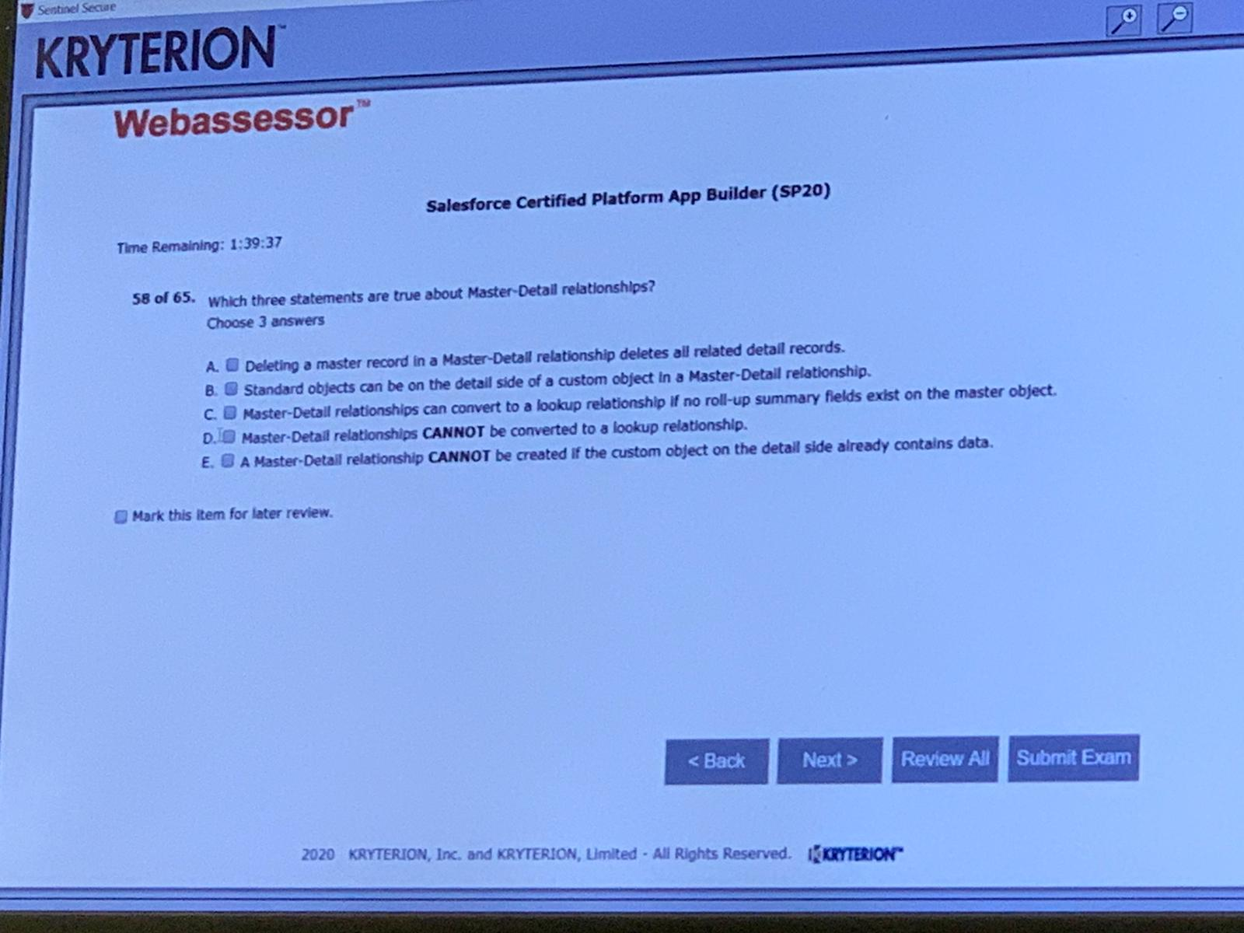

A,C,E

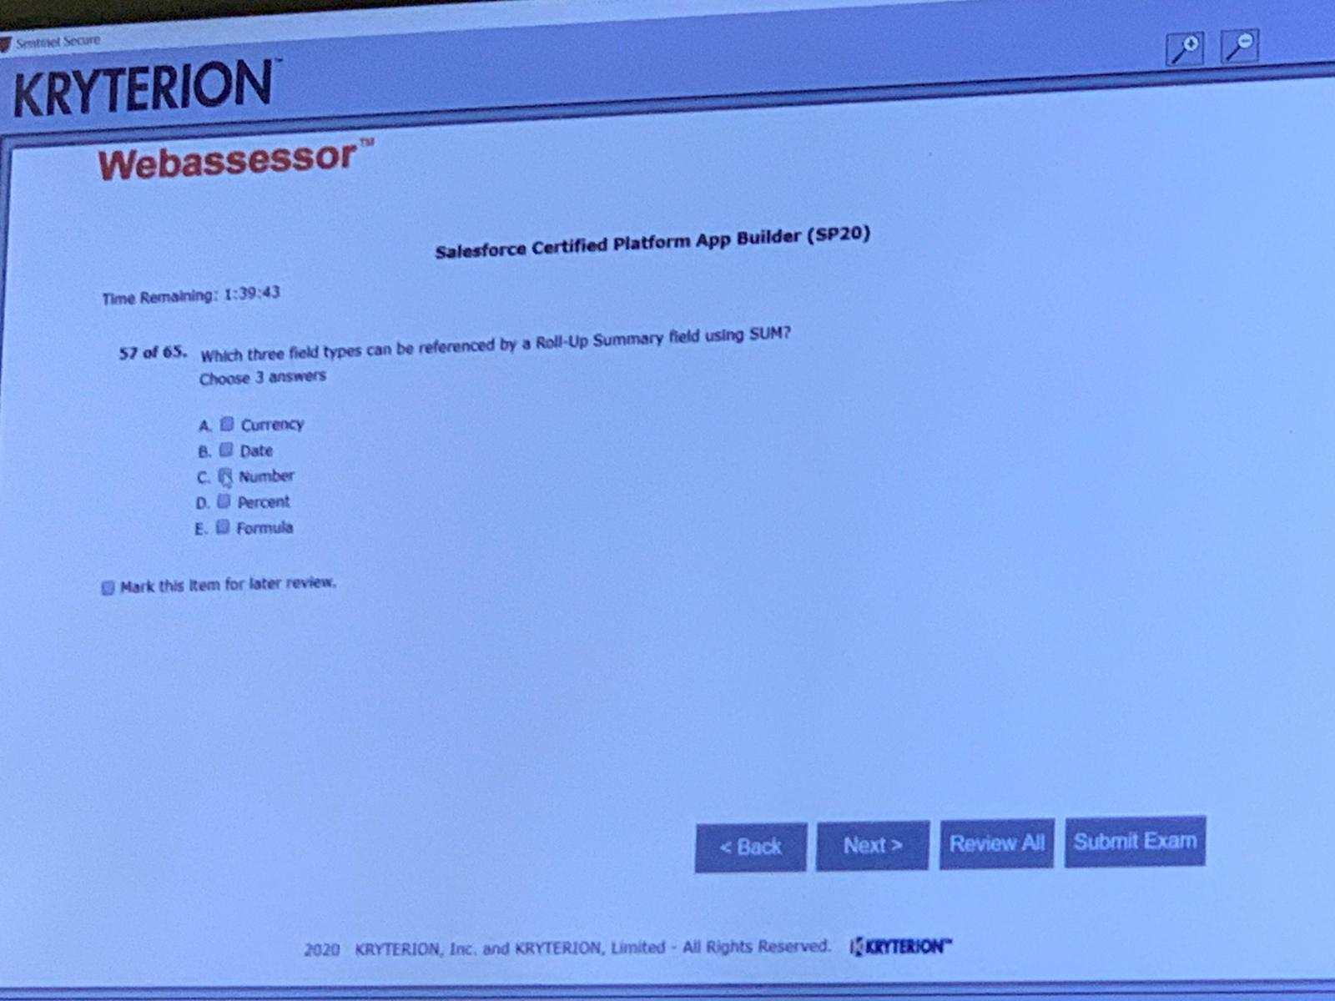

A,C,D

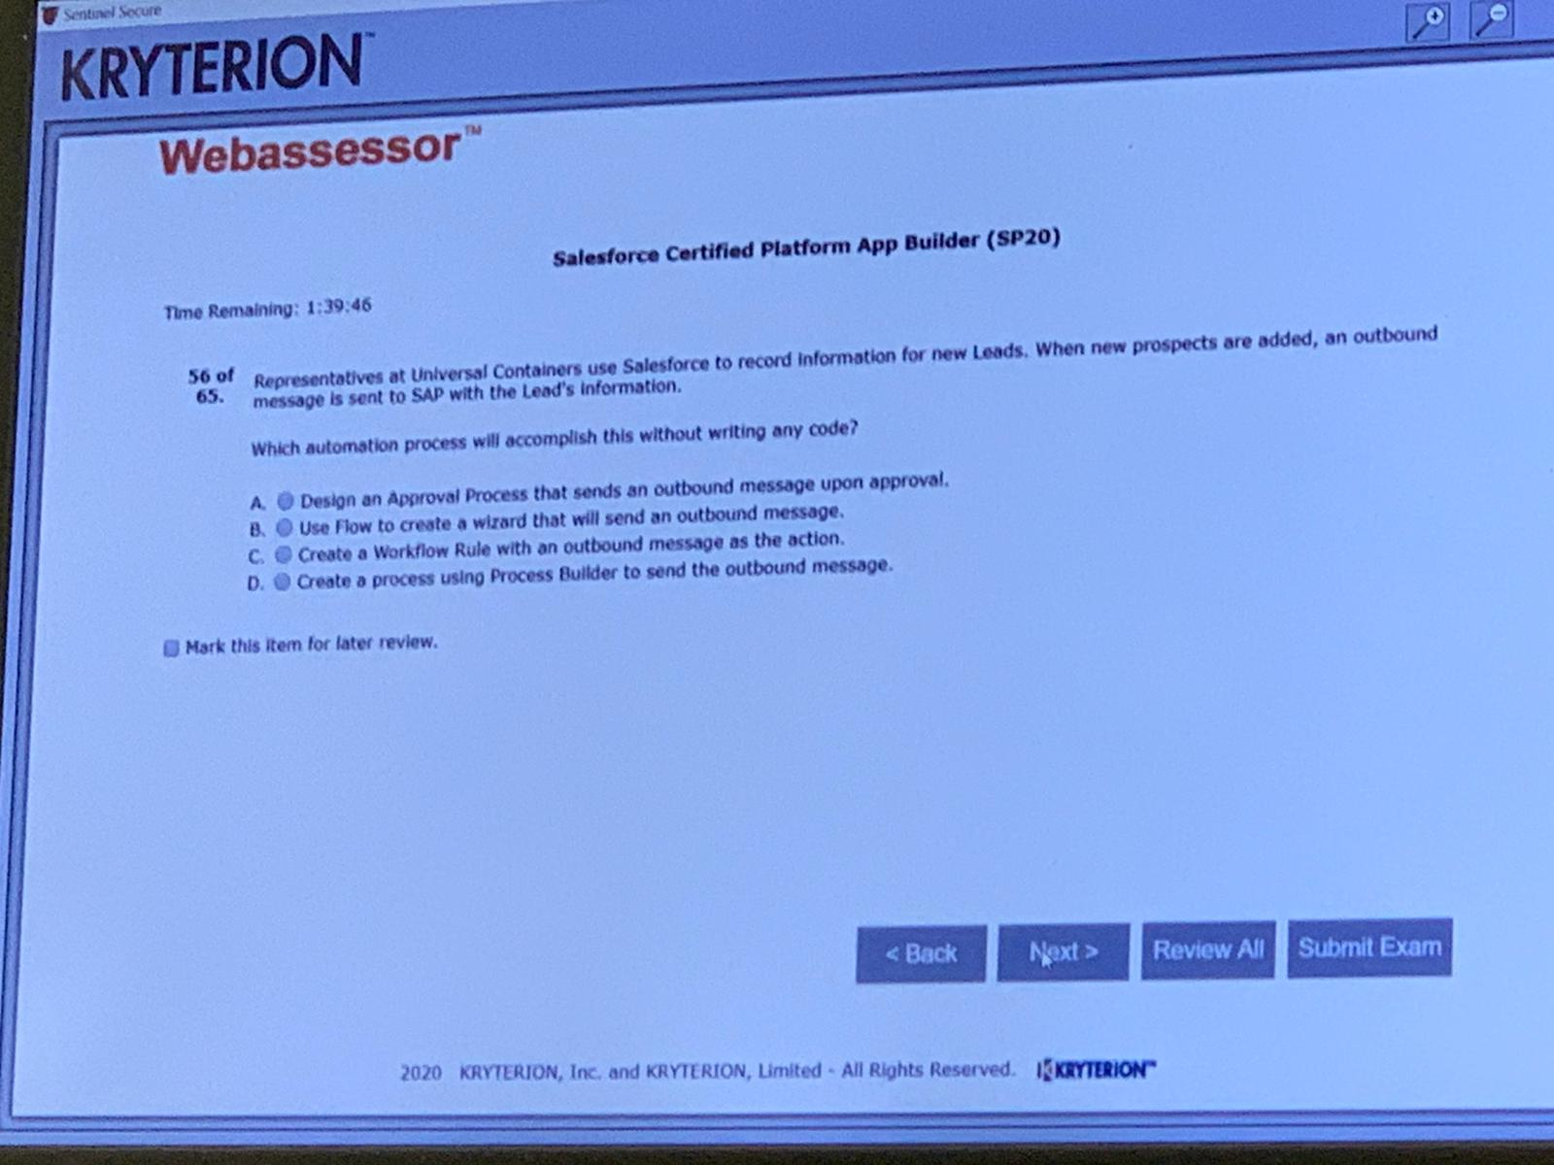

C

C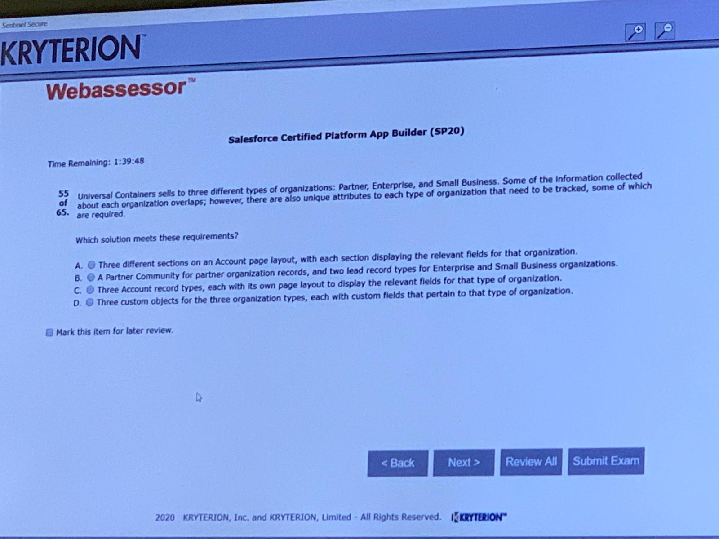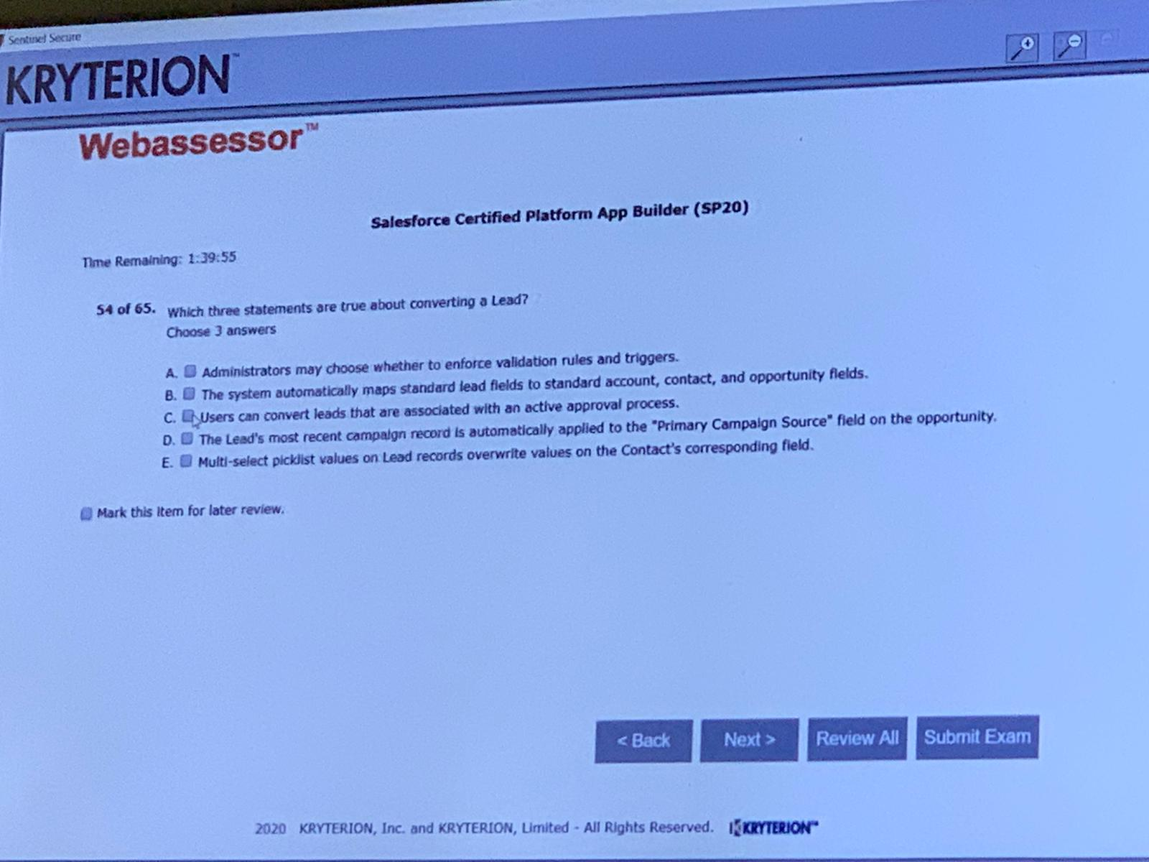

A,B,D

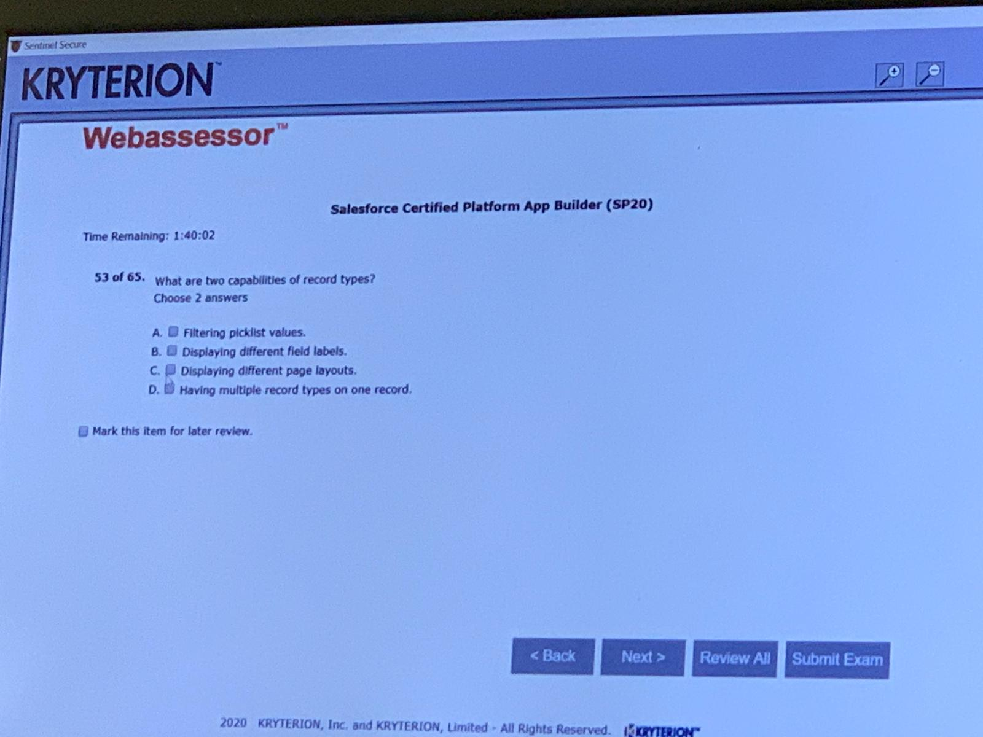C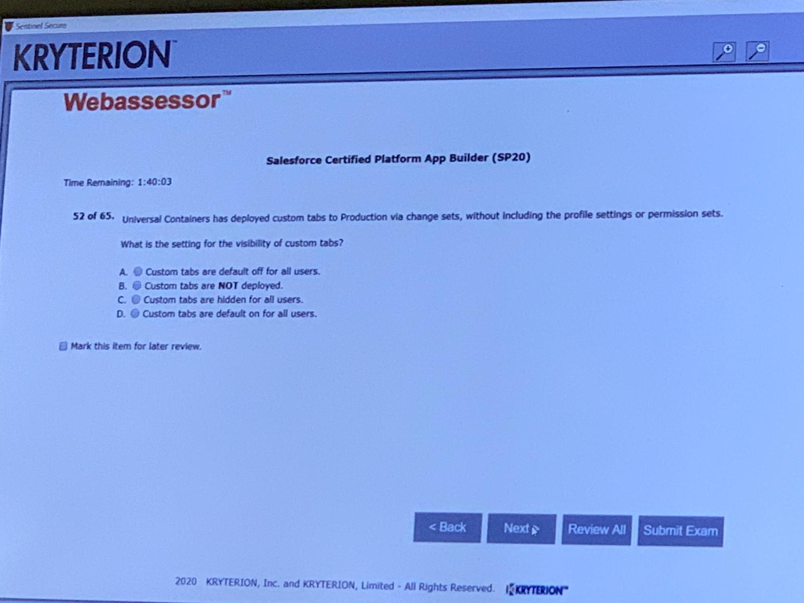C

B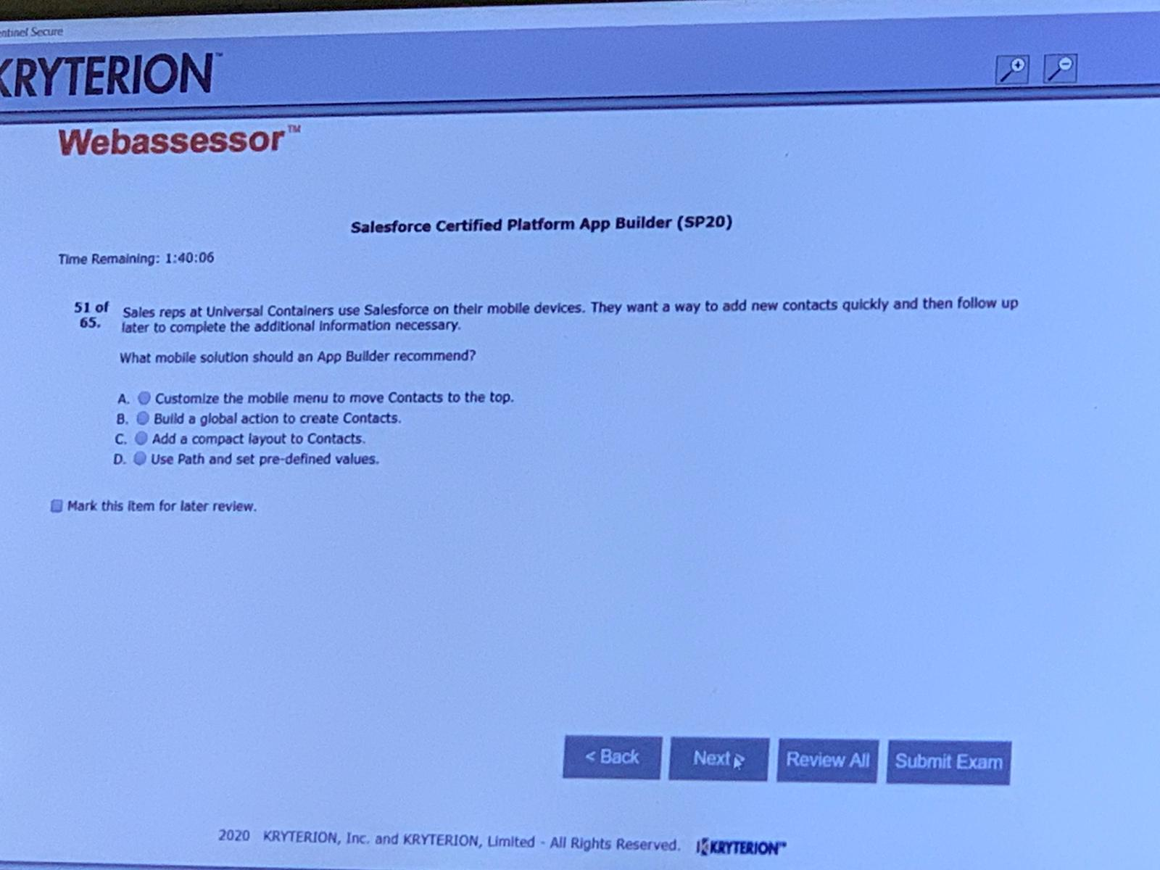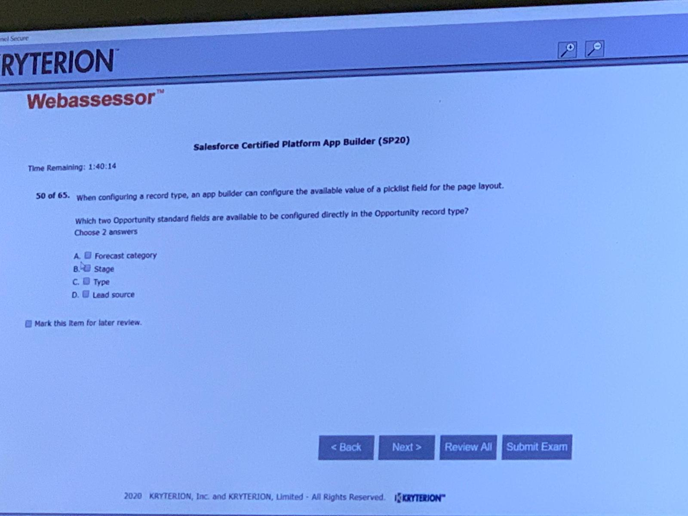C,D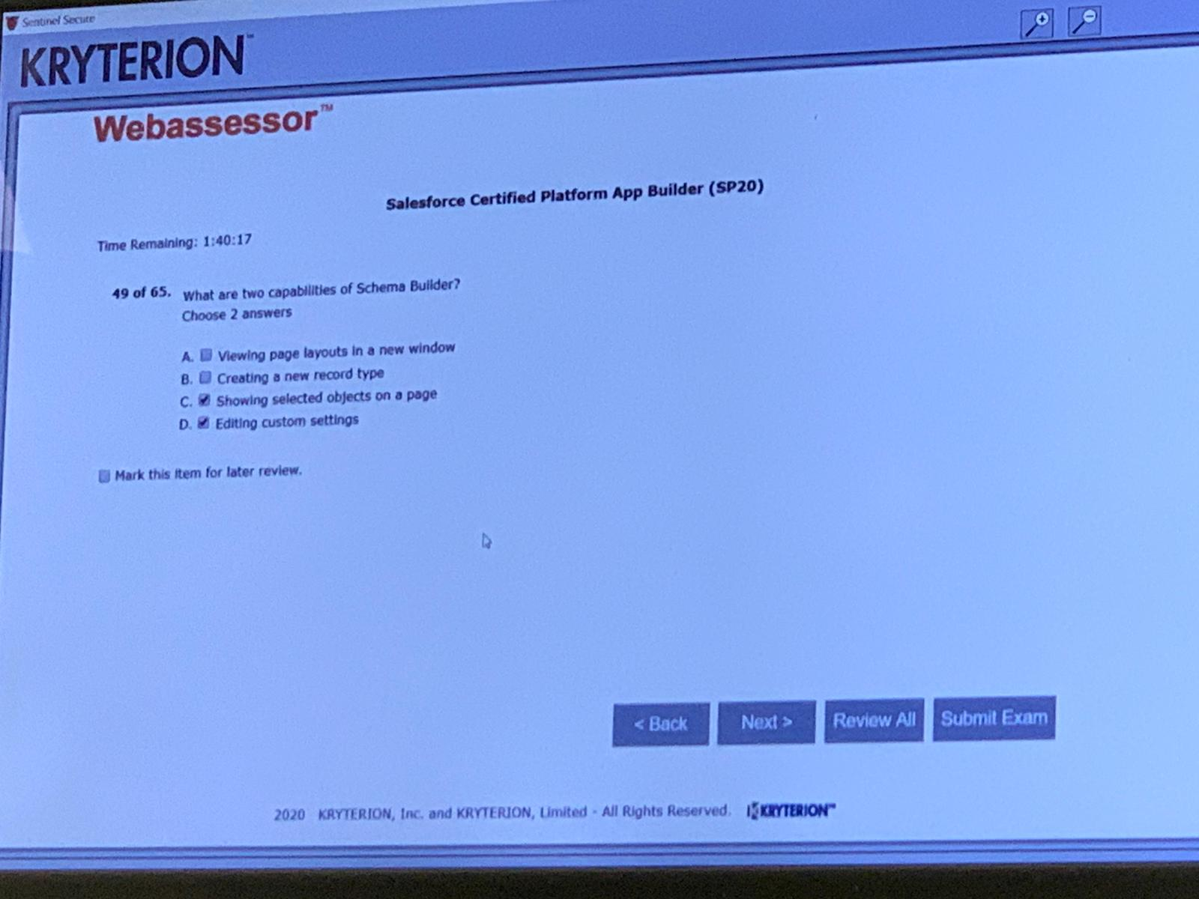A,CA,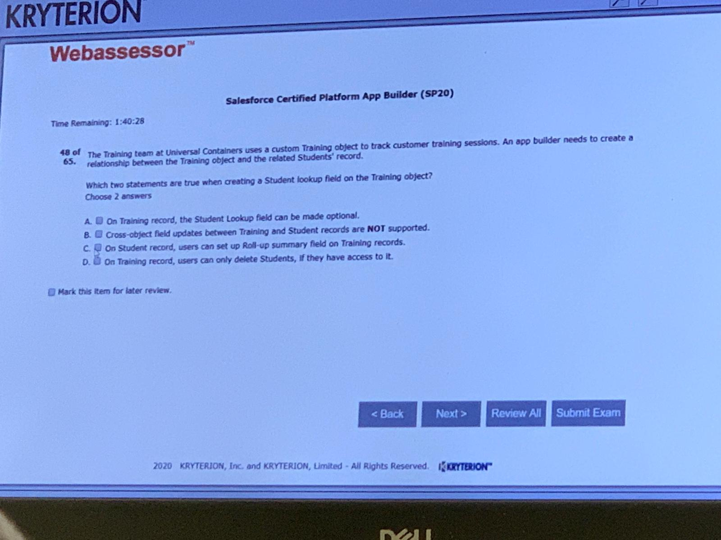A,D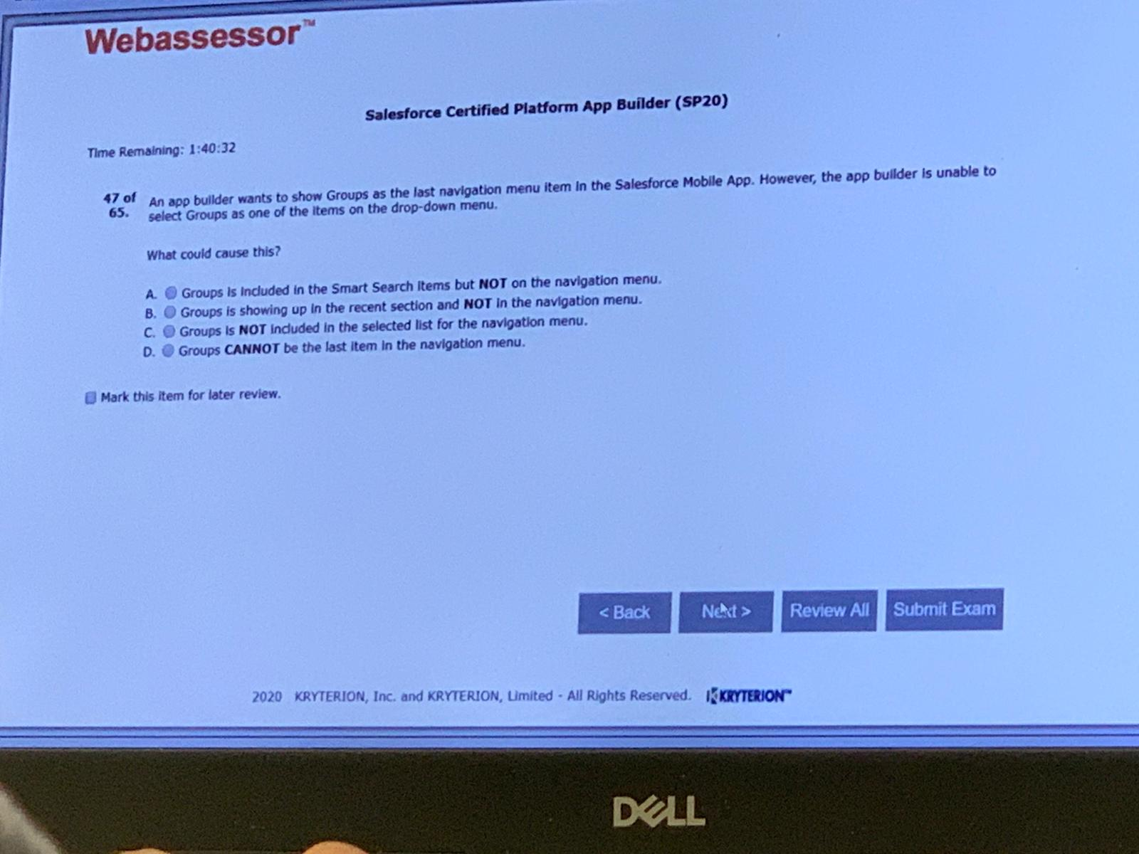A

DEB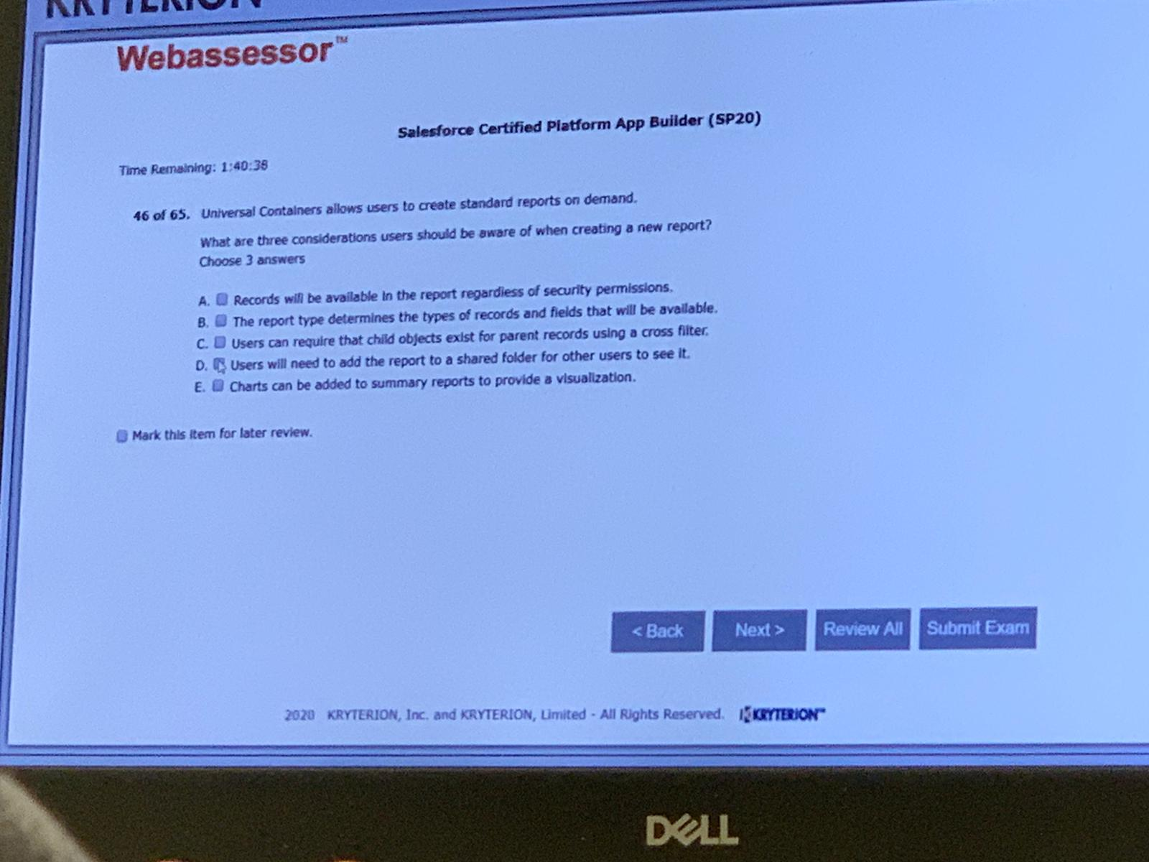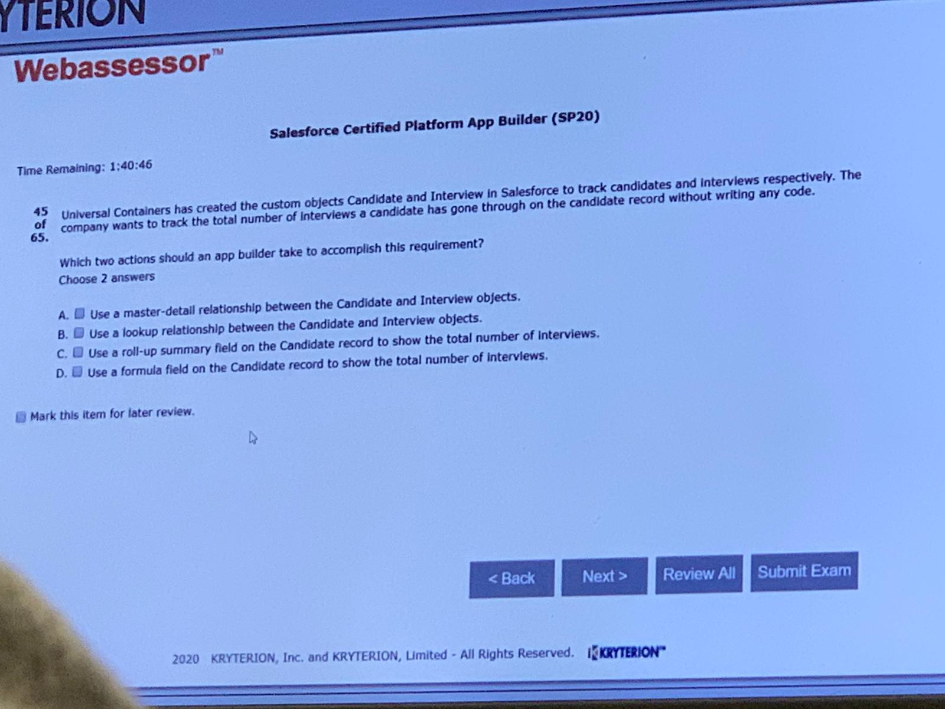A,C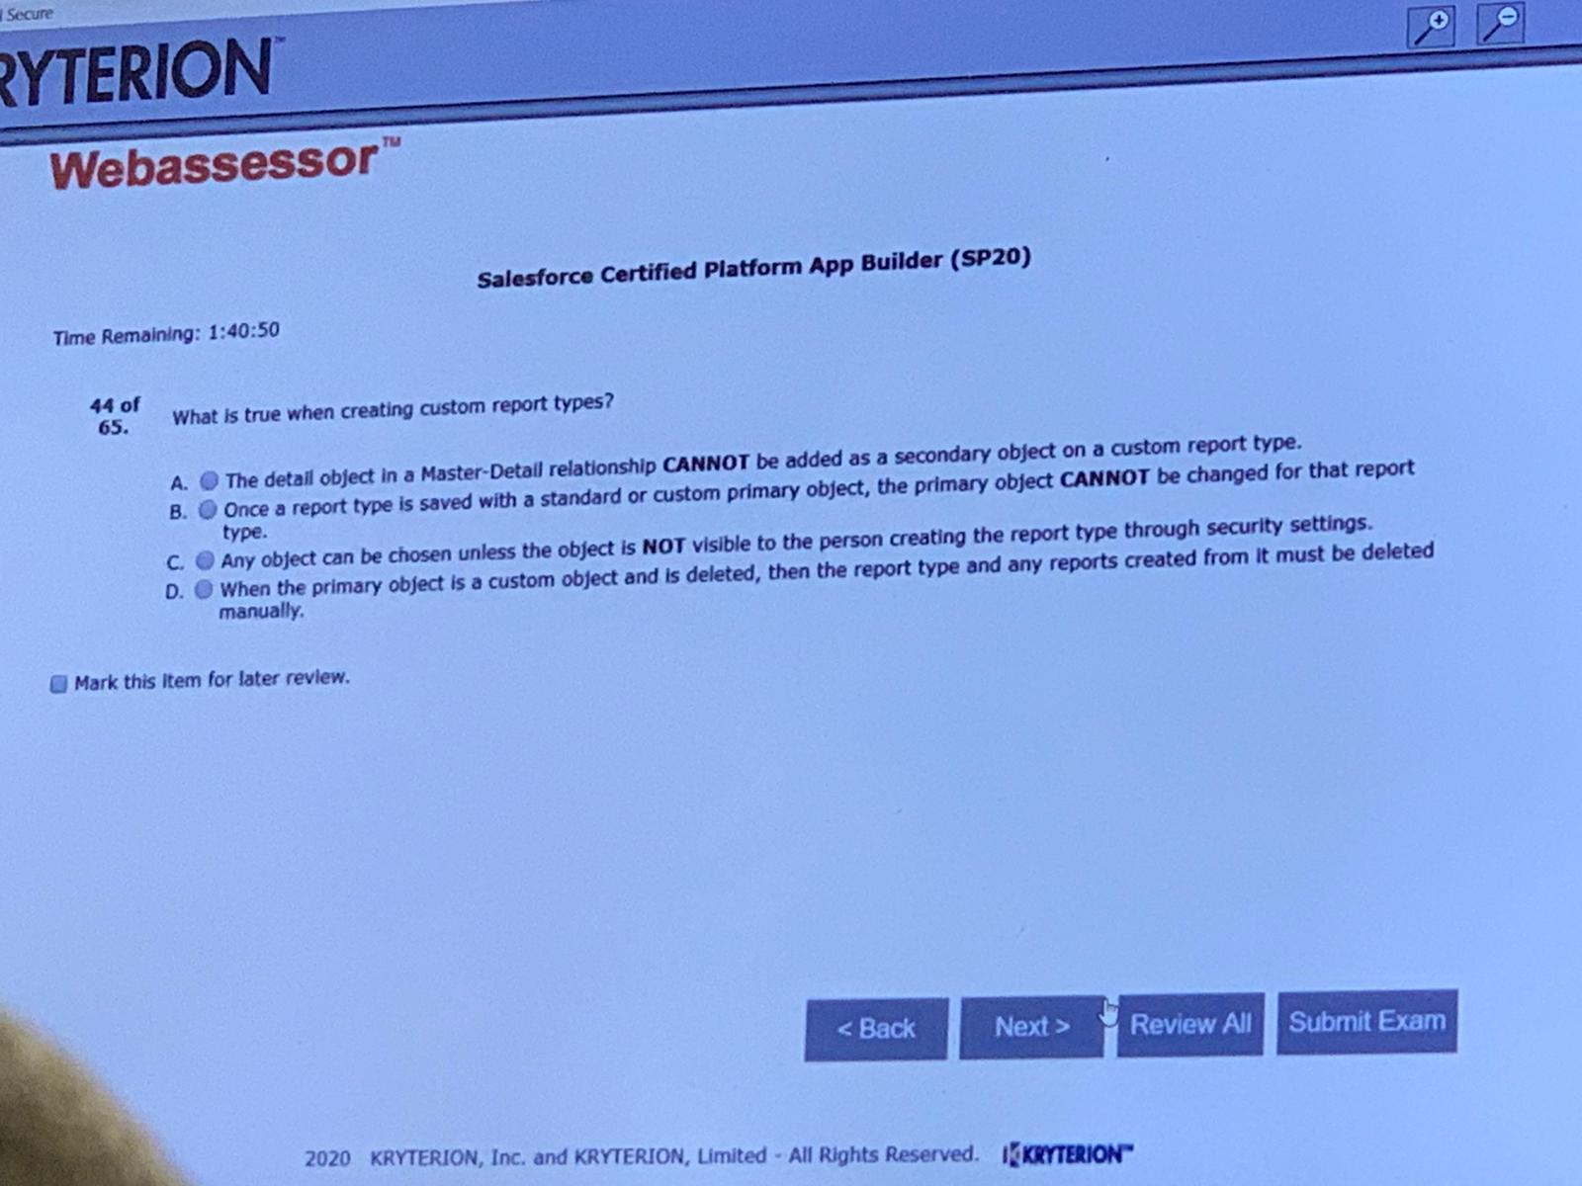B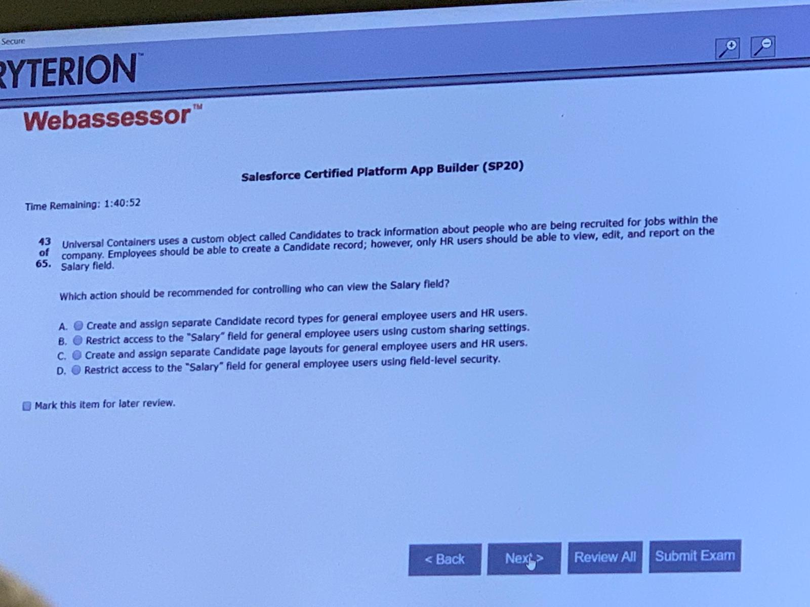D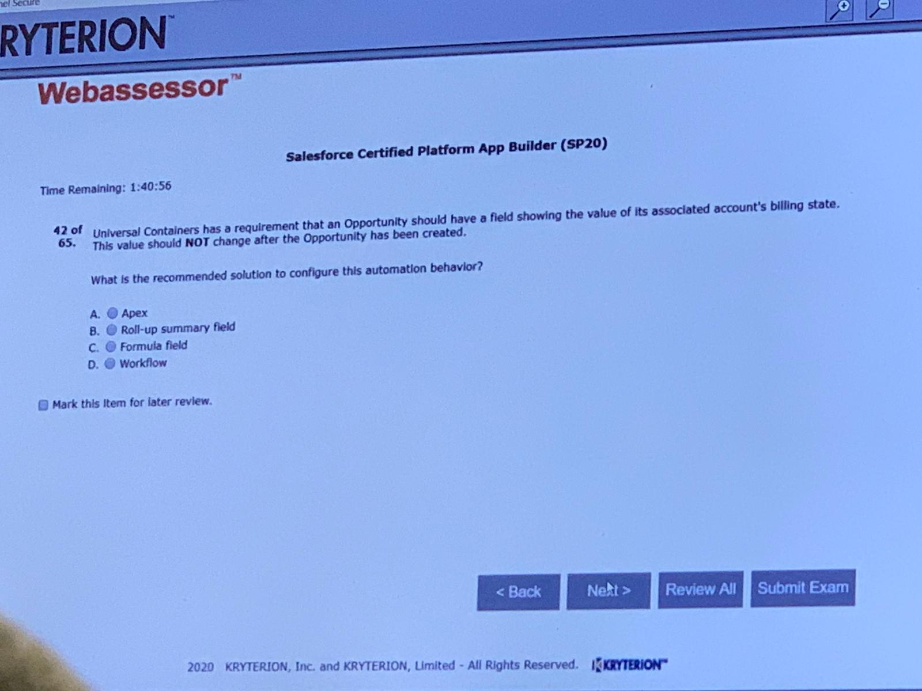A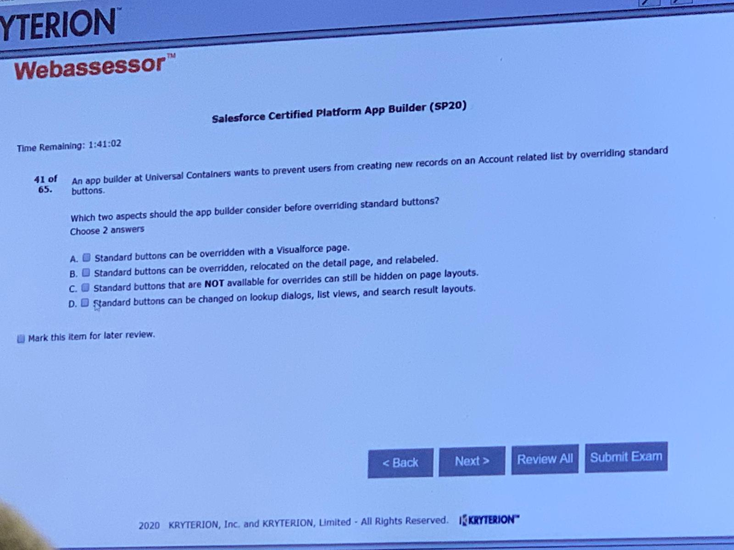A,C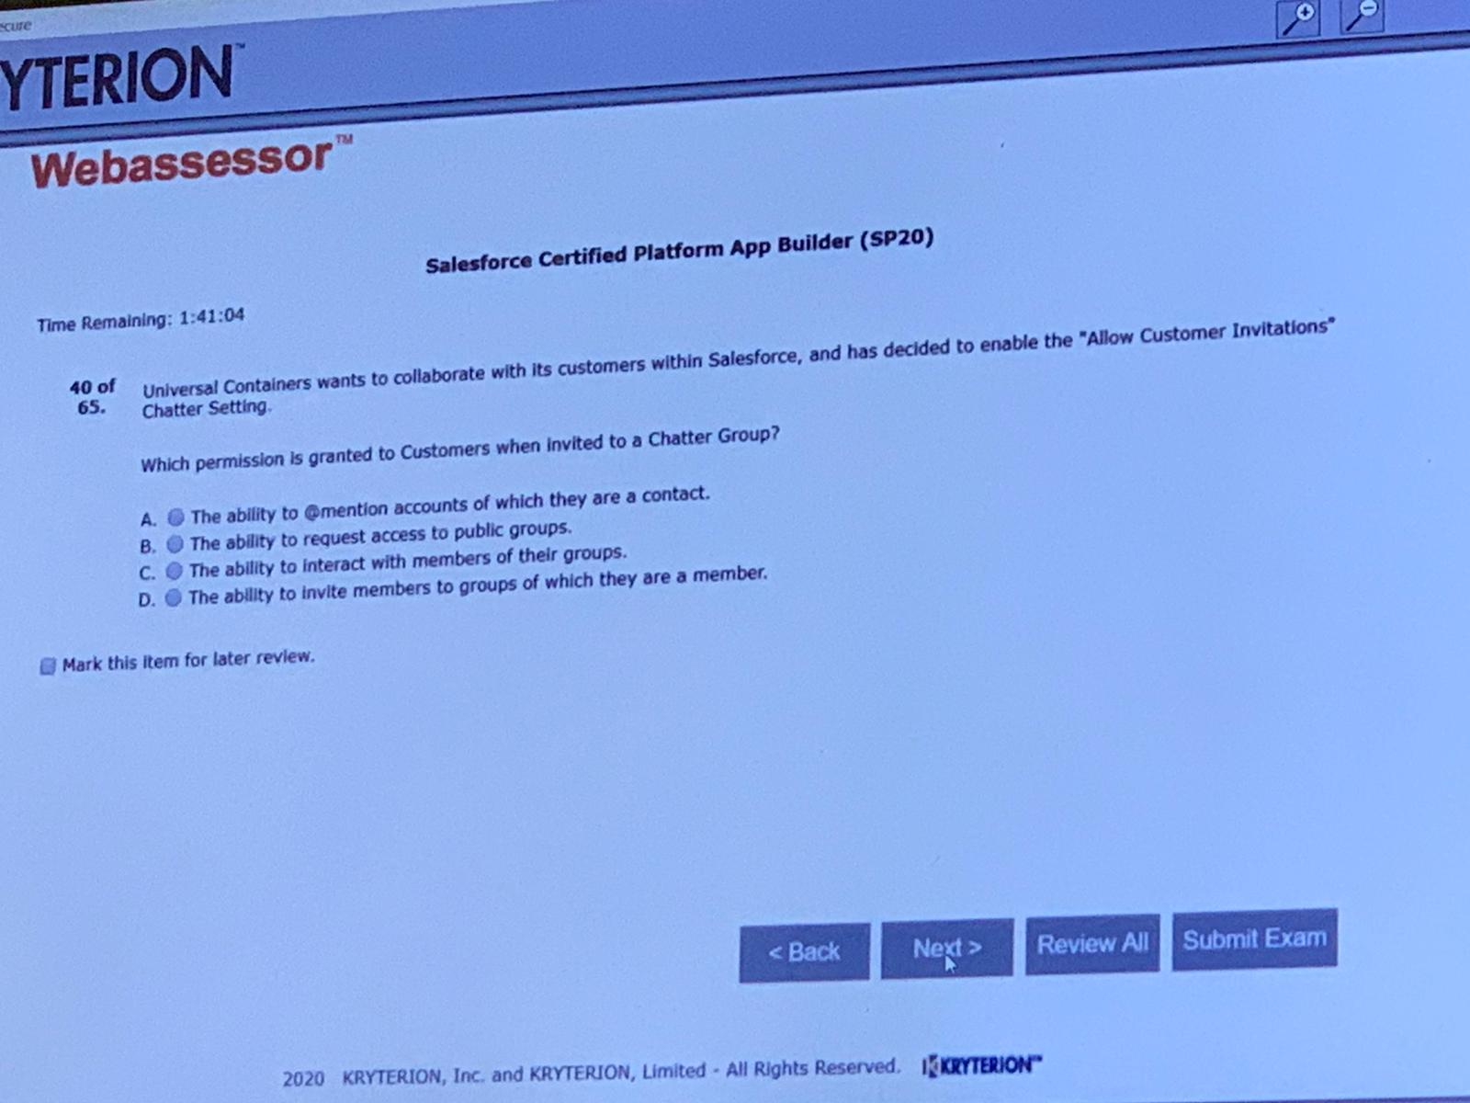C

D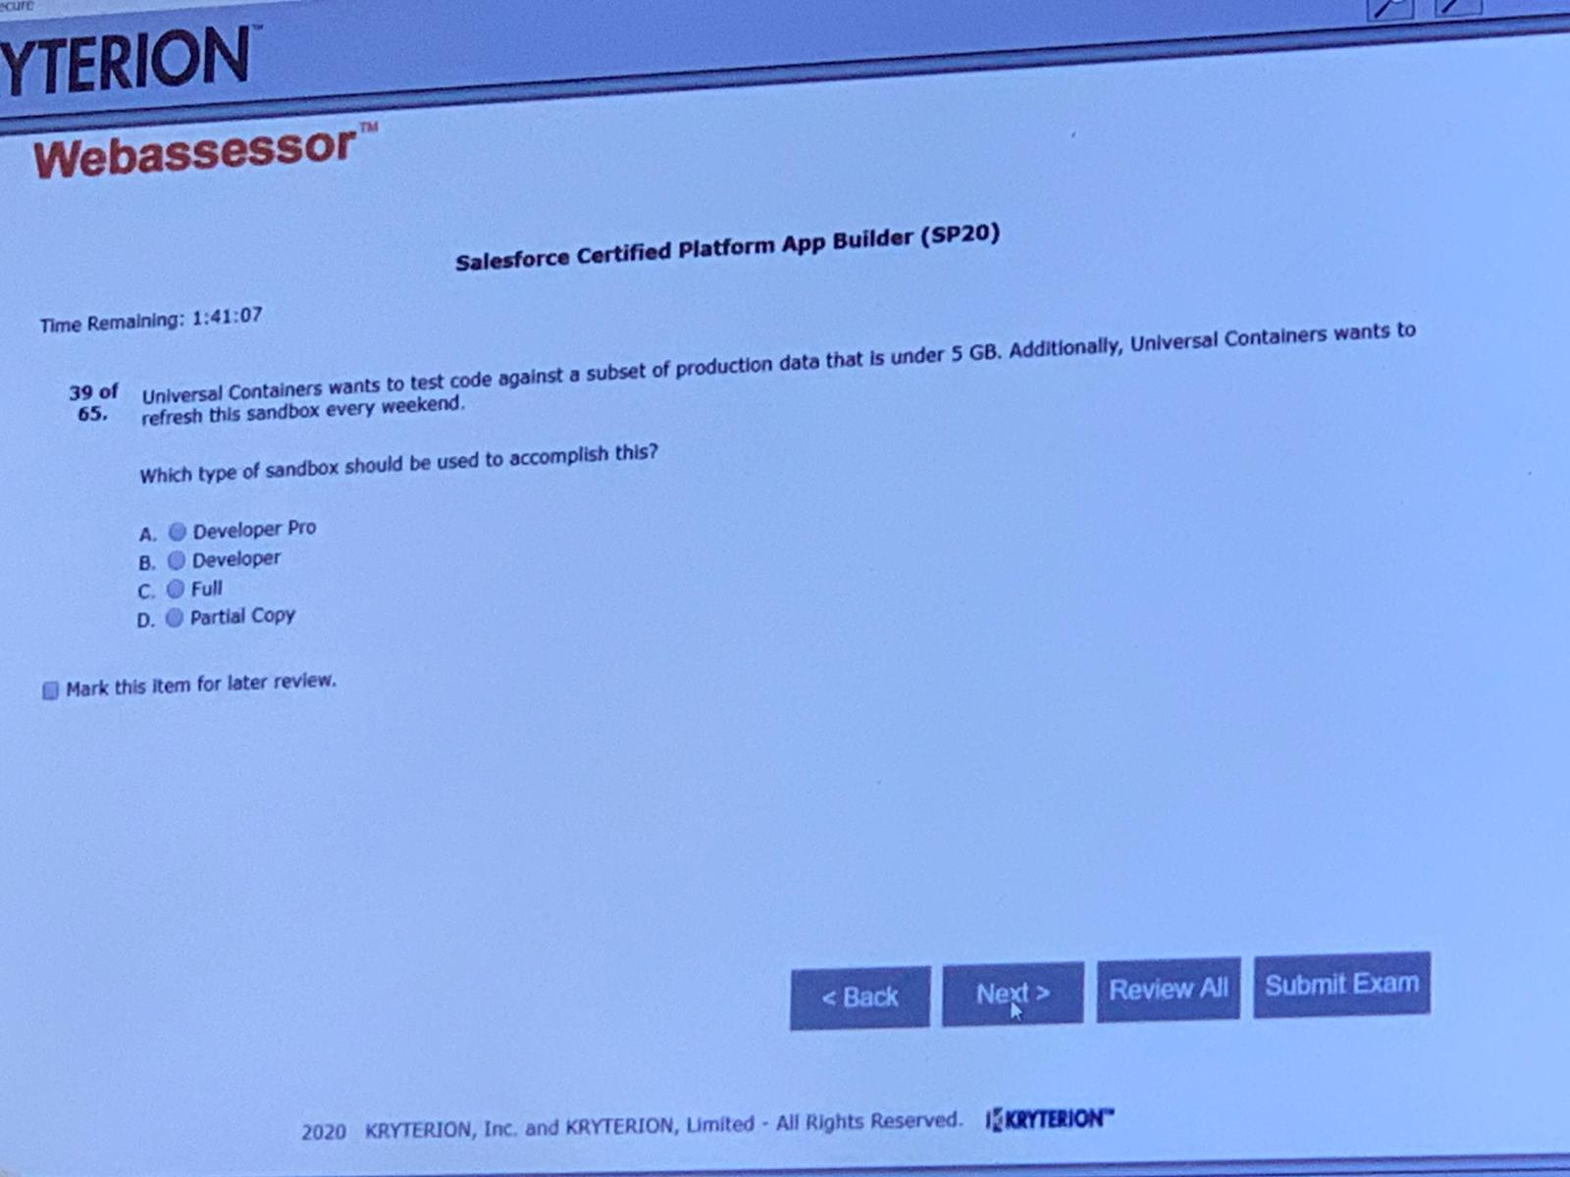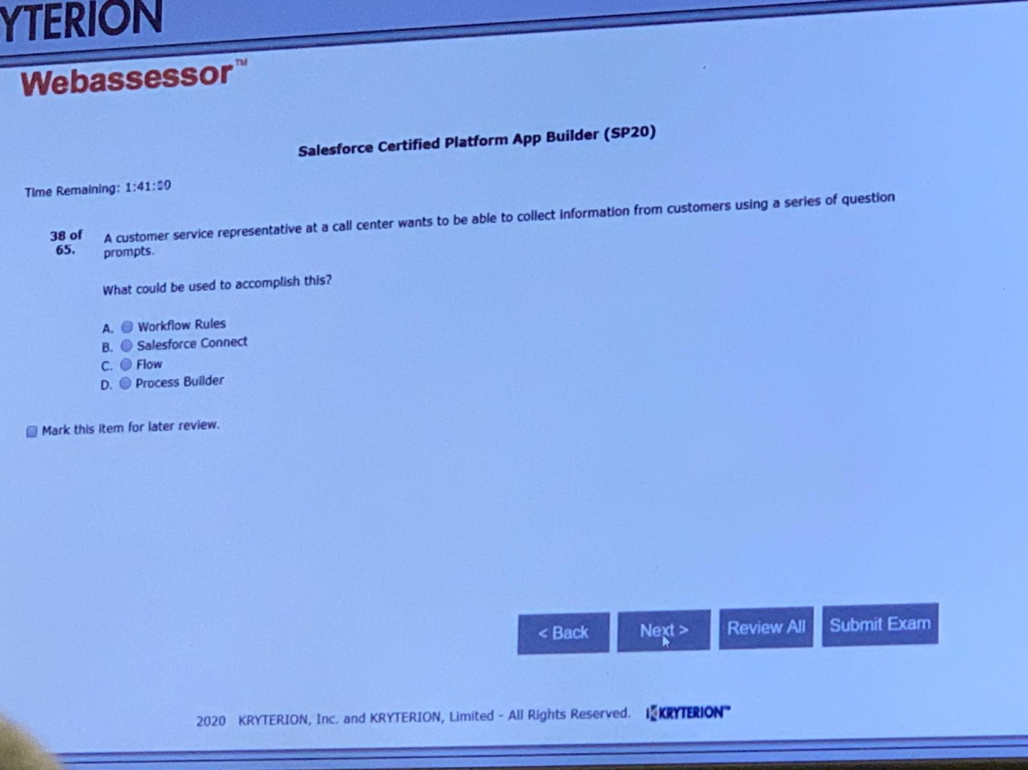C

BA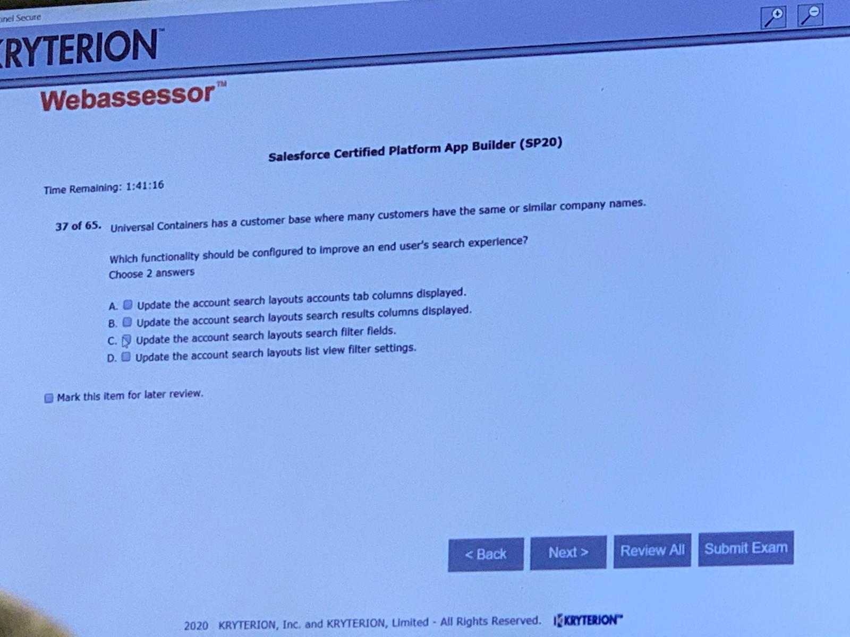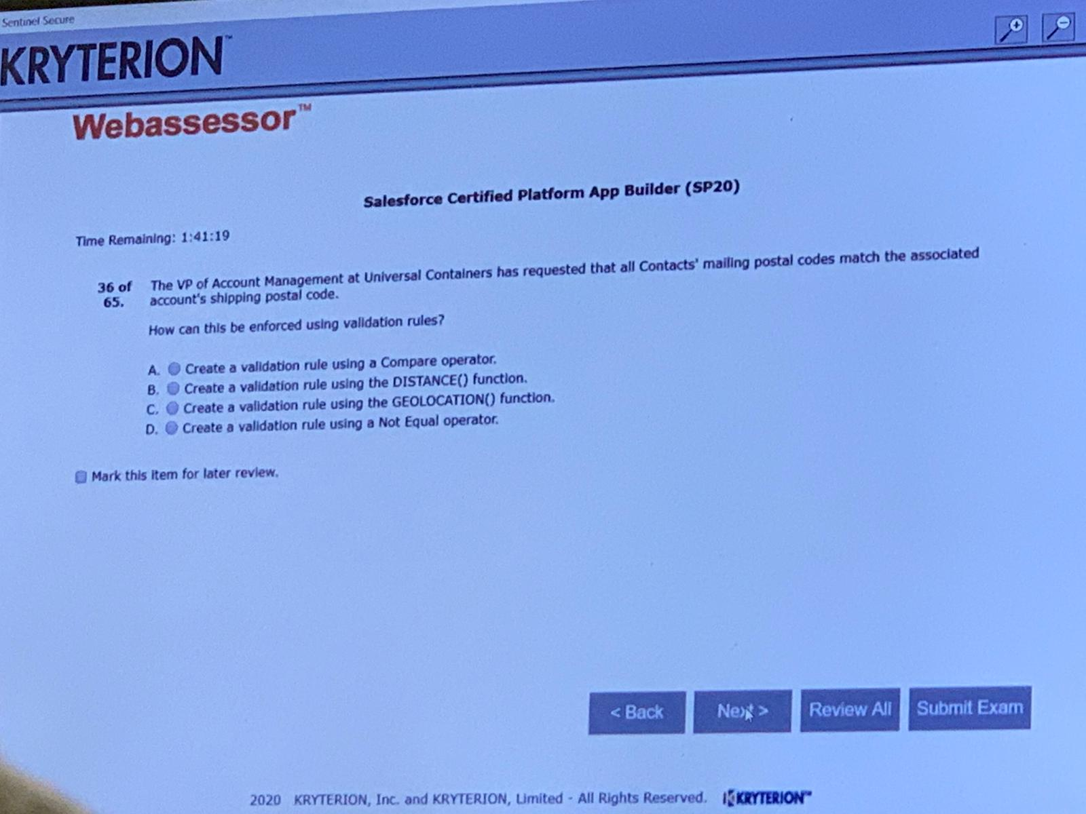D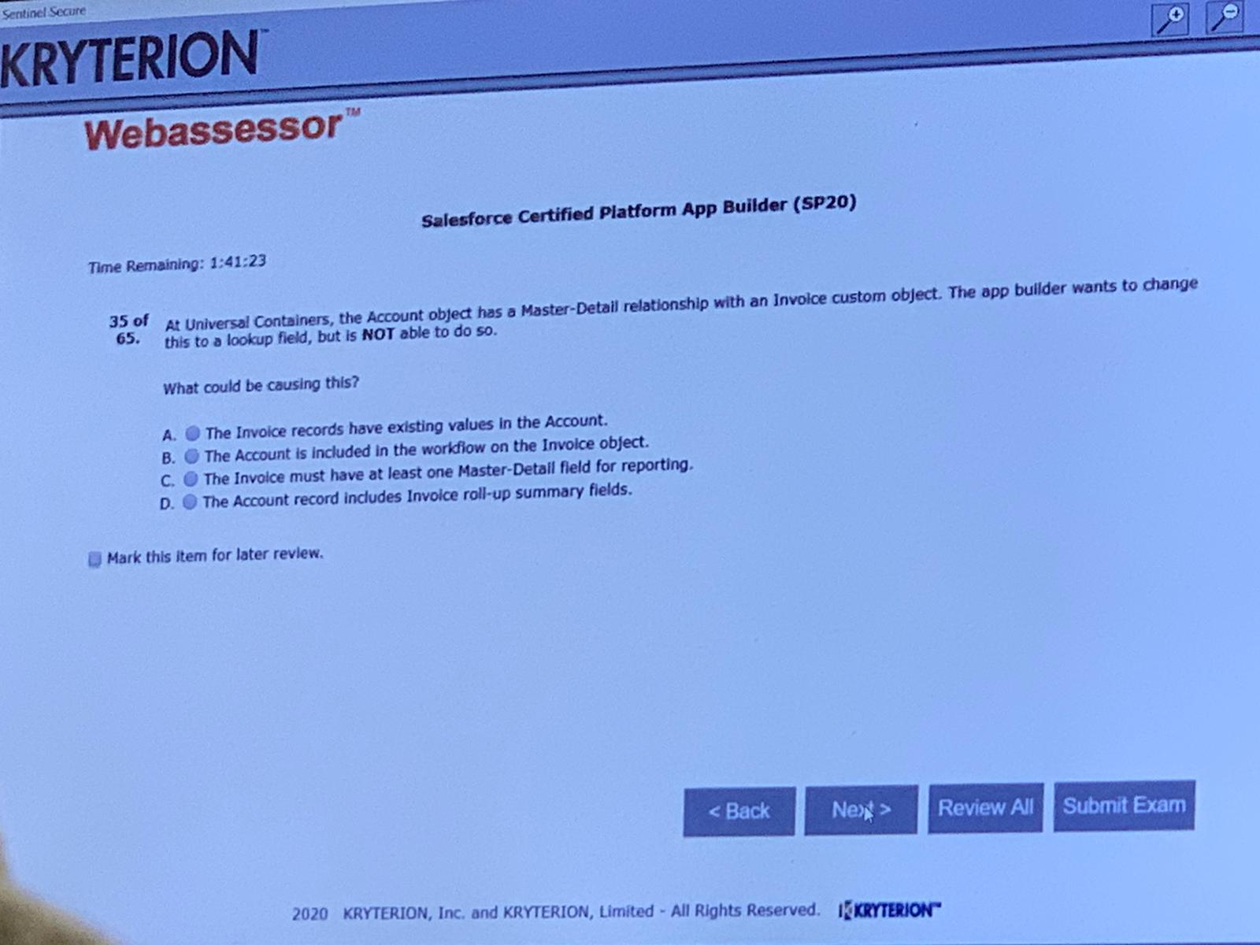D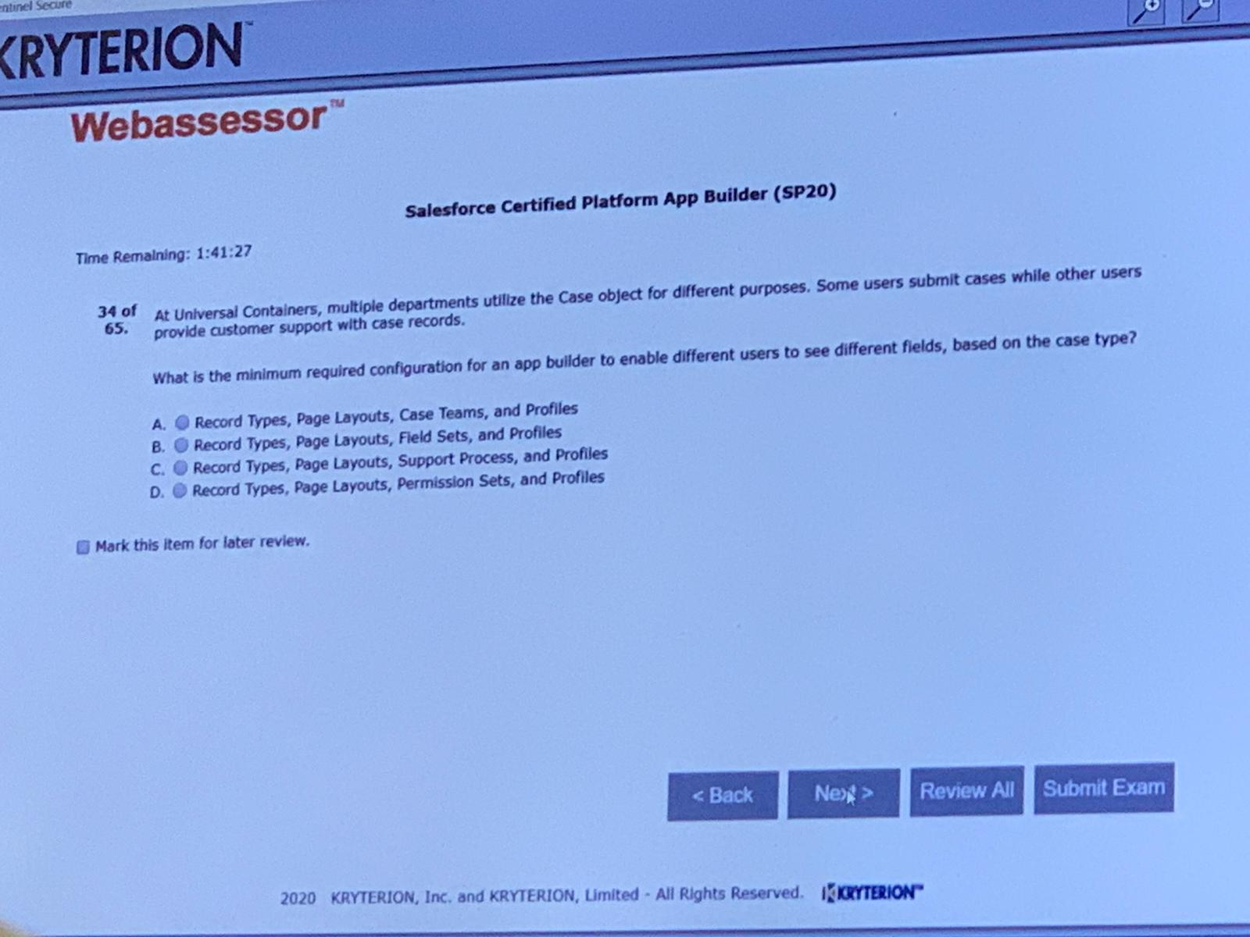C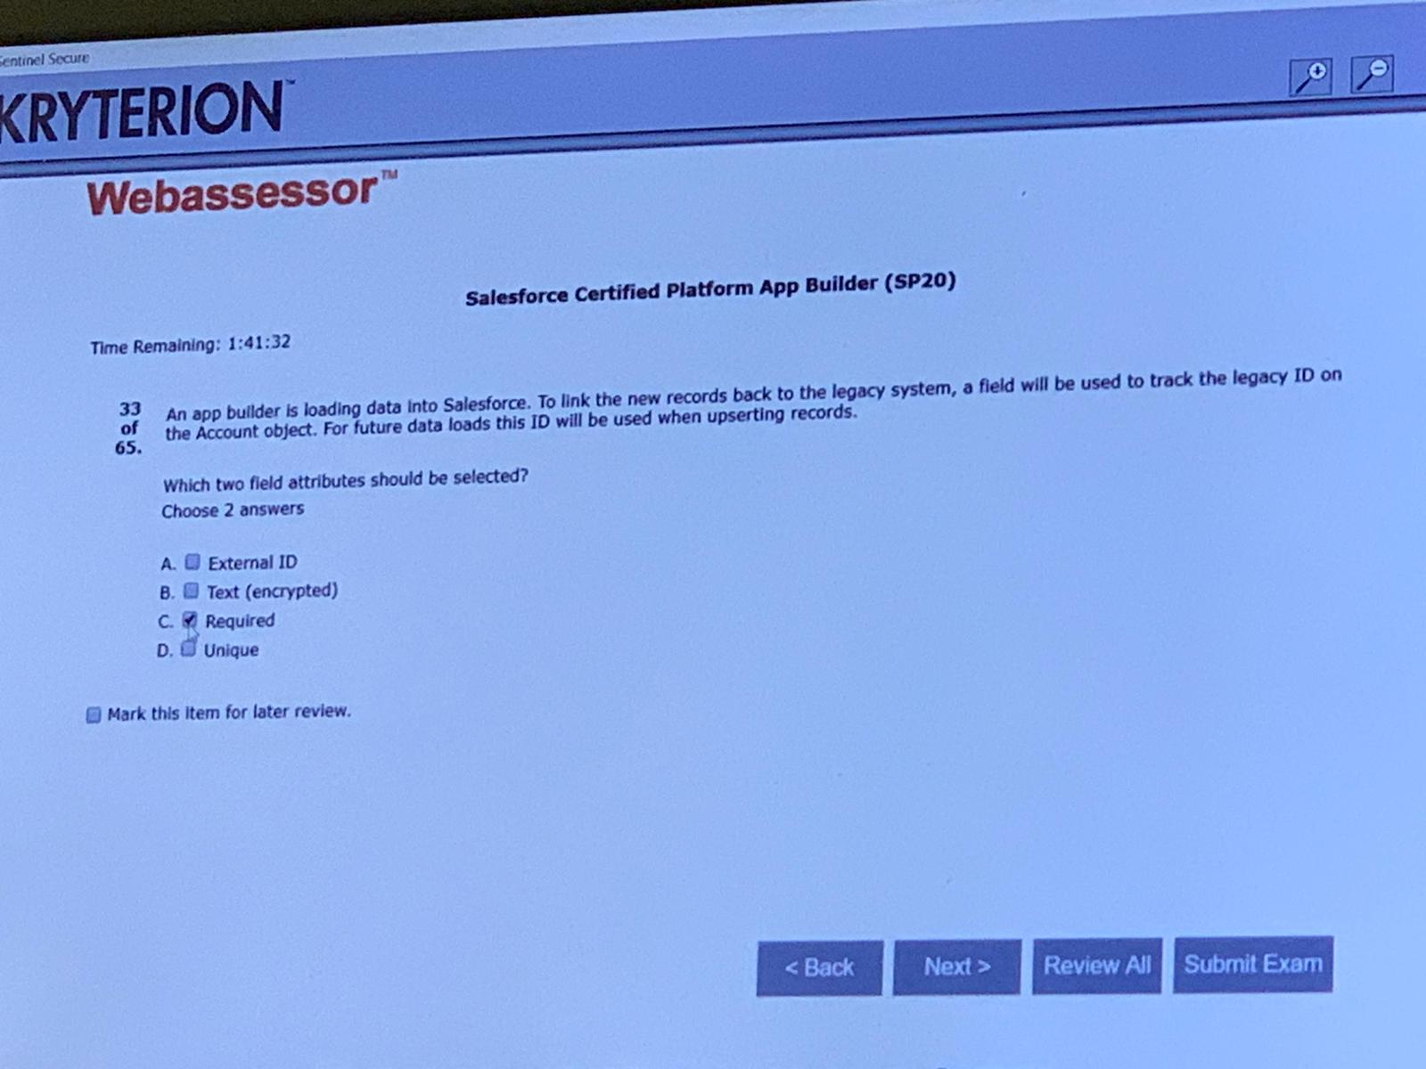DA,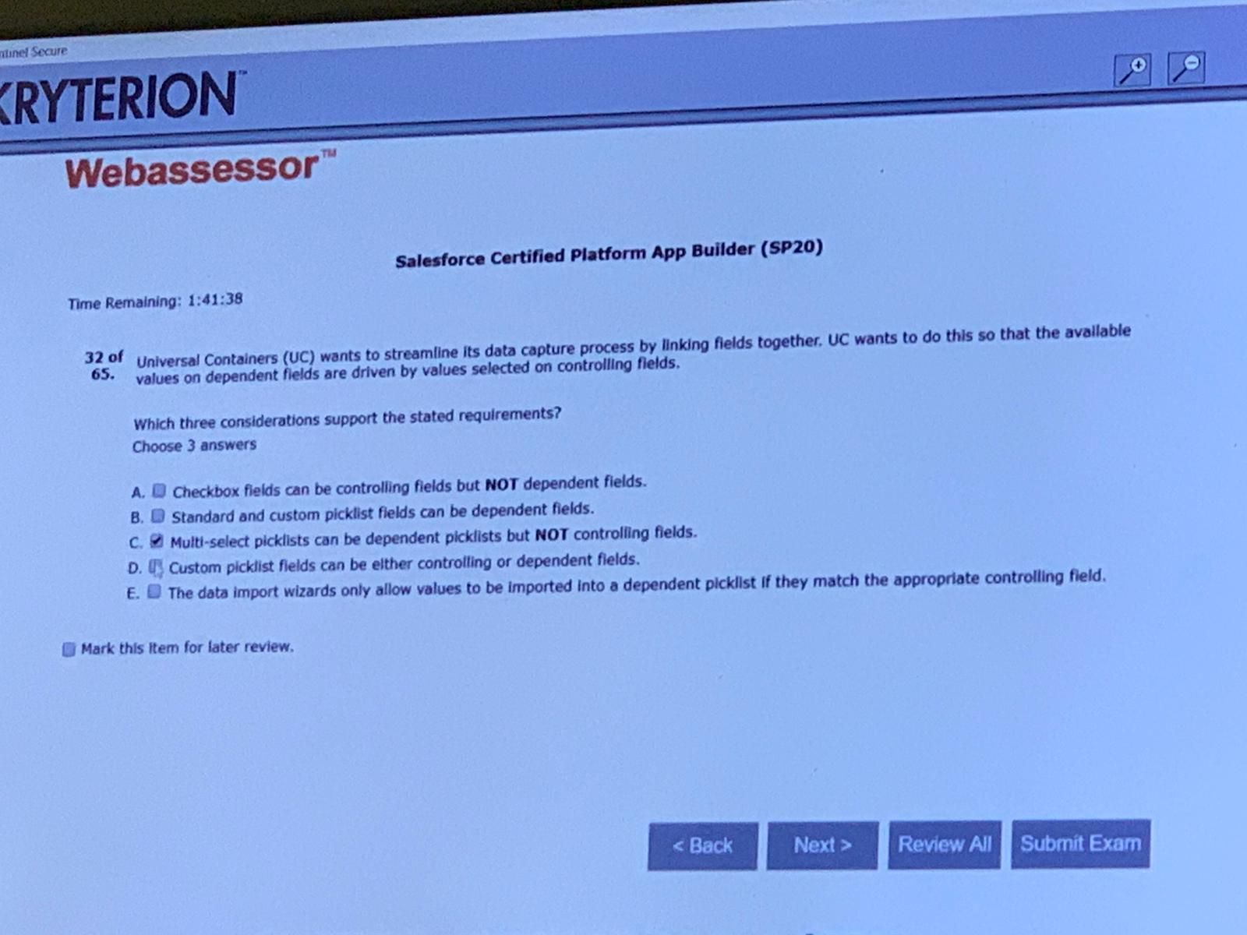ACD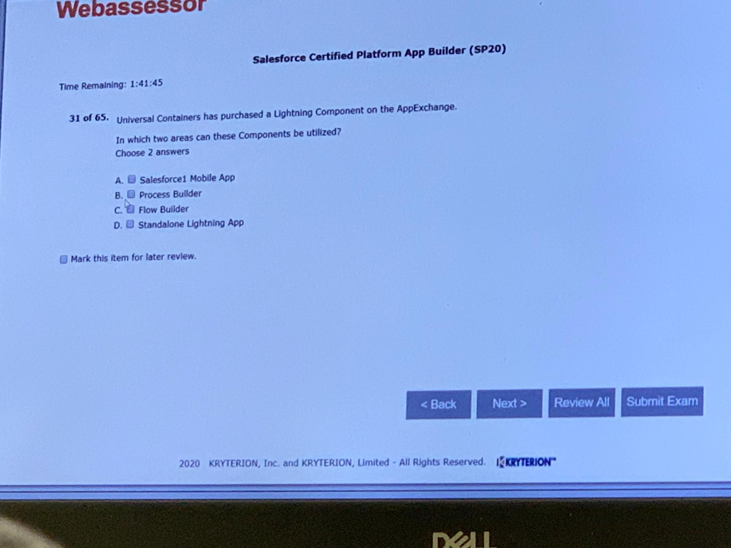AD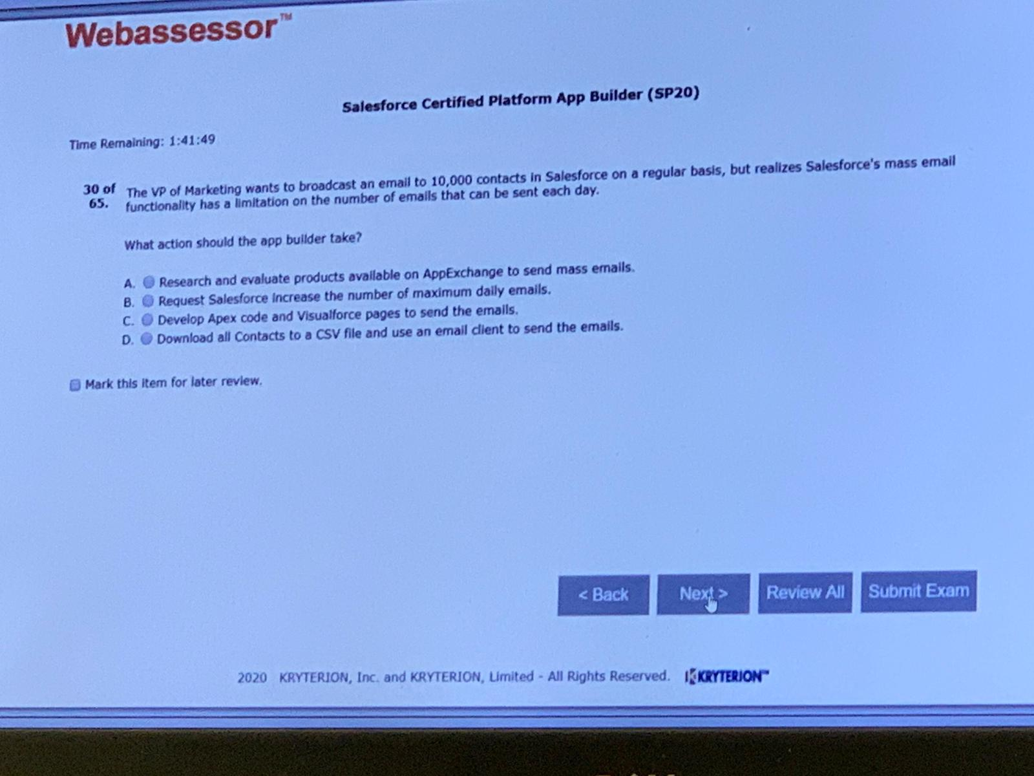A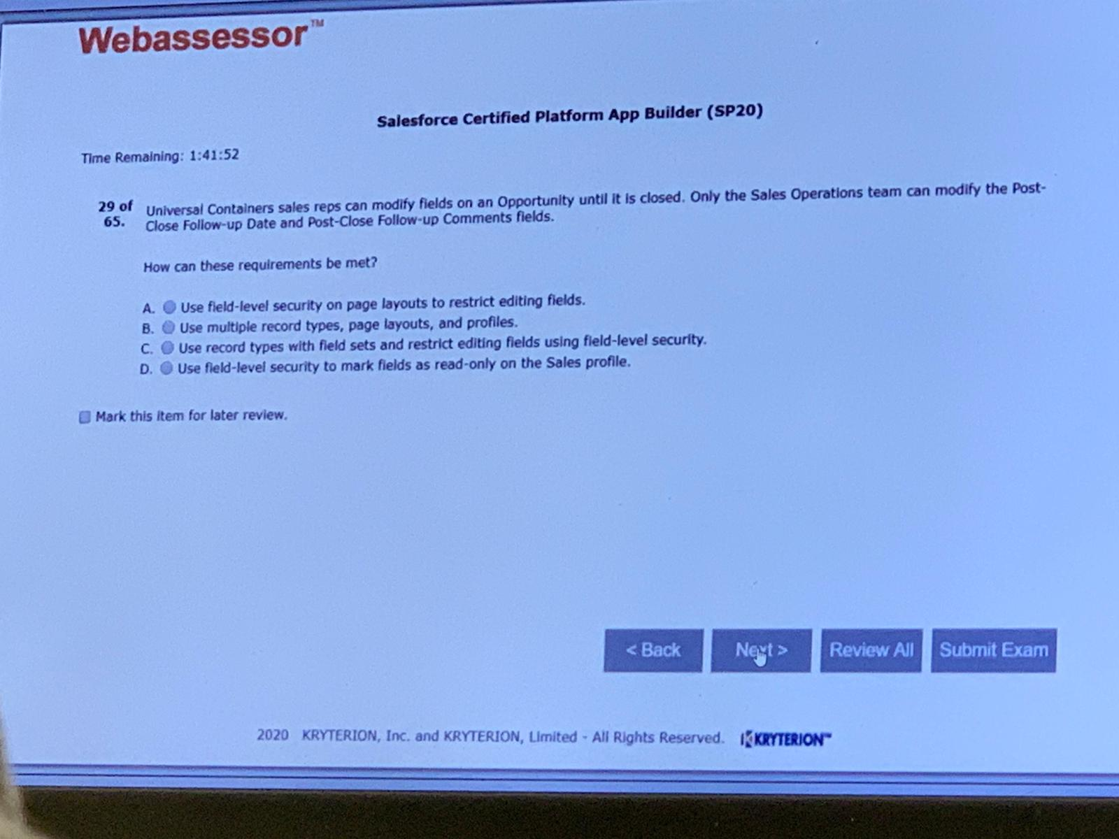A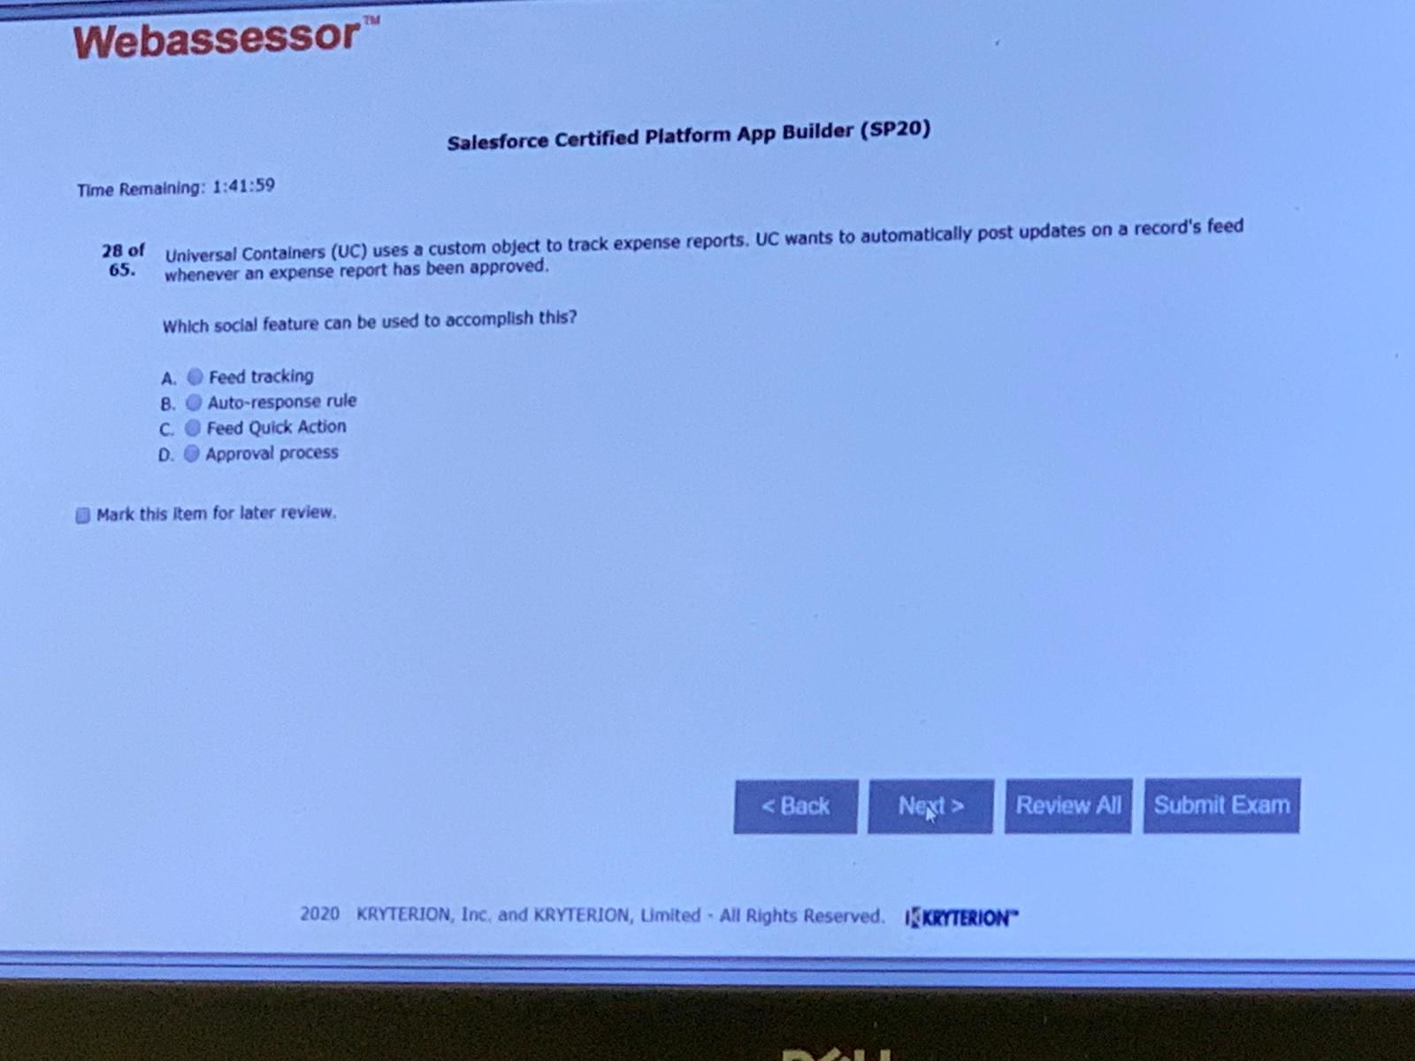A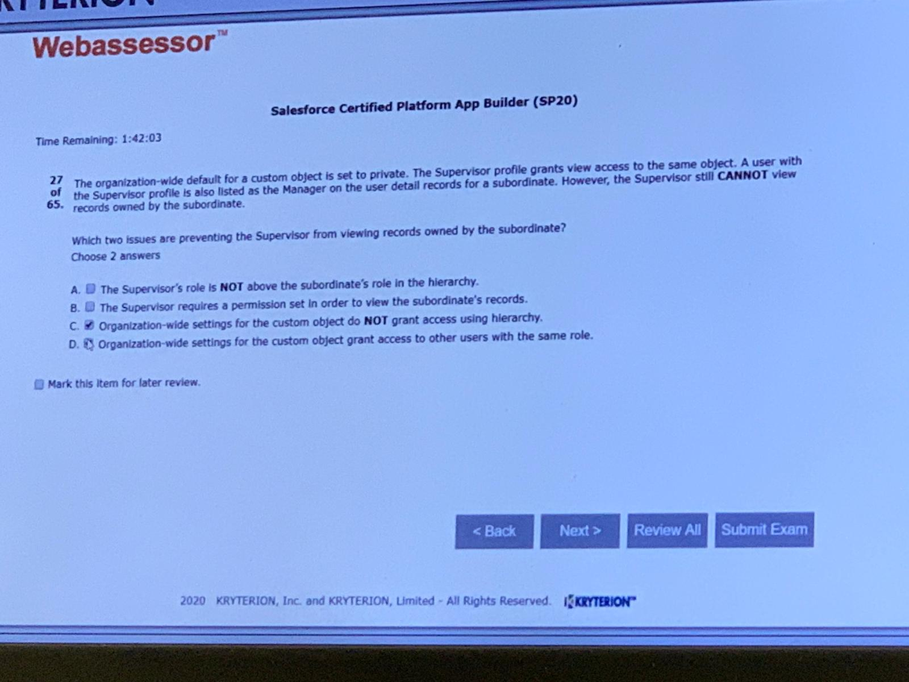AC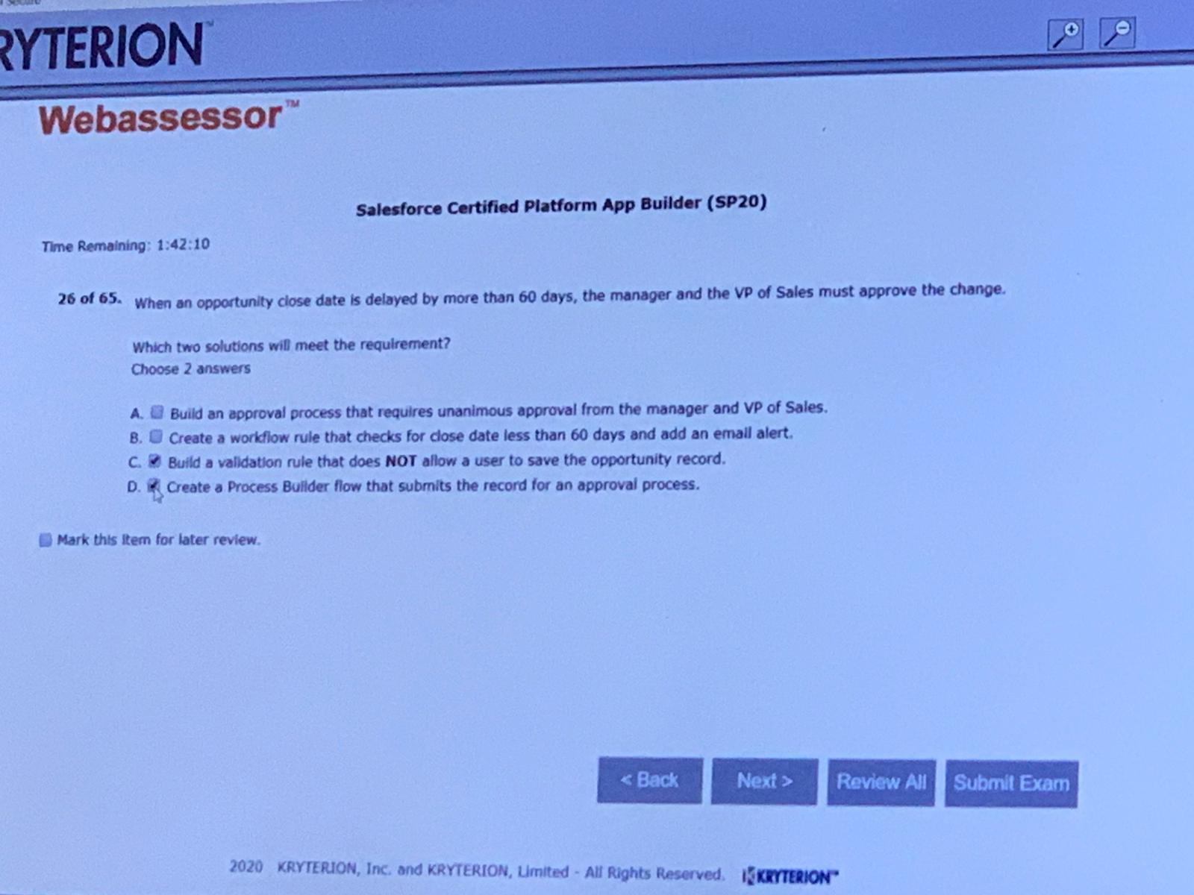AD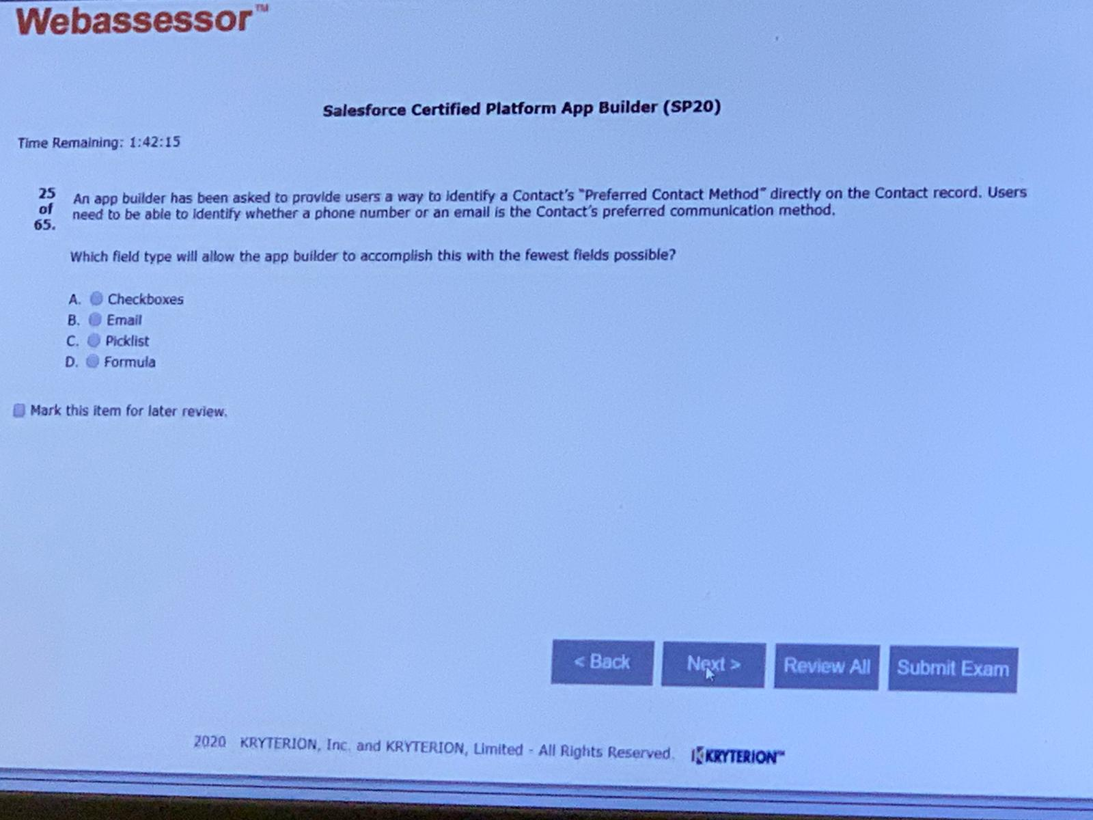C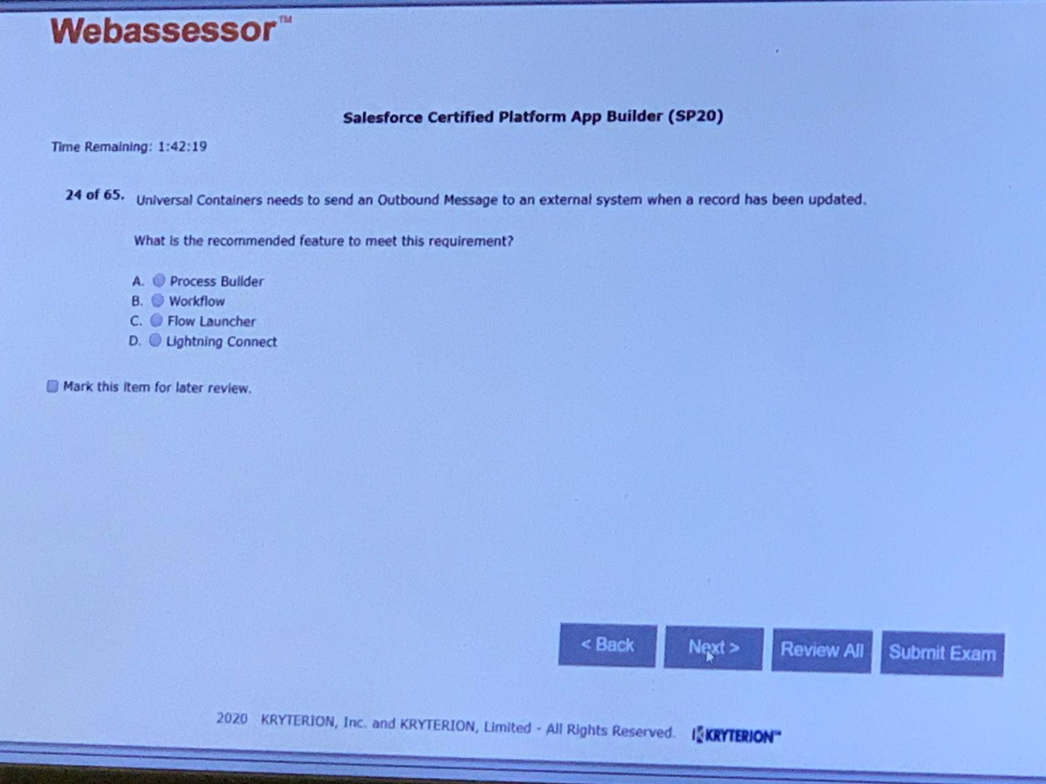B

C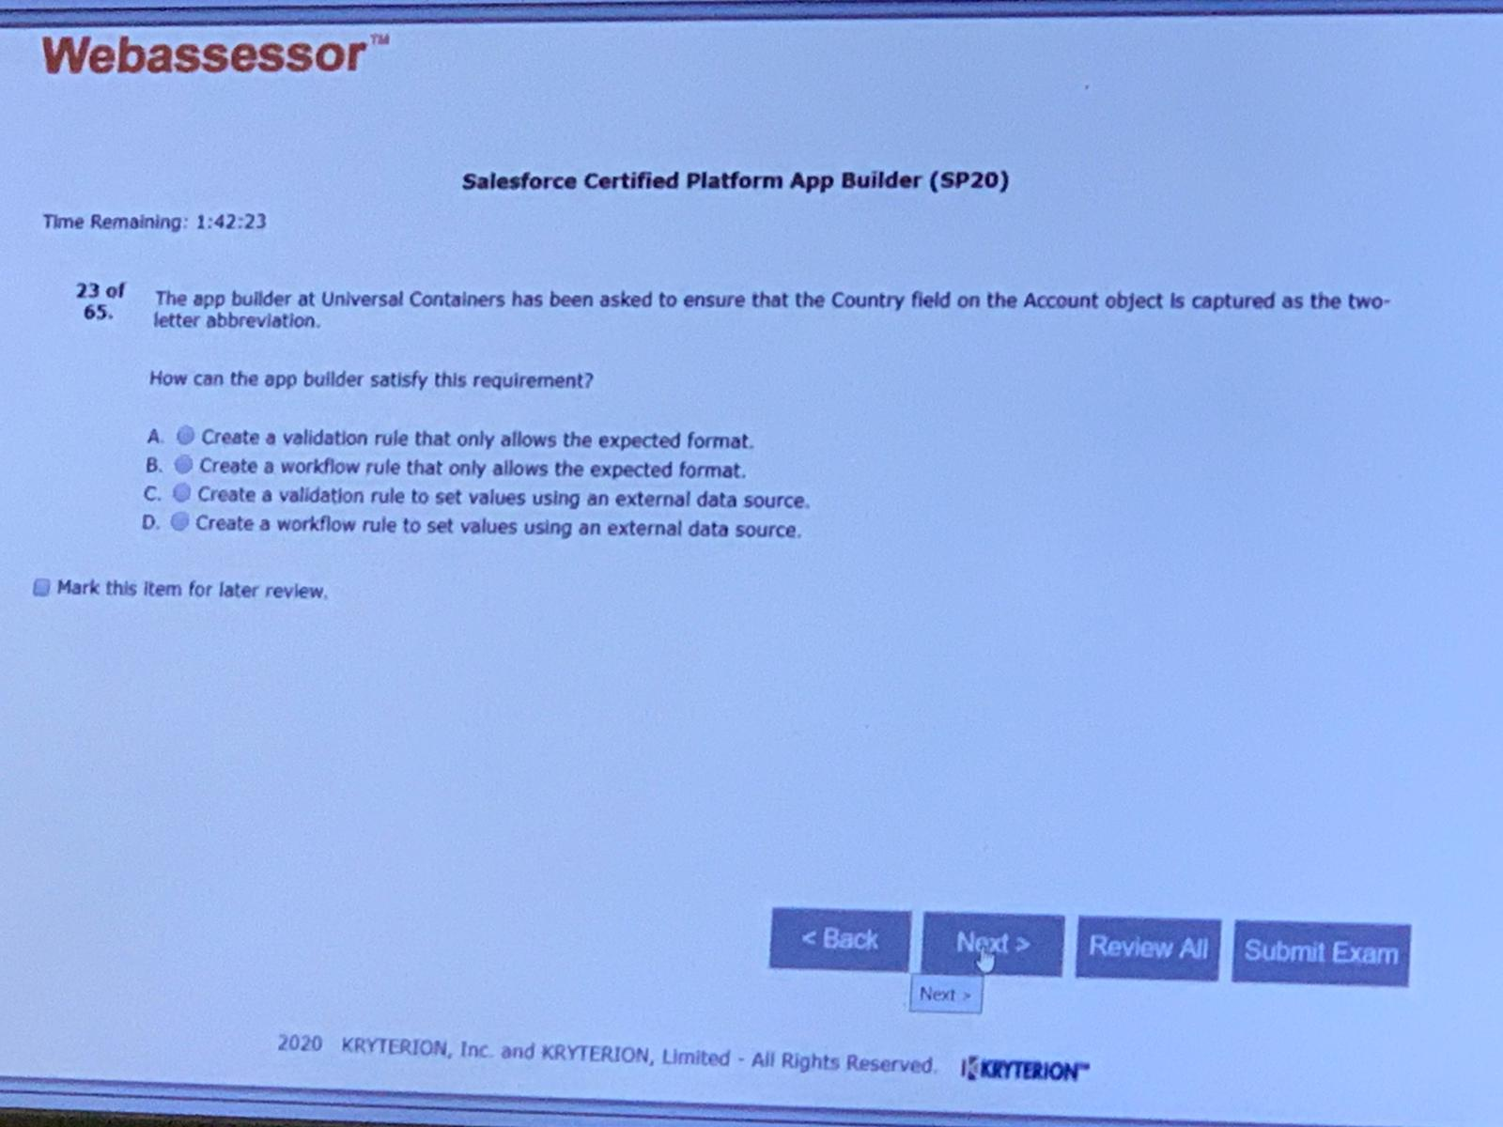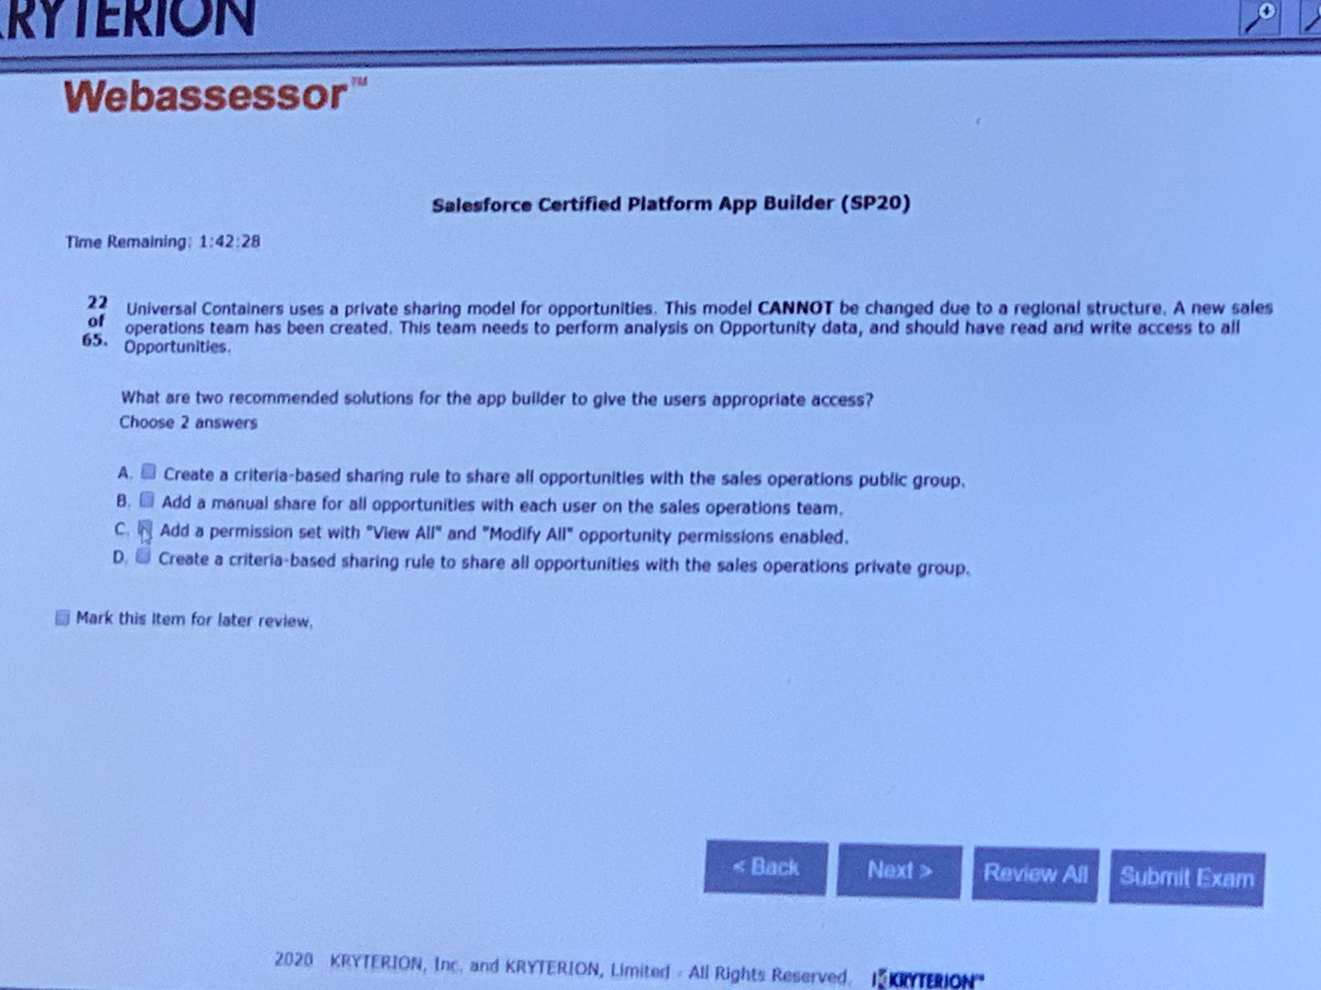B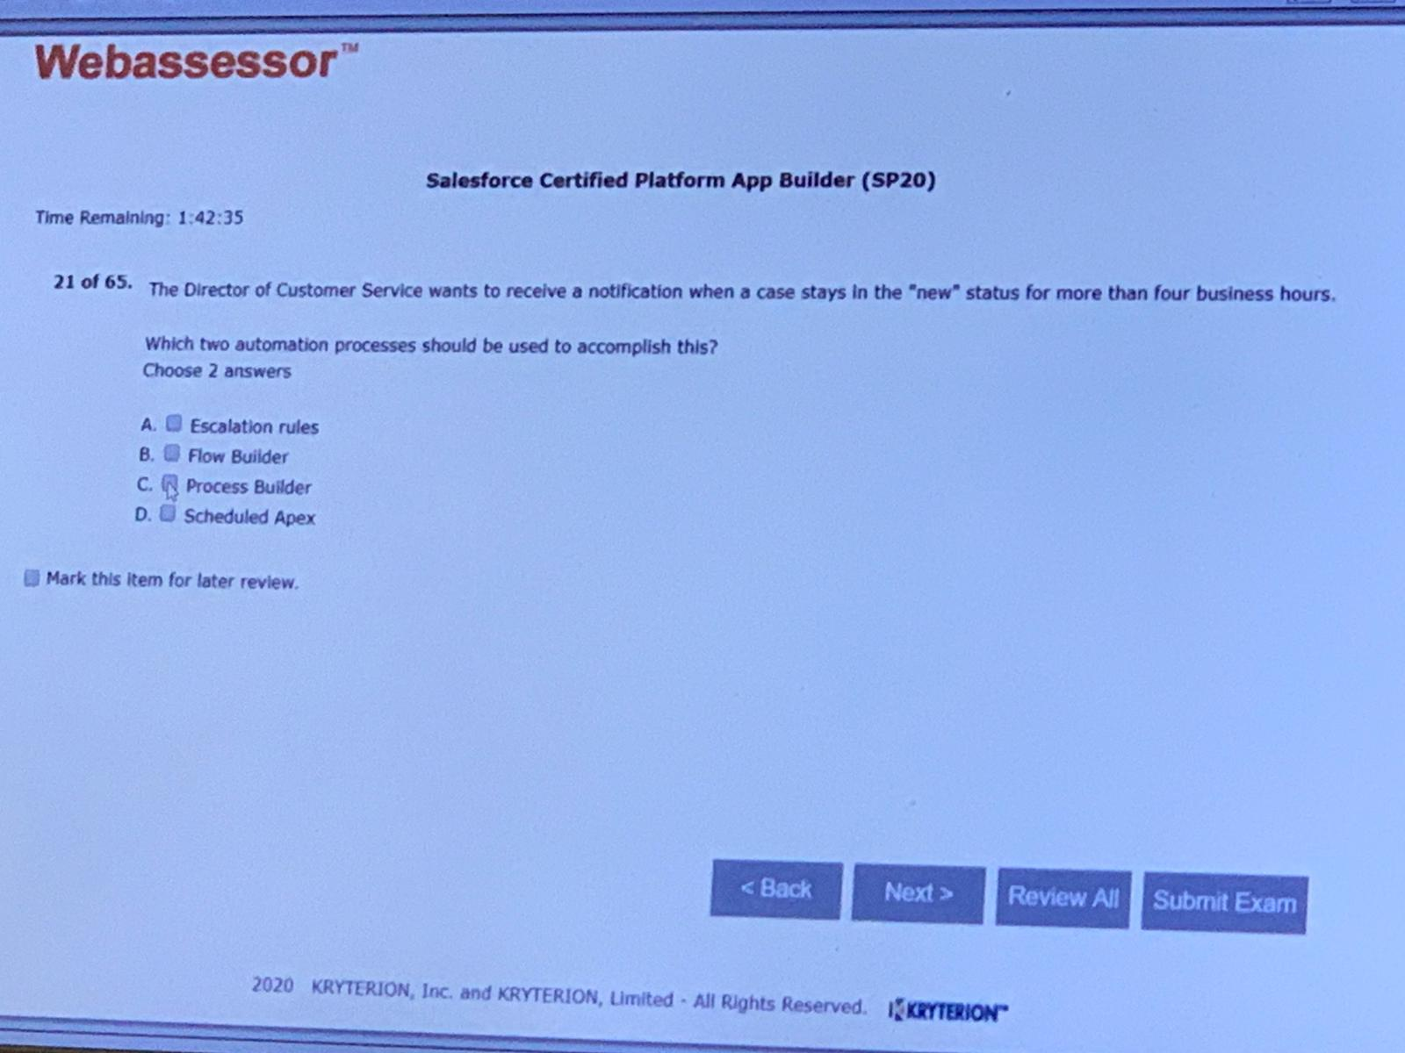AC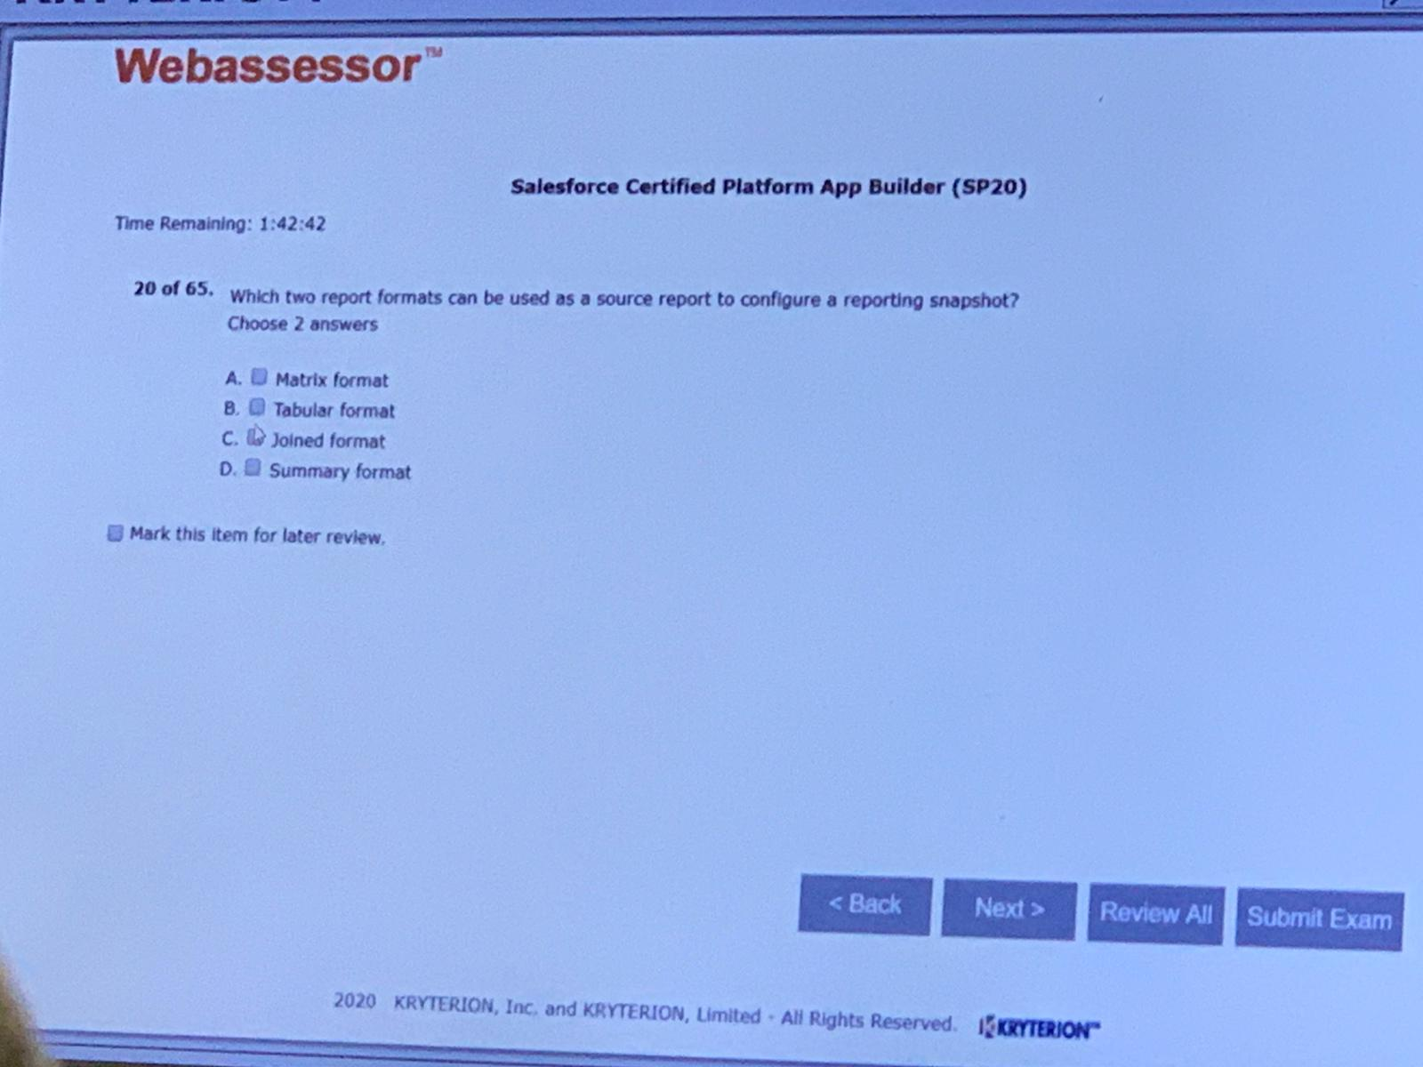AD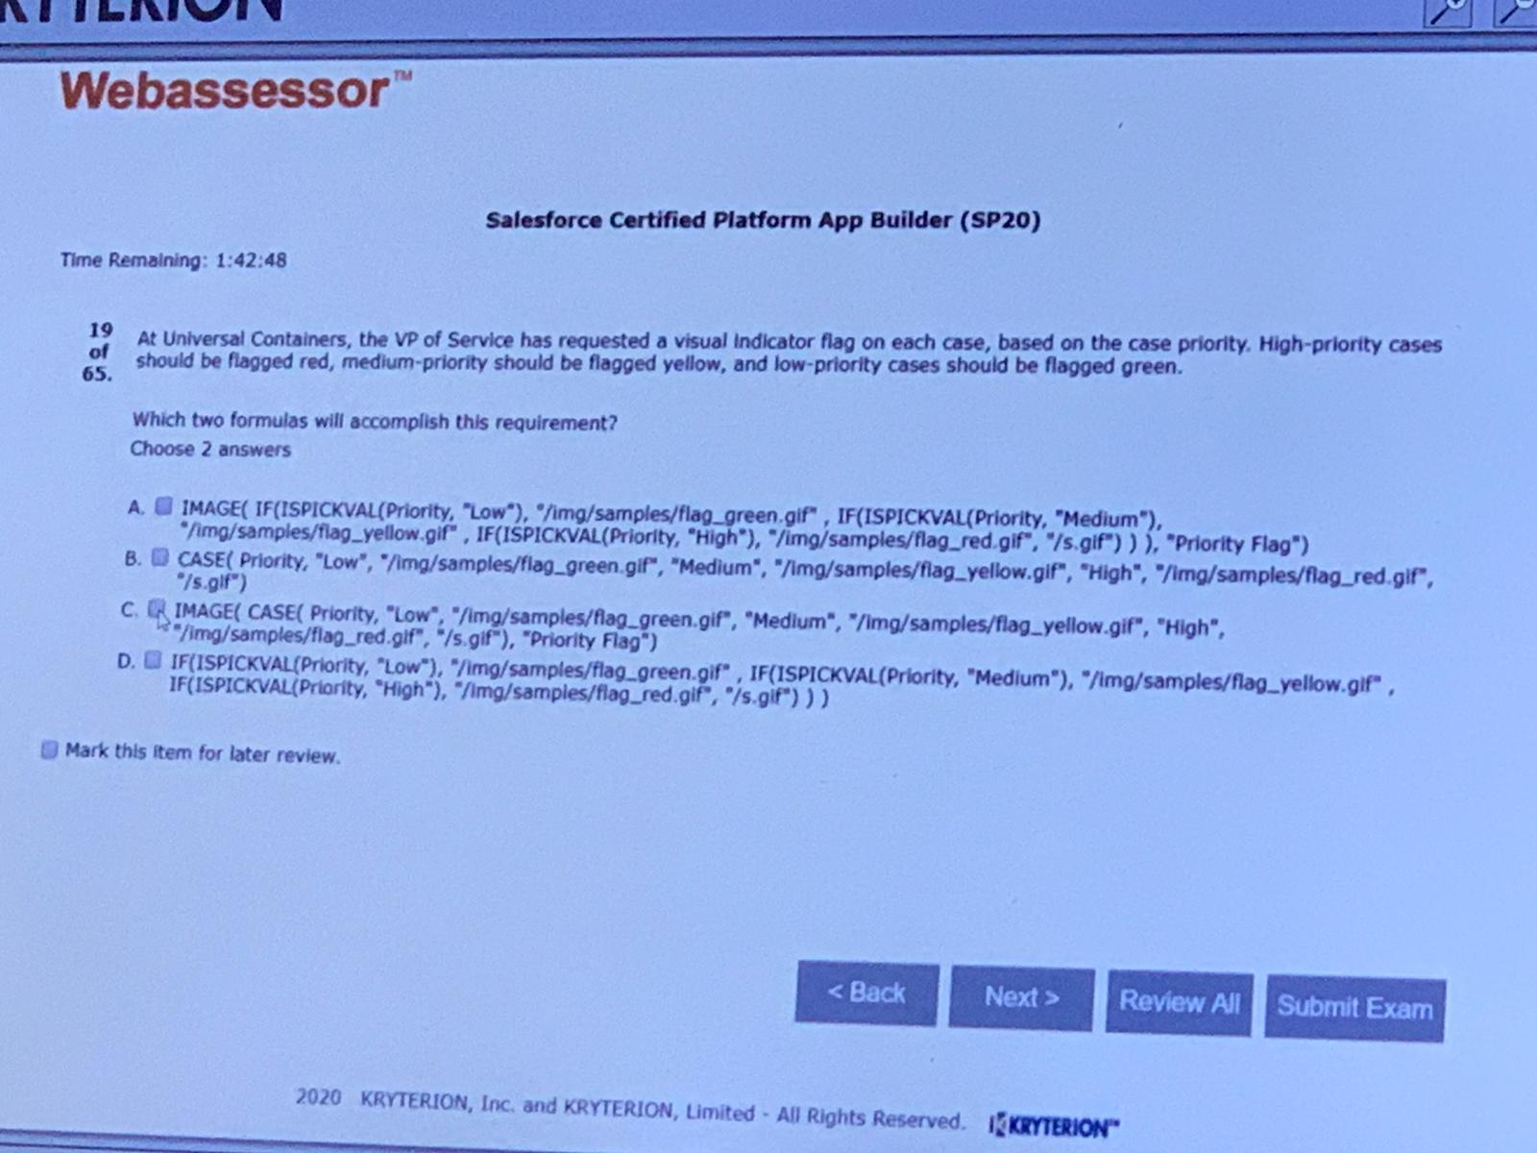AC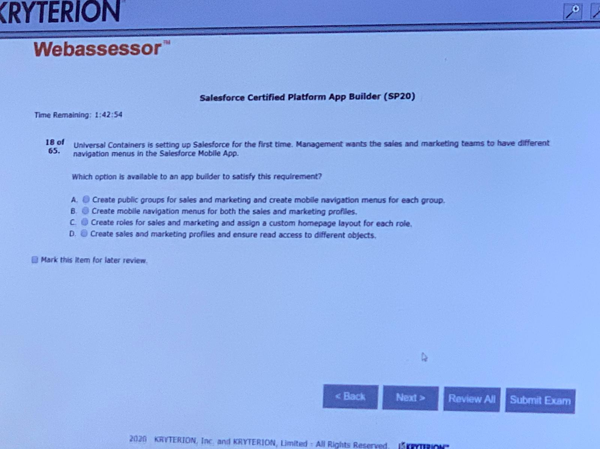D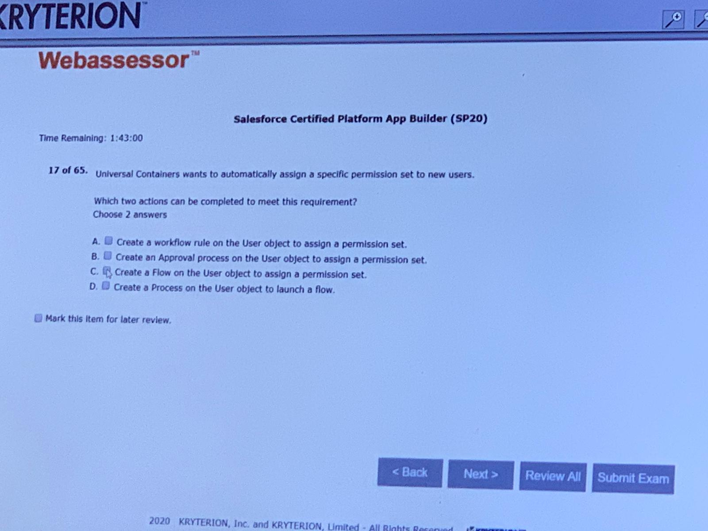CD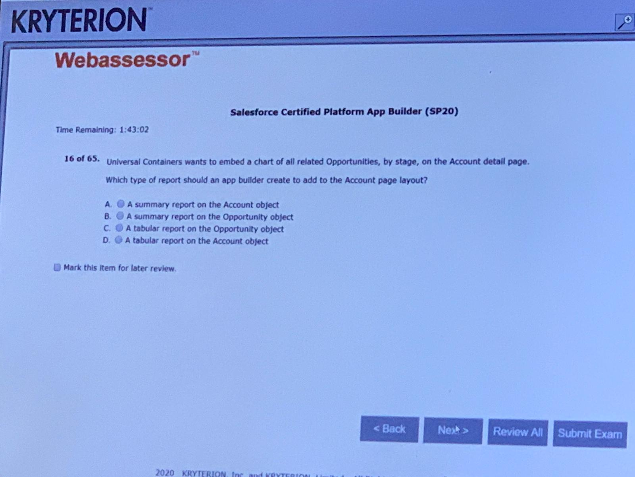B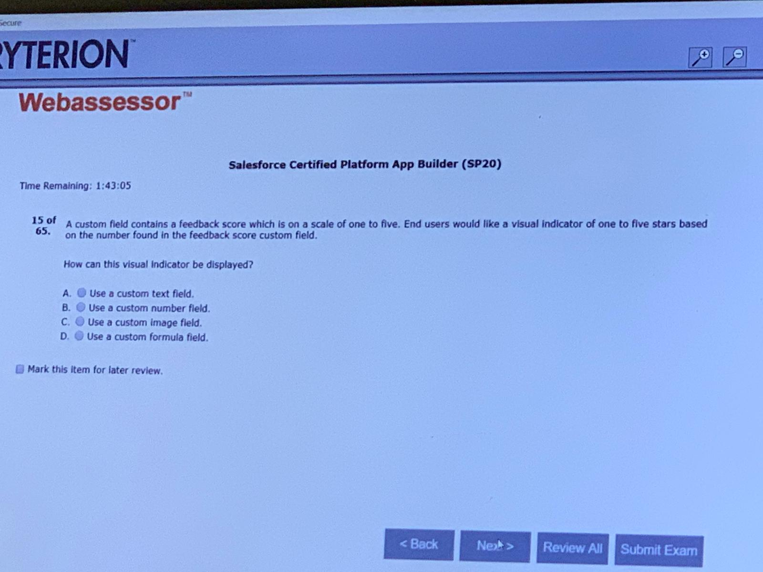D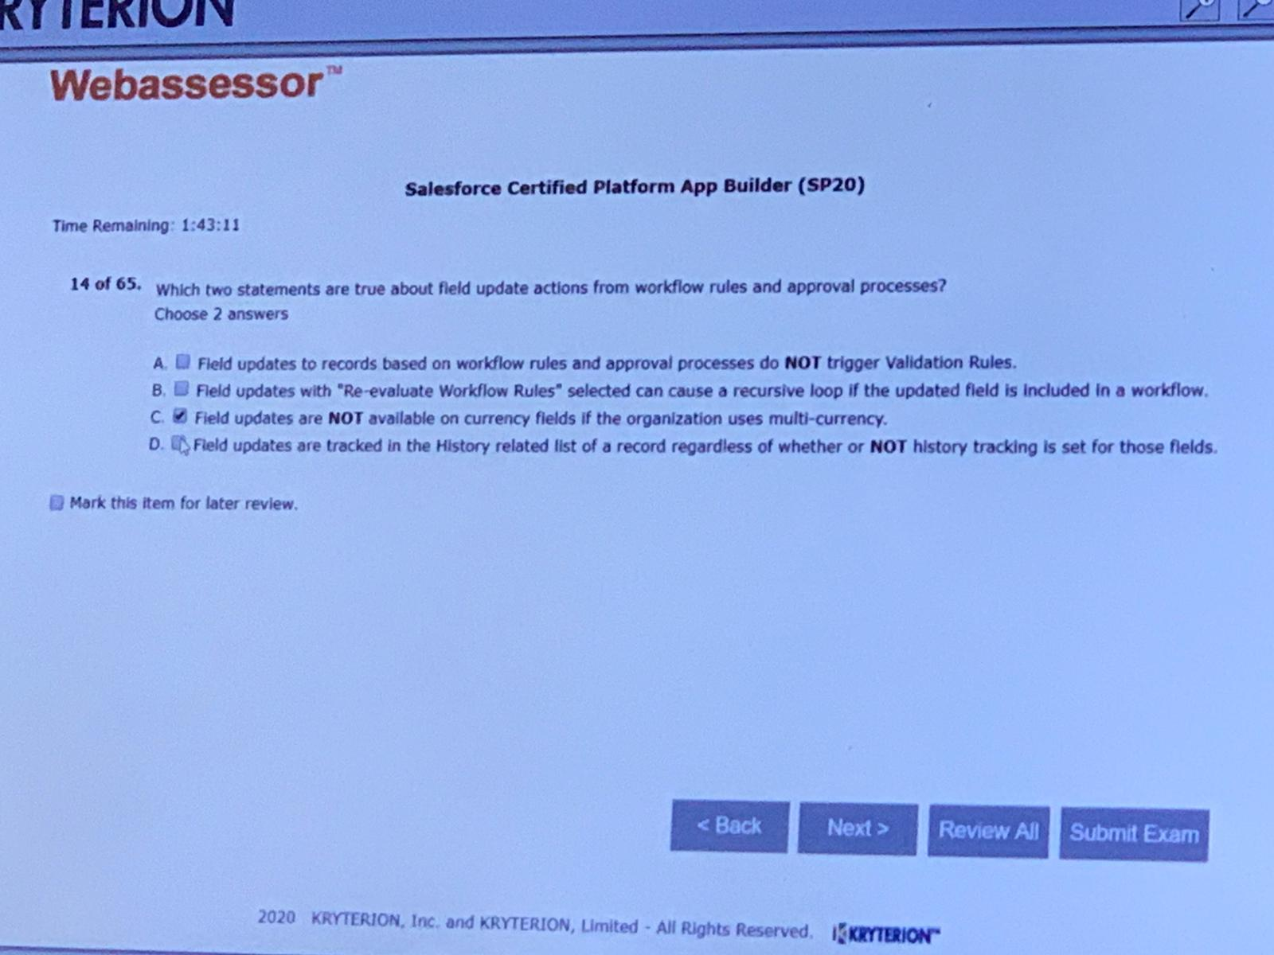AB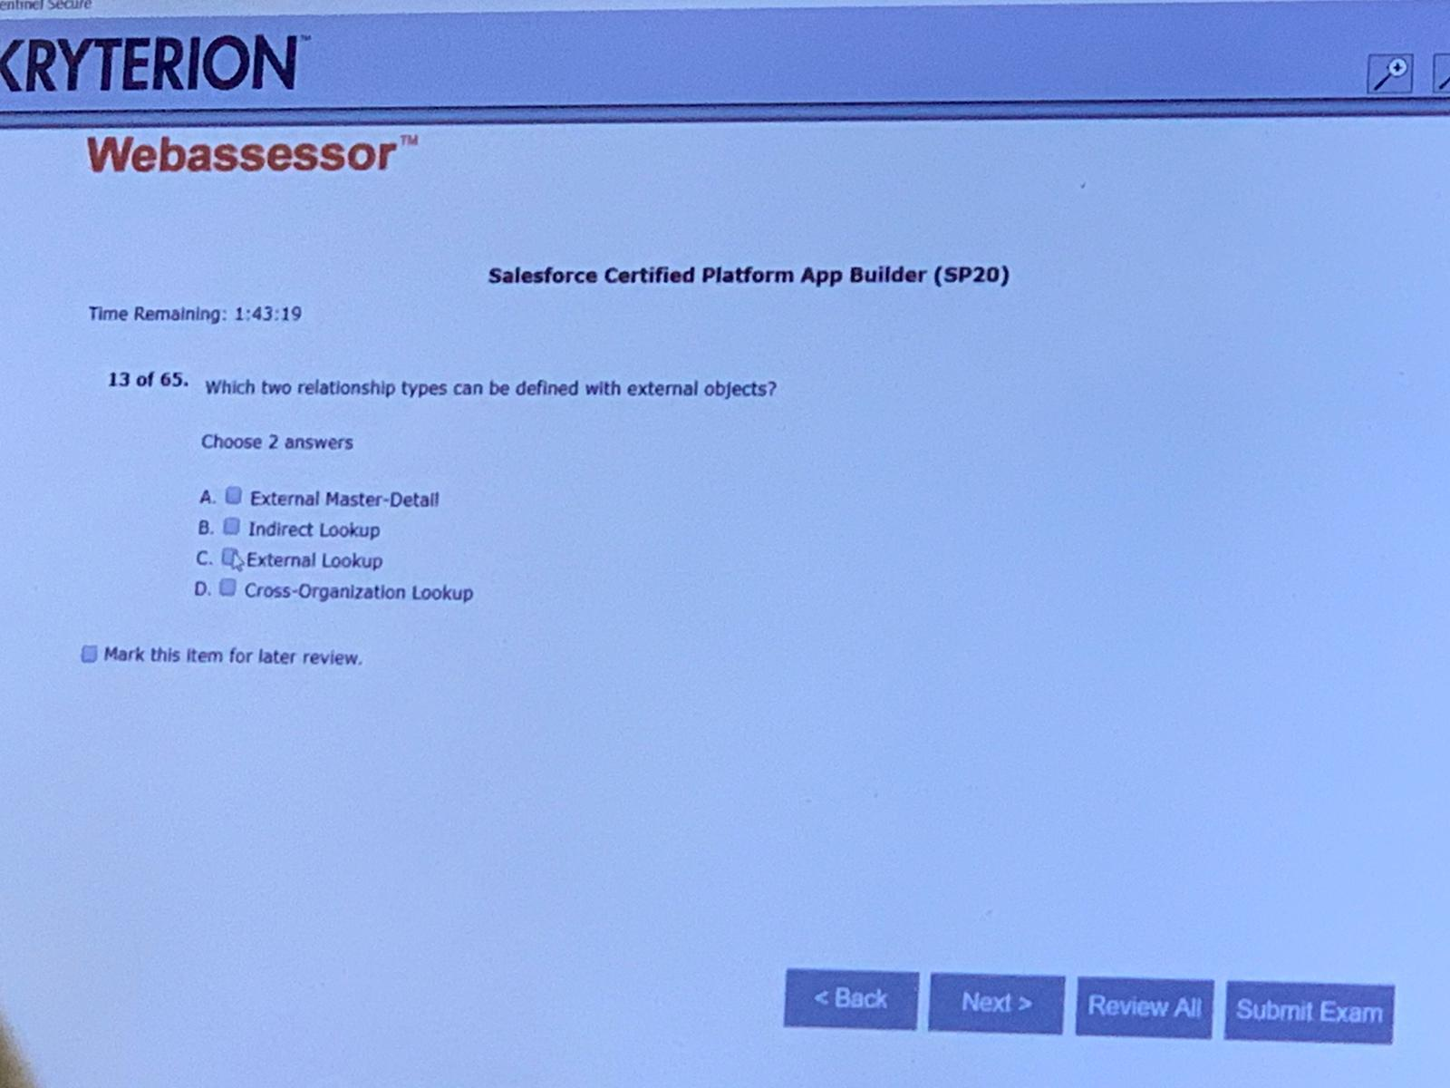BC

C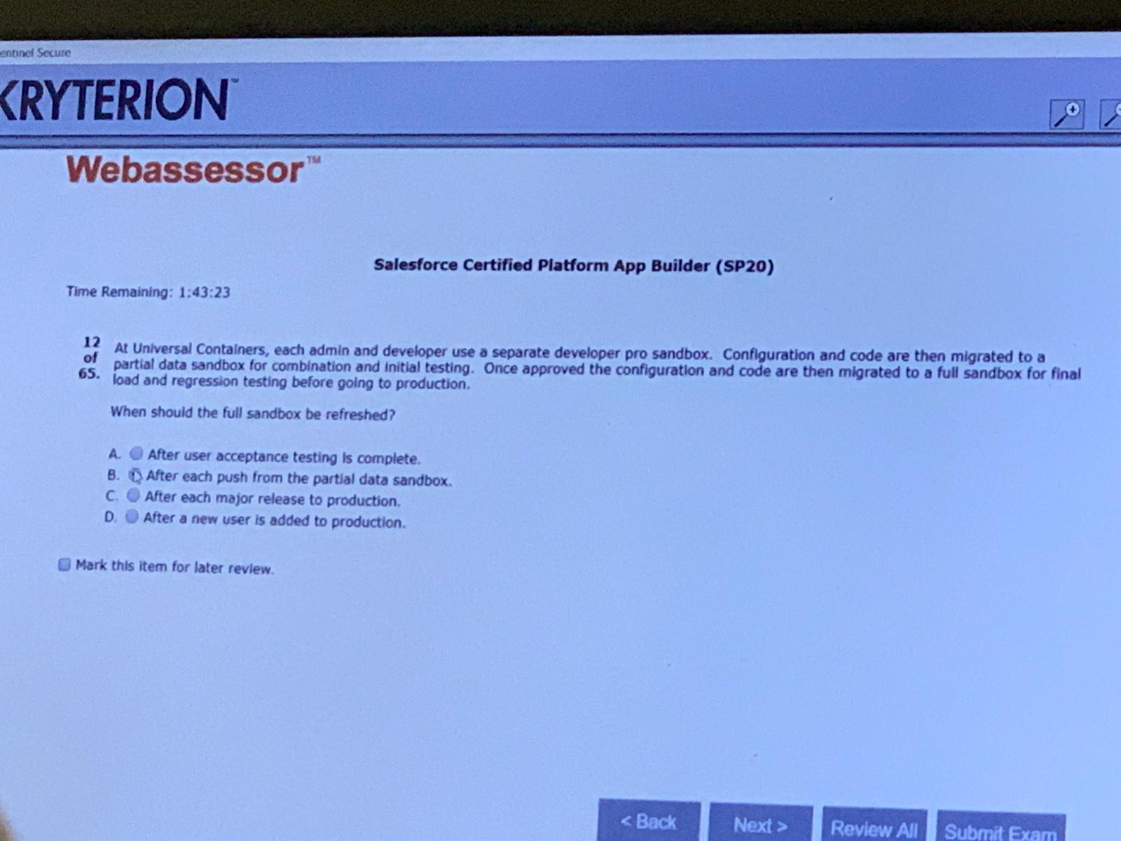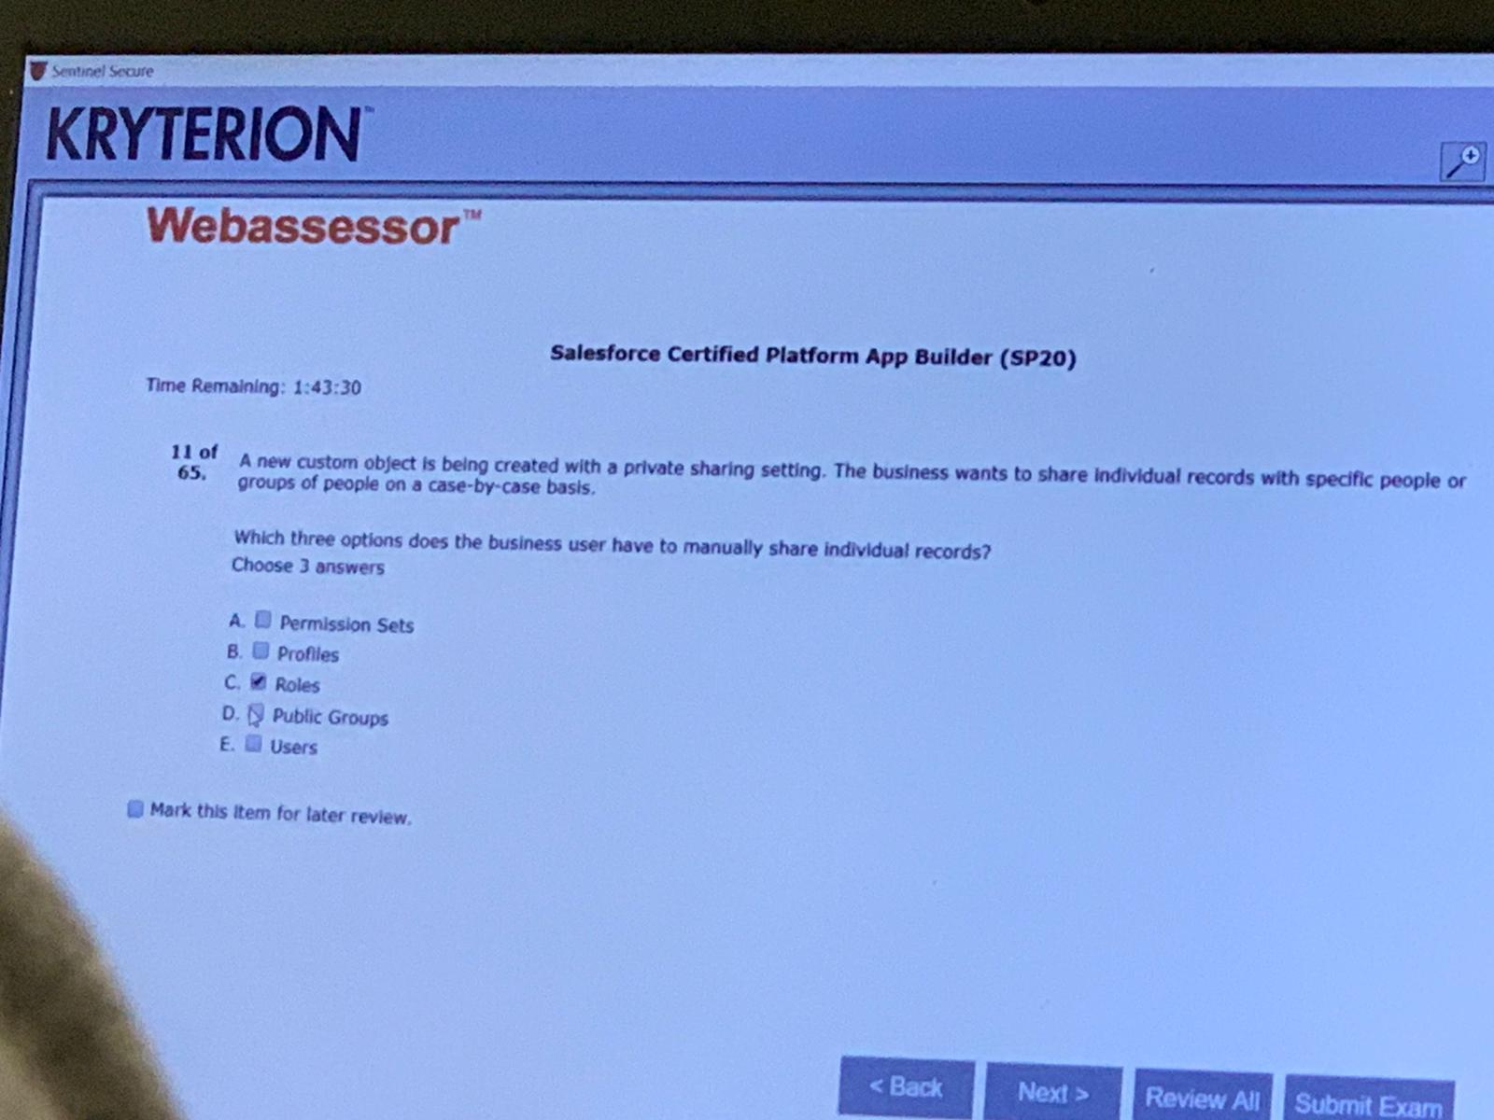CDE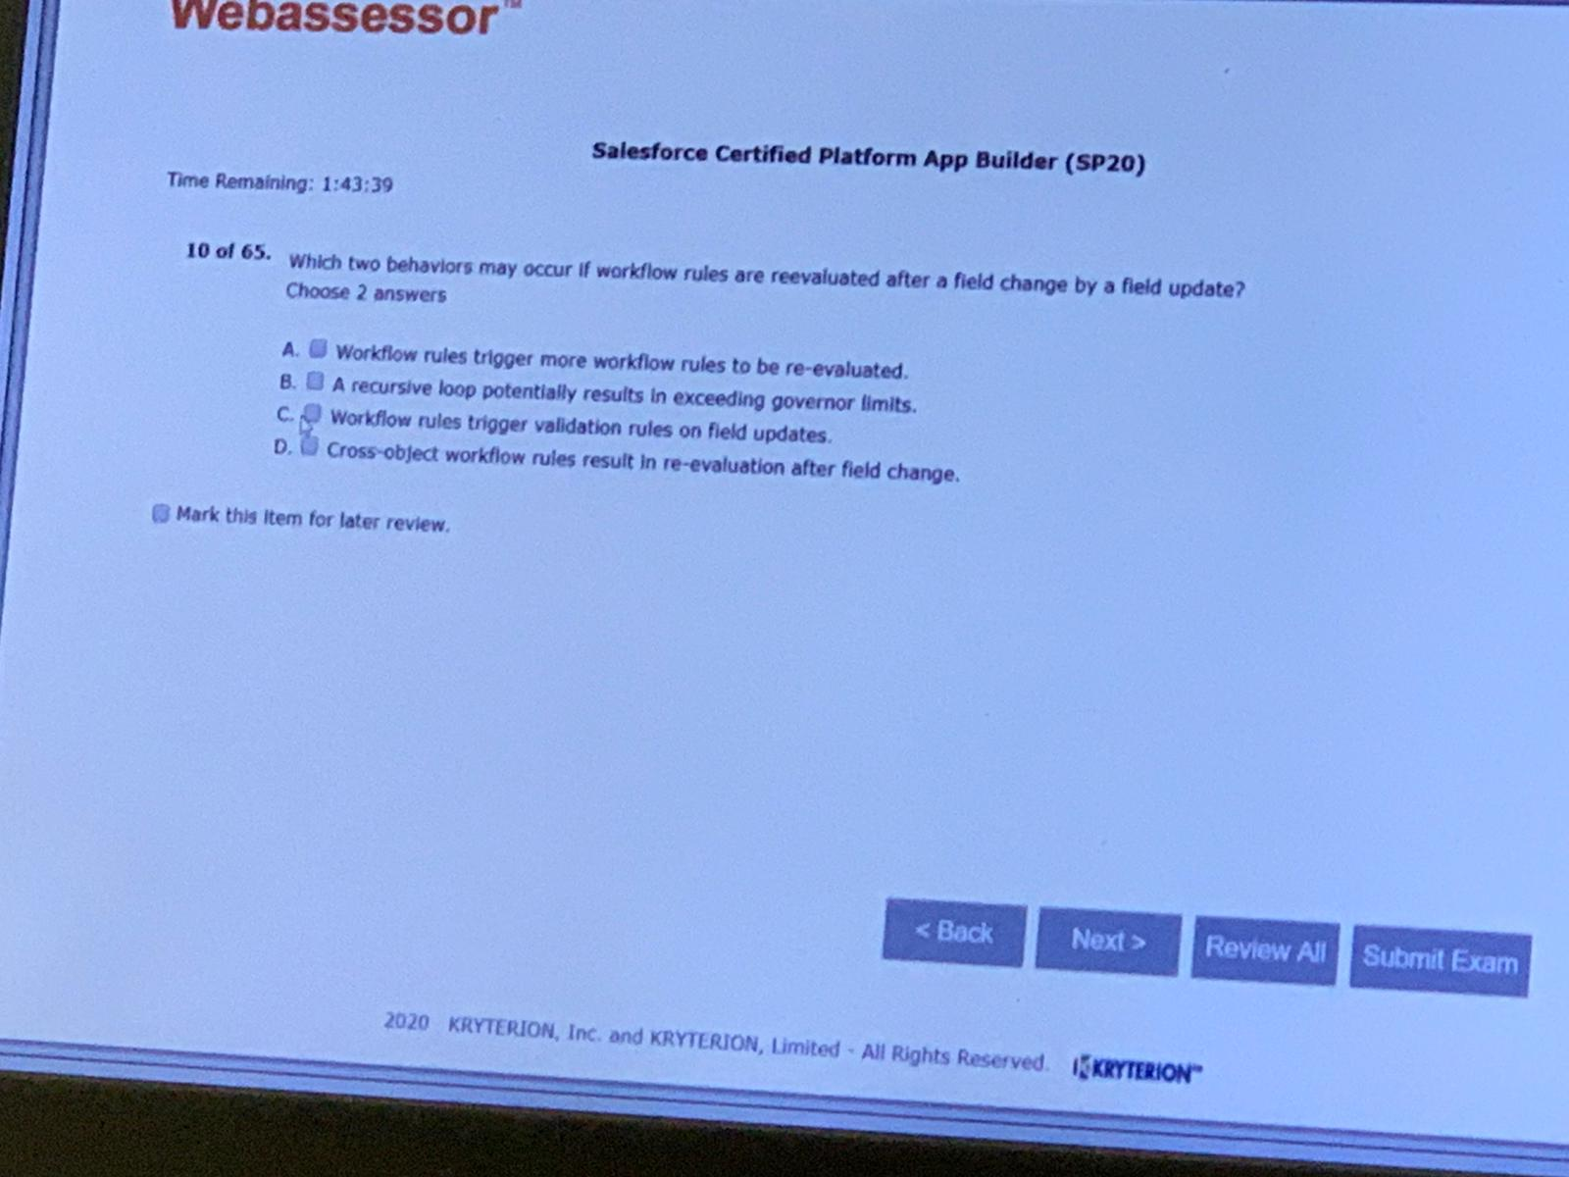AB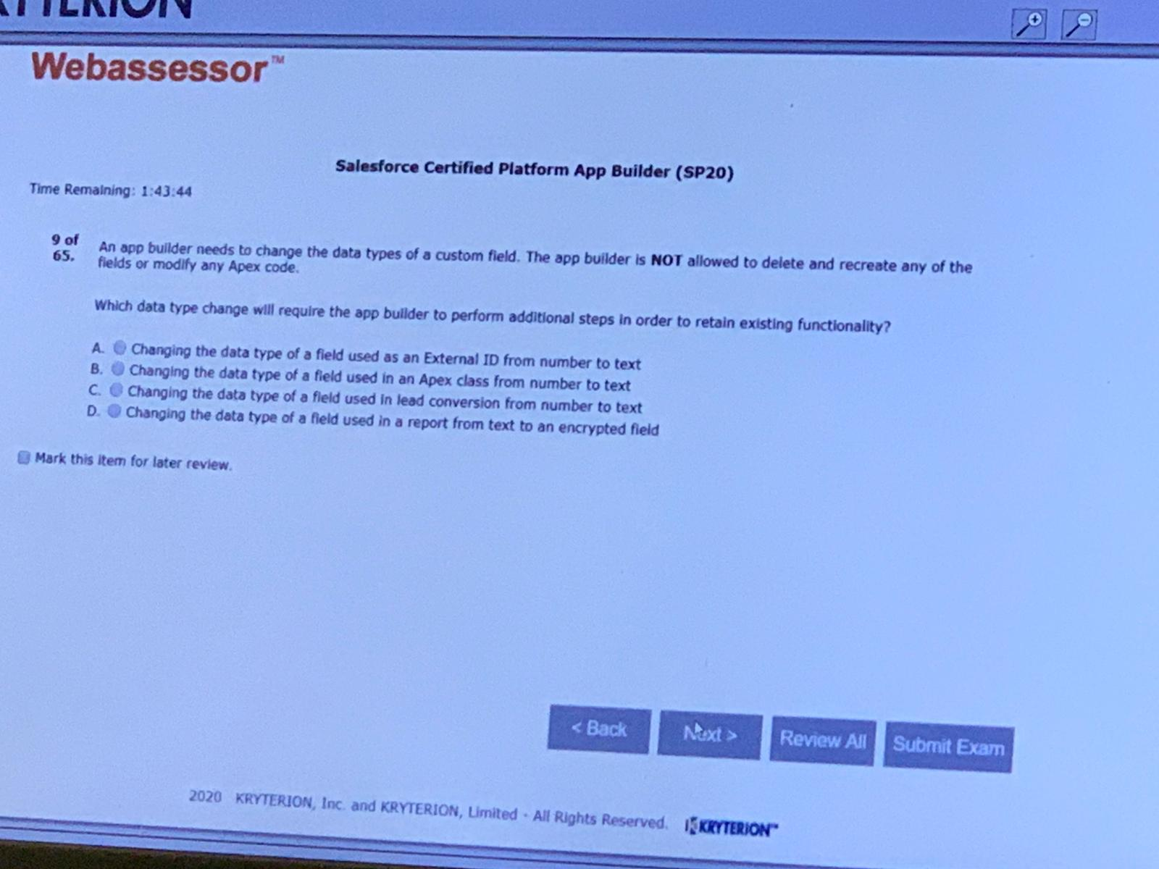A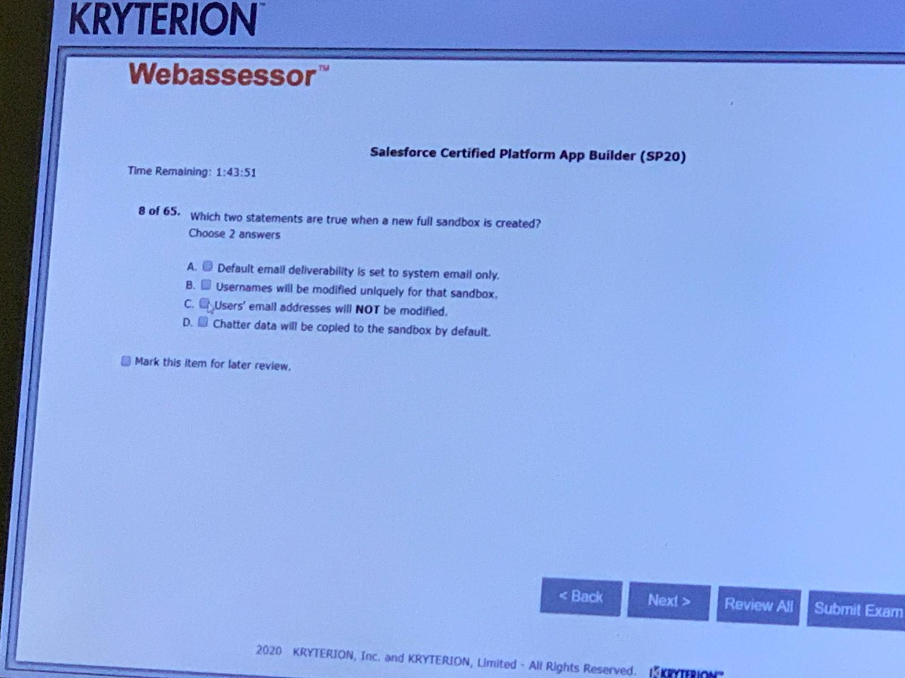AB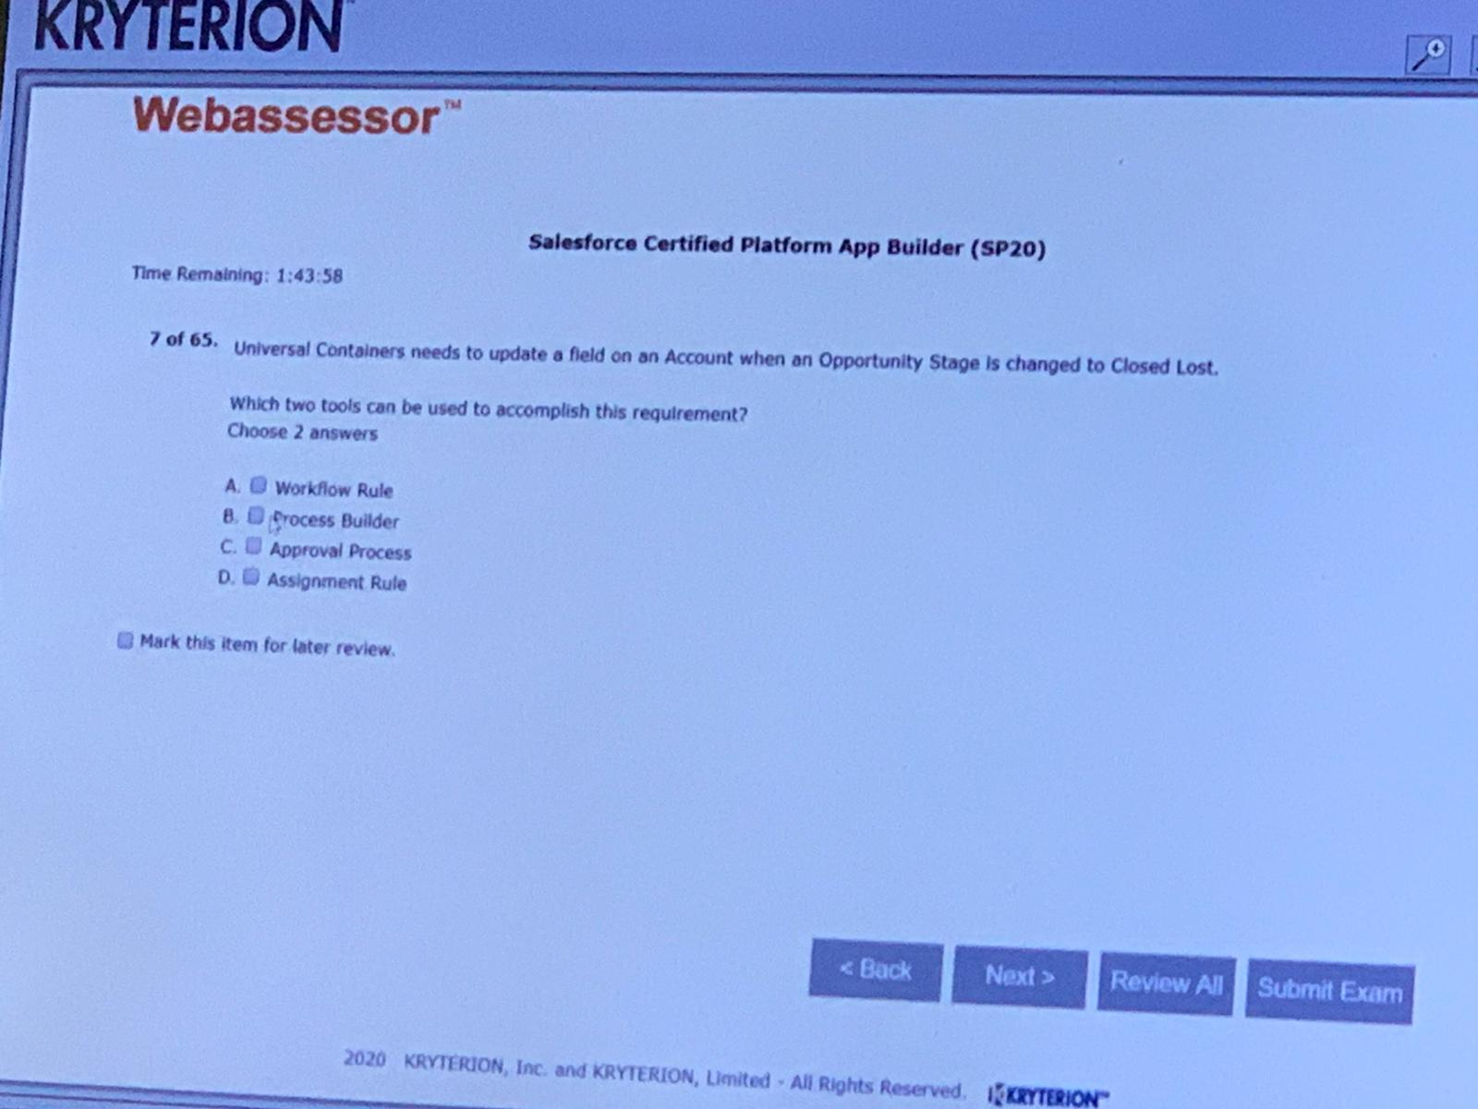AB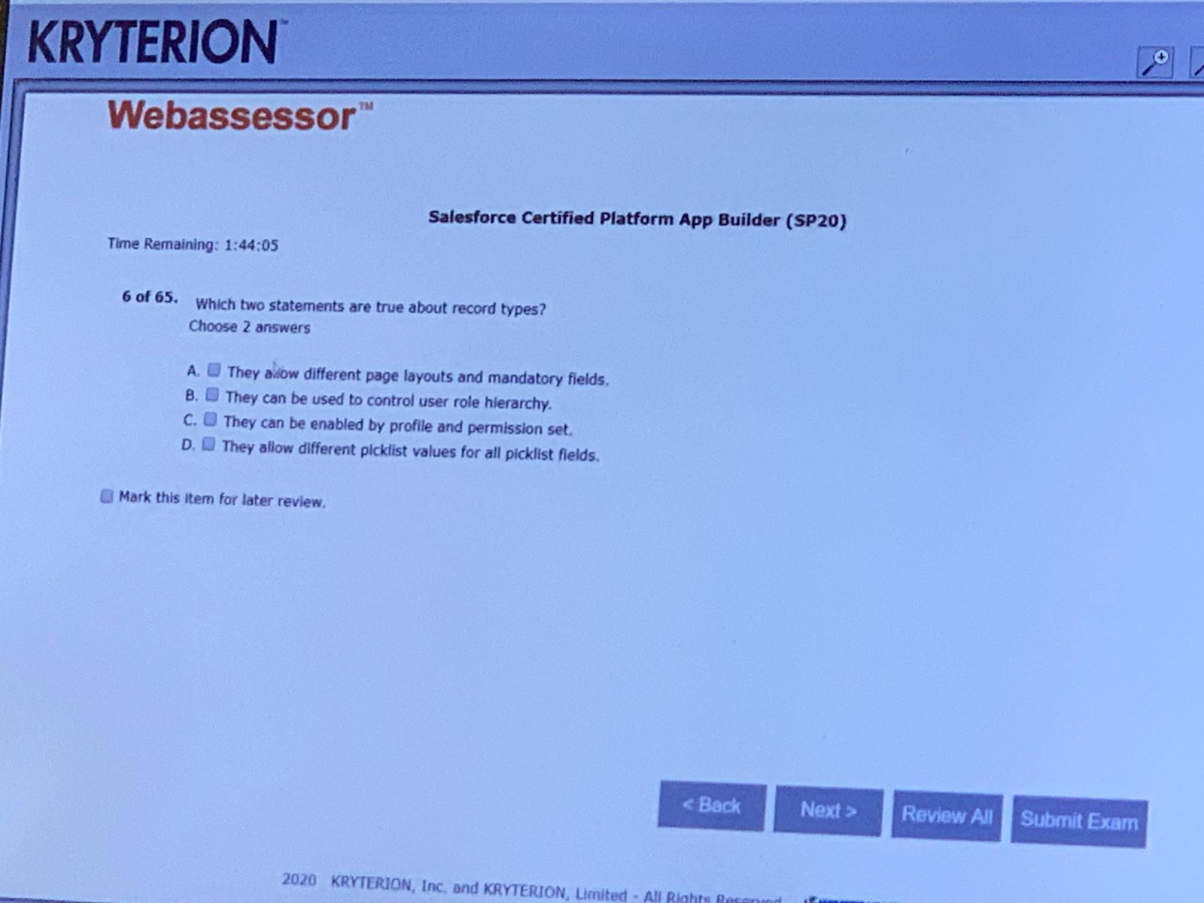CD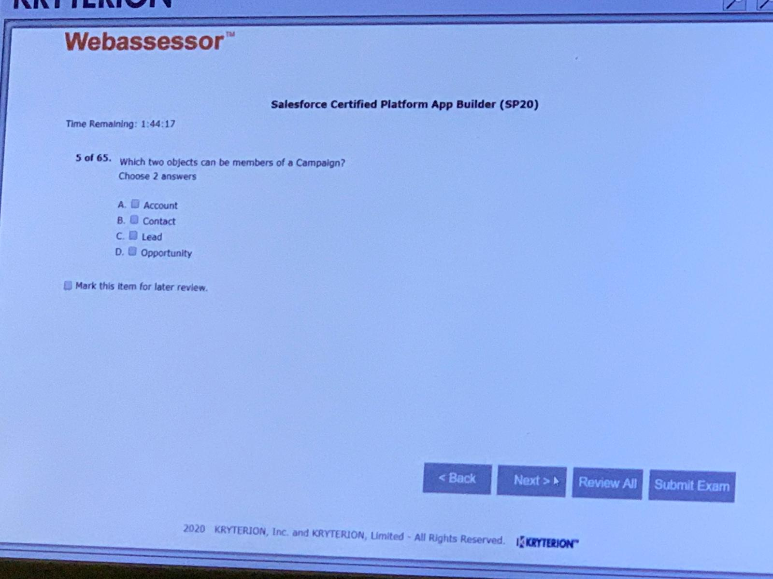CD

A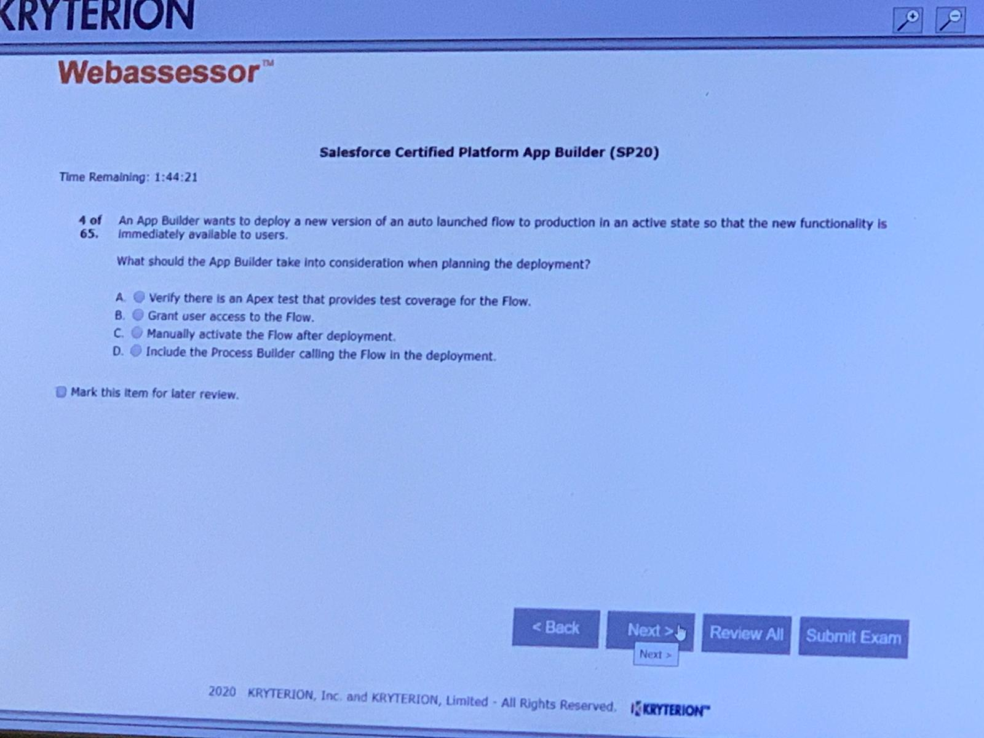A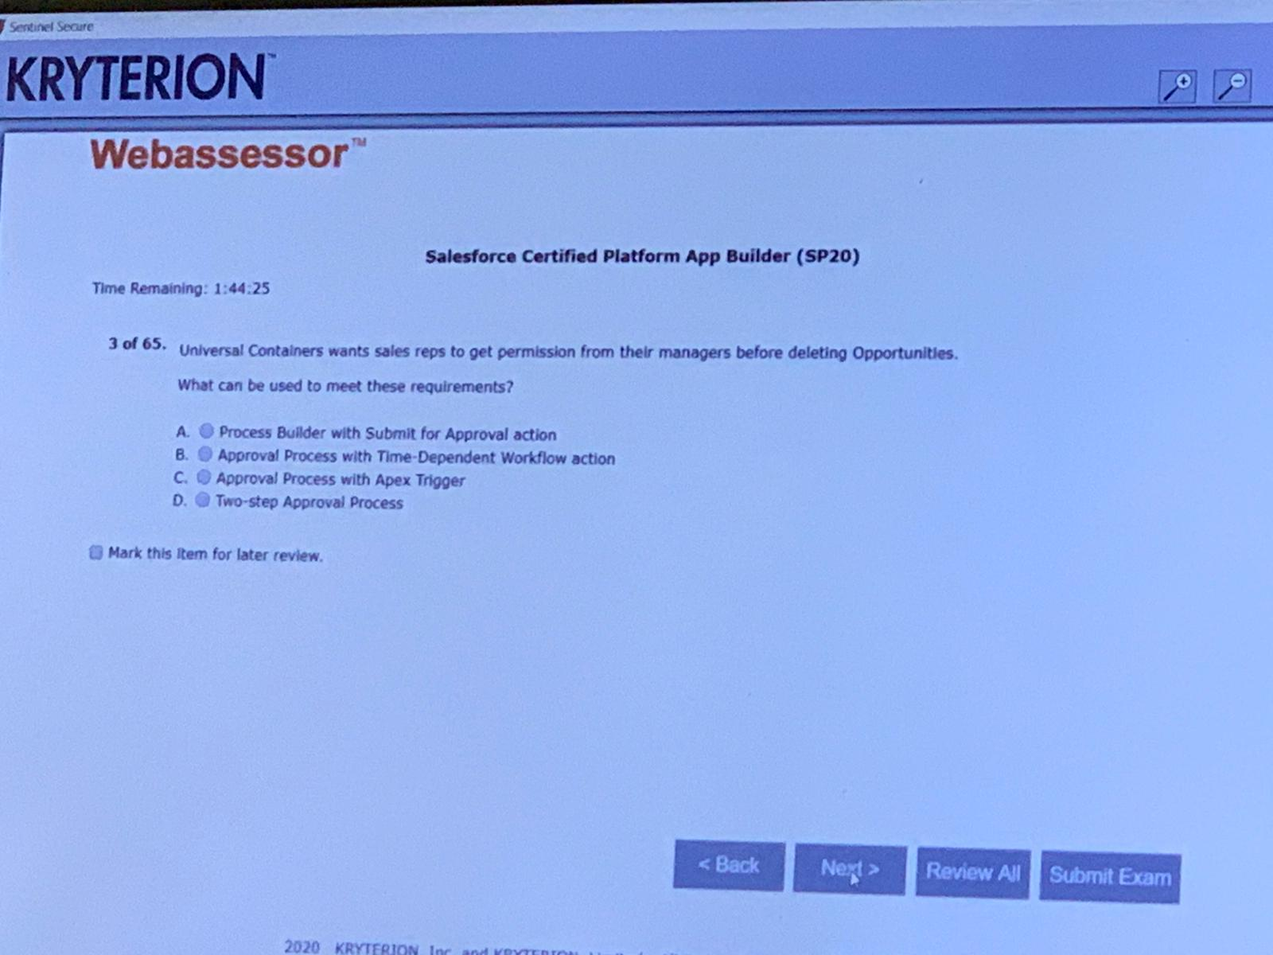

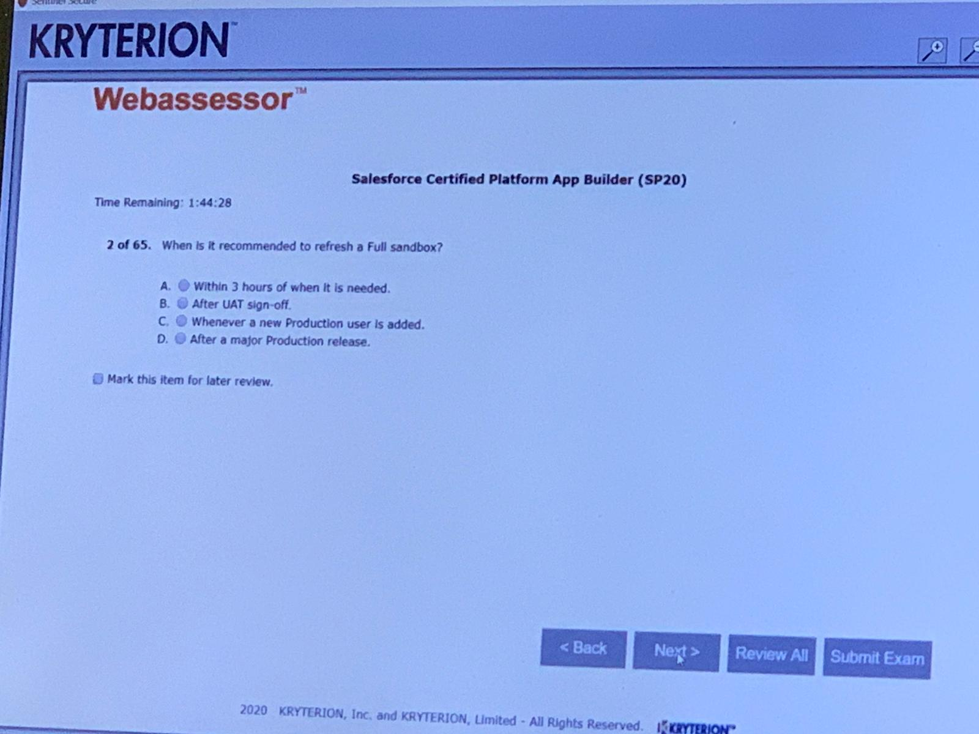D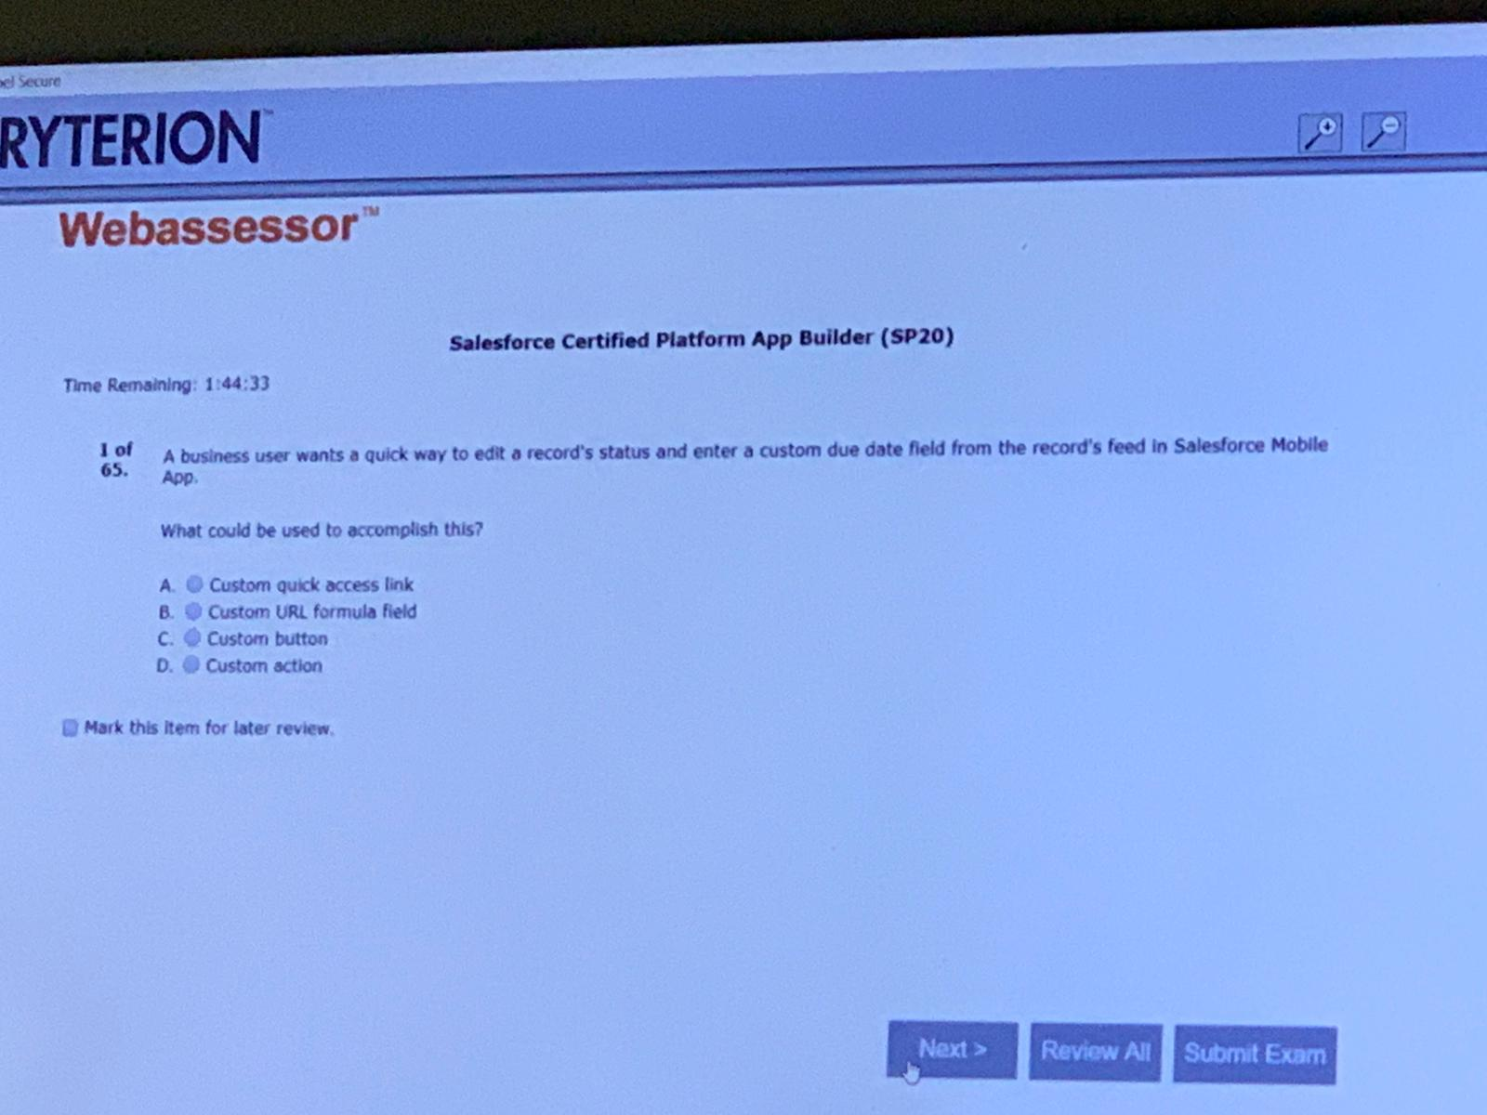D

Extra question captured from Exam :

EXAM SP20 (Candidate Passed 17th June2020)

**1. UVC wants to automate a business process using workflow. They are aware that workflow rules may cause recursive behaviour, and as a result certain actions will only cause workflow rules that didn't fire previously to be retriggered. Which workflow action might cause this behaviour?**

A. Workflow Outbound messages with the “Protected Component” field selected

B. Workflow Field Updates with the “Re-evaluate Workflow Rules After Field Changes” field selected

C. Workflow Emails containing hard coded links with Salesforce IDs referencing specific workflow rules

D. Workflow Tasks where the “Due Date” field is set to “Rule Trigger Date” minus X days

**2. UVC’s CFO has asked that all deals with more than a 40% discount get automatically sent to the VP of Finance. He will review these deals without the sales rep needing to take action Which two ways can this be accomplished without building code? Choose two answer**

A. Launch a new approval process that has automatic submission enabled as an initial submission action

B. Create a new process with a submit for approval action to automatically submit deals for approval

C. Create a new approval process that has automatic submission enabled in the entry criteria

D. Launch a flow that uses the submit for approval action to submit deals for approval

**3. What is a use case for validation rules?**

A. Prevent non-managers from joining a private Chatter Group

B. Restrict partner Lead visibility to the channel sales team

C. Ensure zip/postal codes are entered in the correct format

D. Prevent deals with less than a 10% discount from entering an approval process

**4. What is a true statement when deleting a dashboard?**

A. Deleting a dashboard requires a user to first edit the components to remove the underlying reports

B. Deleting a dashboard also deletes the components within it. It does not delete the custom reports used by the components.

C. Deleting a dashboard also deletes the components within it, as well as the custom reports used by the components

D. Deleting a dashboard does not move the dashboard to the recycle bin and therefore the dashboard cannot be recovered.

**5. A new custom object called invoices needs to have an invoice date for the date and time it was invoiced. What field type should be selected for this?**

A. Date/Timestamp

B. Date/Time

C. Date

D. Time

**6. Which three standard component types are available in the Lightning App Builder? Choose 3 answers**

A. Plain Text

B. Filter Text

C. Rich Text

D. Report details

E. Recent Items

**7. Which two features can be used to allow users to access Visual Workflows? Choose 2 answers**

A. Custom Button

B. Invoked by Process

C. Visual Workflow Launcher

D. Quick Action

**8. UVC wants their Field Sales team to only see the accounts that they own. Separate North American and European marketing teams should only see accounts in their respective regions. The Inside Sales Team needs to see all accounts in Salesforce. How can this be accomplished?**

A. Set the OWD to Public for all accounts. Create criteria-based sharing rules for each Marketing Team, and create an Inside Sales Team permission set with the “View All” settings for accounts

B. Set the OWD to Private for accounts. Create permission sets for each Marketing team, and create an Inside Sales team profile with the “View All” setting for accounts

C. Set the OWD to Private for all accounts. Create Criteria-based sharing rules for each Marketing Team, and create an Inside Sales Team Profile with the “View All” setting for accounts

D. Set the OWD to Public for accounts. Create profiles for each Marketing team, and create an Inside Sales Team role that is at the top of the Role Hierarchy

**9. UVC has two types of customer support processes: Platinum and Diamond. The App Builder created separate record types for each process on the Case Object. The customer support team should not be able to create new cases with the Diamond record type. How can this requirement be met?**

A. Update the profile to remove the Diamond record type from the support team

B. Make the record type hidden to all users and then use sharing rules to share it

C. Update the OWD to private

D. Remove the ability for the support team to create new case records

**10.**[**Which two solutions prevent a formula field from being referenced by a Roll-Up Summary Field?**](https://www.proprofs.com/discuss/q/1771298/which-two-solutions-prevent-formula-field-from-being-referen)

A. A cross-object workflow updating a field referenced by the formula field

B. A cross-object field reference in the formula field

C. The CASE() function in the formula field

D. The NOW() function in the formula field

**11. The VP of sales requested that Account Site Information should be visible on an Opportunity record. What is the recommended salutation to meet this requirement?**

A. Workflow Rule

B. Cross-Object Formula Field

C. Process Builder

D. Roll-Up Summary Field

Below Questions Collected 18th June, Kindly find the answer from other doc

12. 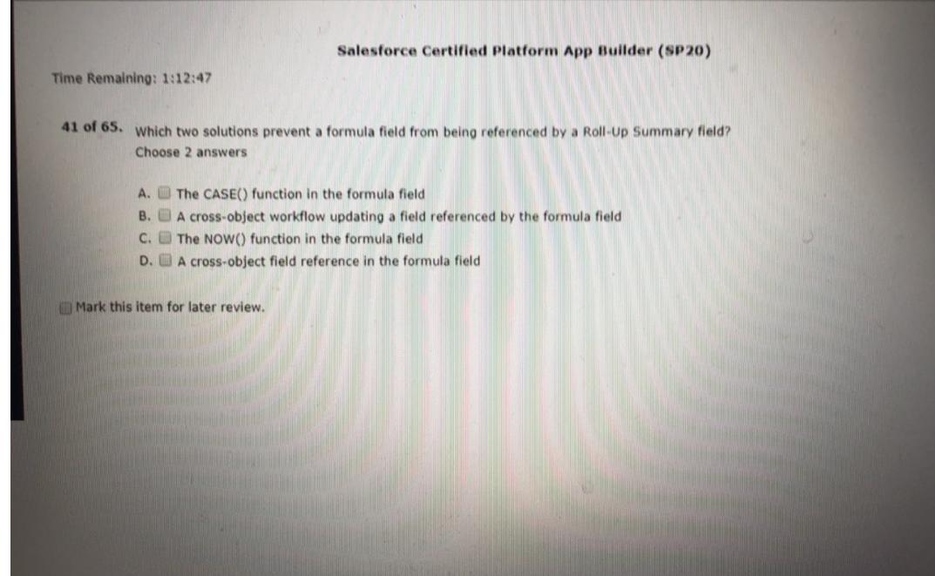

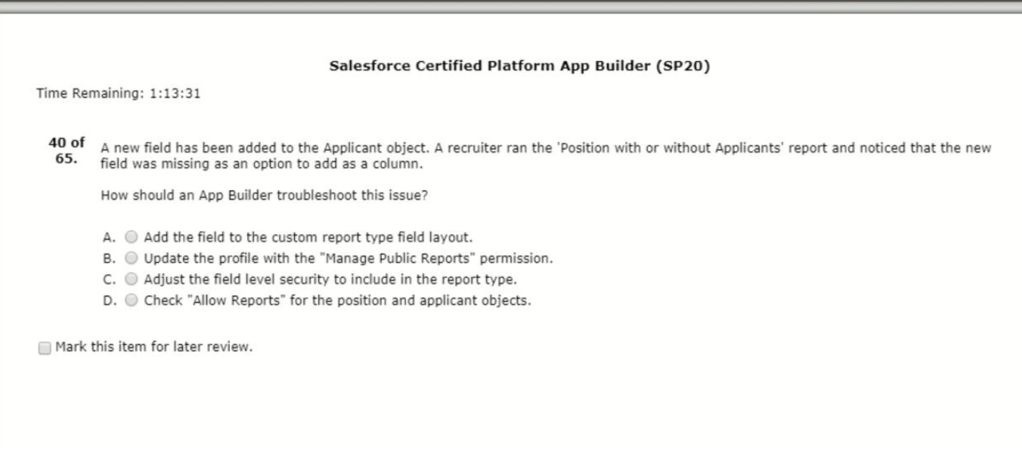

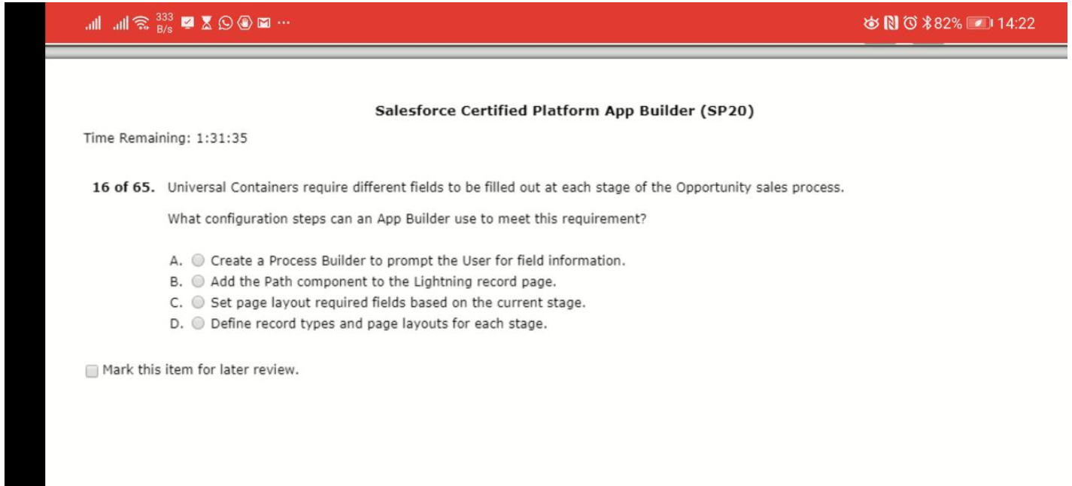

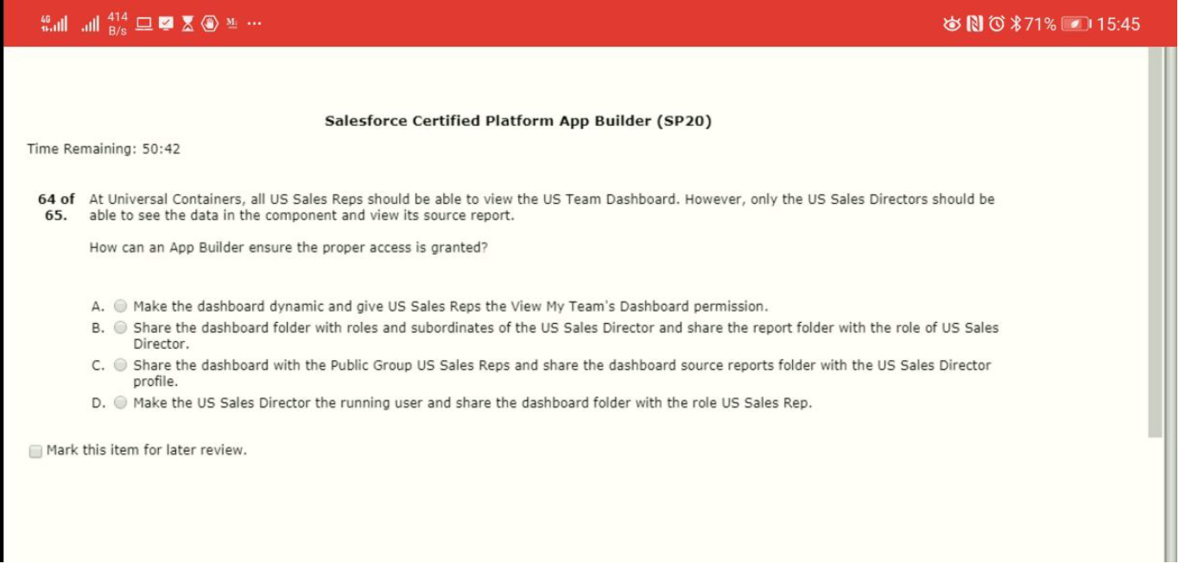

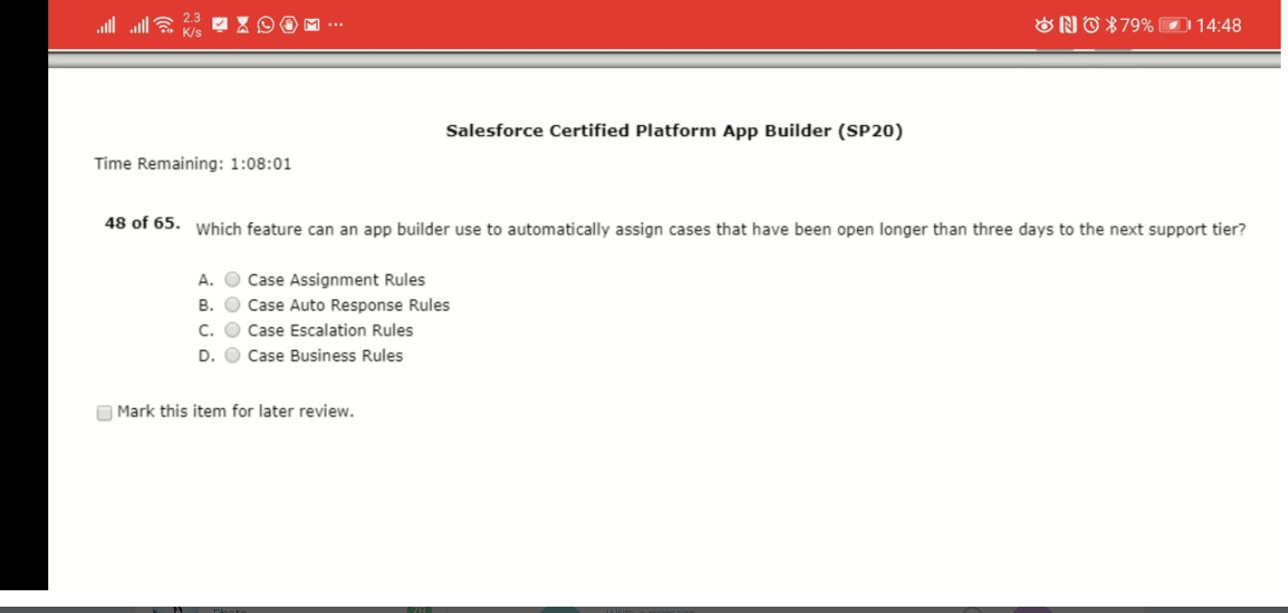

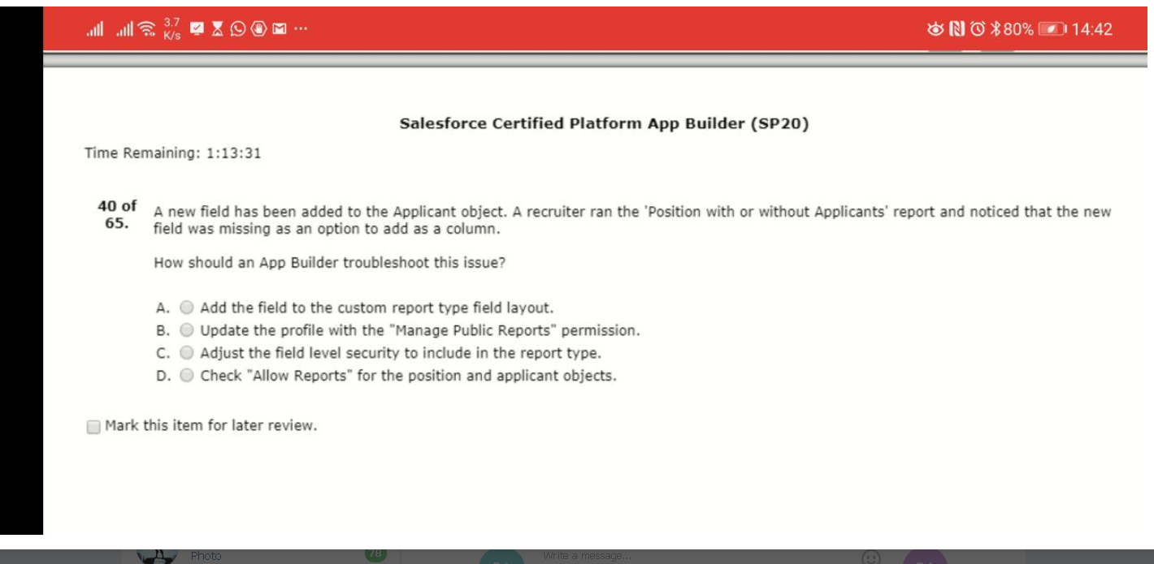

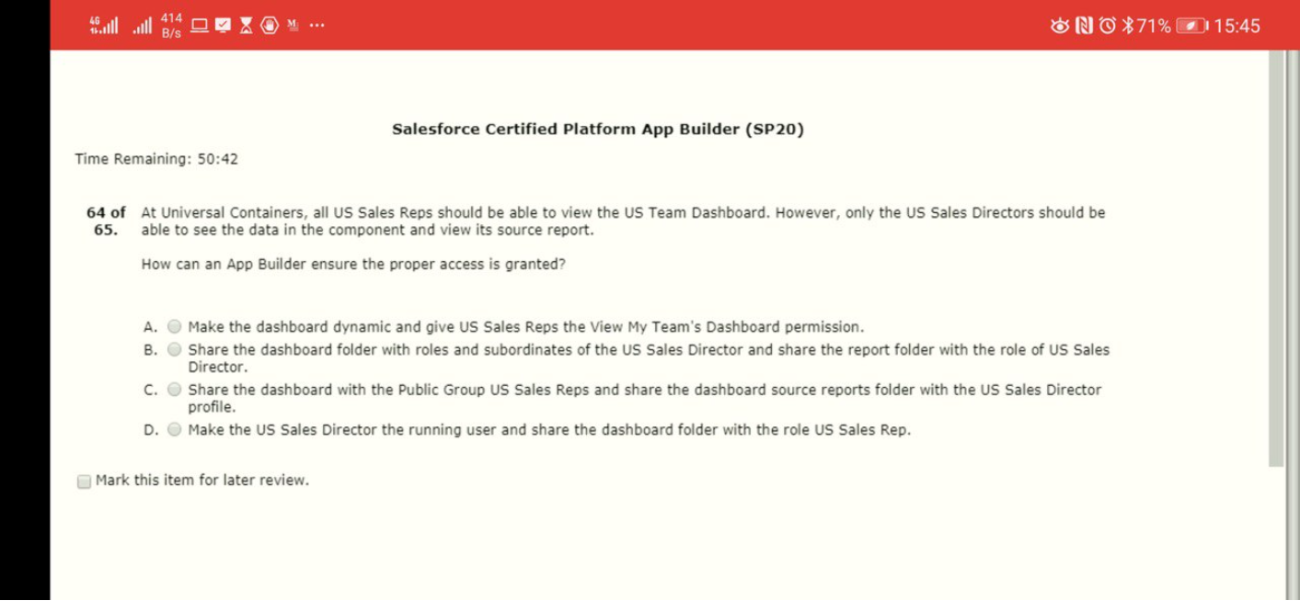

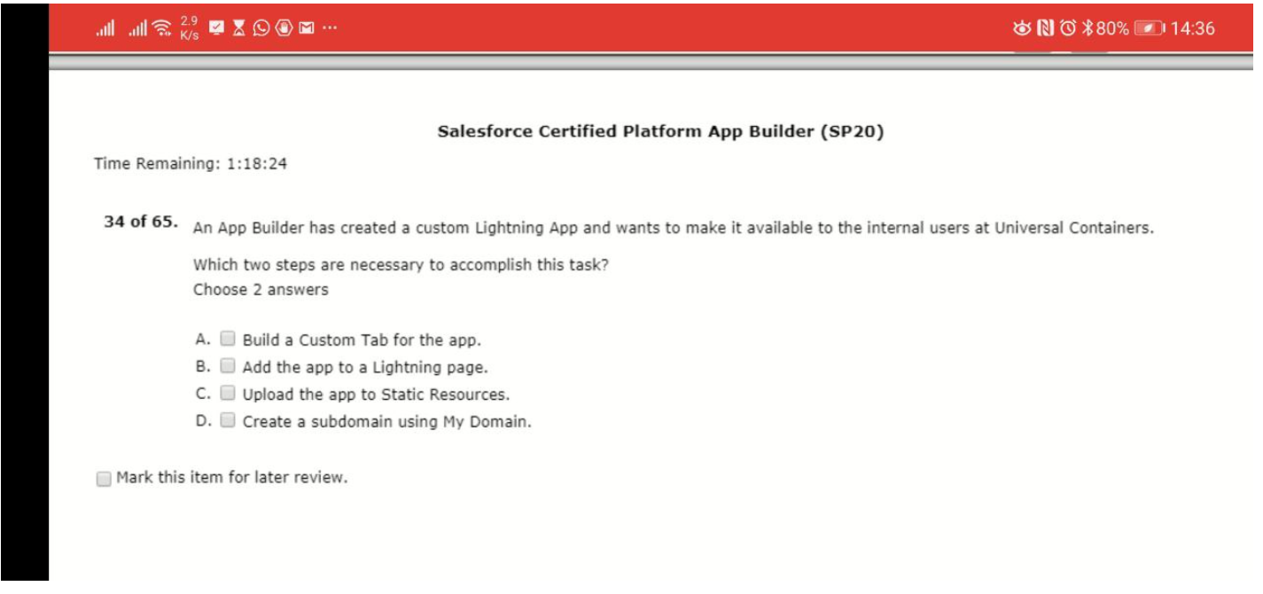

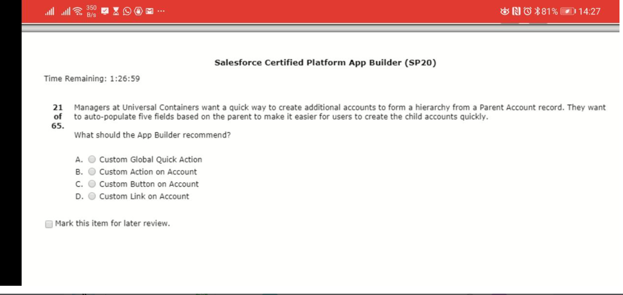

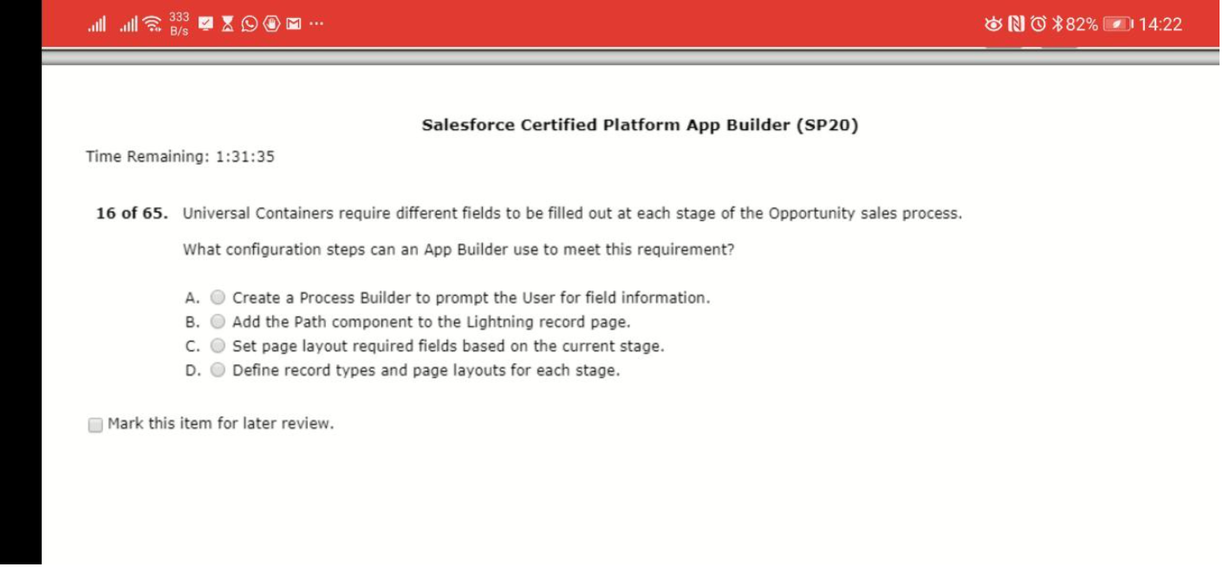

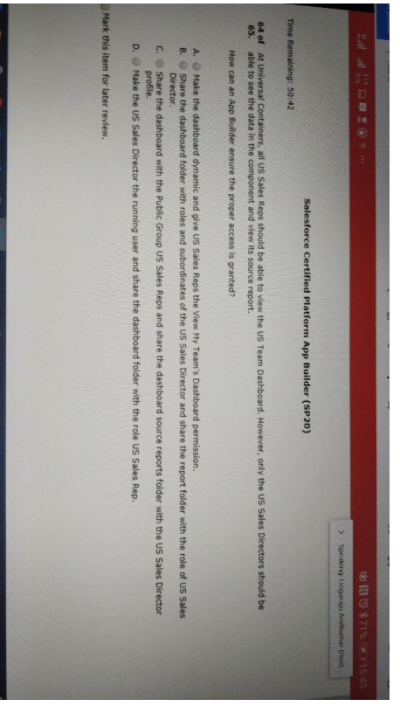s